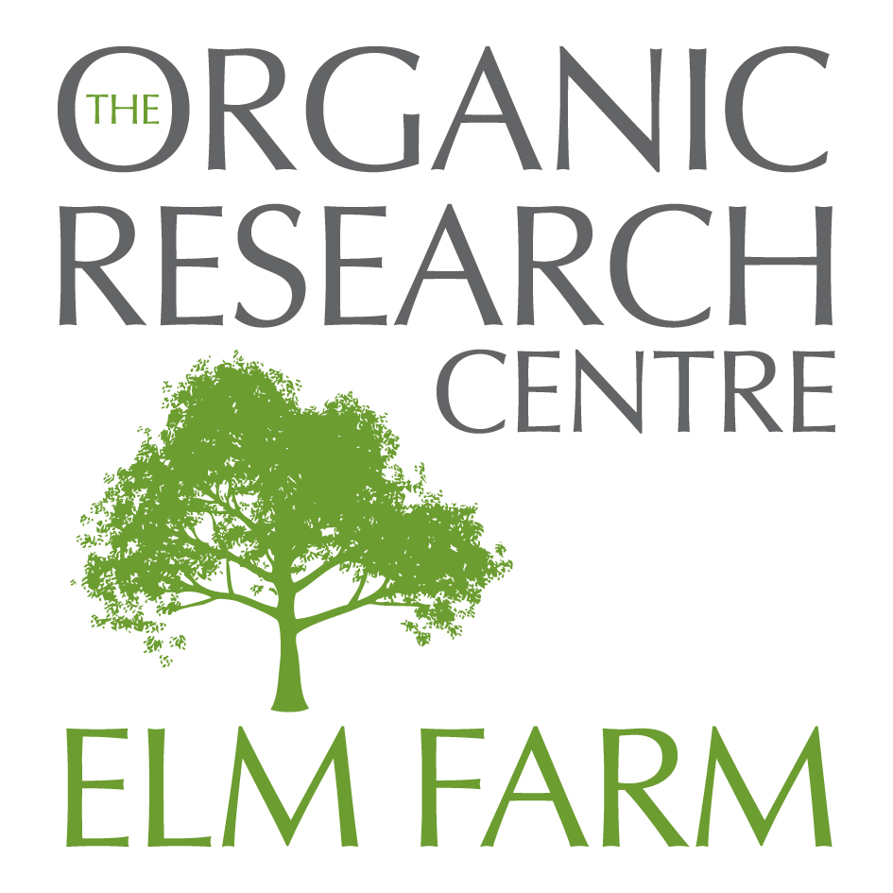
The Organic Research Centre- Elm Farm, Wakelyns Agroforestry, Metfield Lane, Fressingfield, Suffolk, IP21 5SD, UK
Phone/Fax: 01379 586021 E-mail: zoe.h@organicresearchcentre.com

OS Ref: TM 287789

From the east -
from the A12 follow the sign to Halesworth B1123 and then continue on the B1123 to Metfield. As you come into Metfield, take the left fork signposted Fressingfield. Follow this for 1-2 miles until the road takes a sharp bend to the left at Lawn Farm (Landquip). Turn right here, marked 'No Through Road'. Follow this through the Landquip (Lawn Farm) yard. Continue along the No Through Road, when you can go no further you are at Wakelyns Farm!

From the west –
past Diss, continue on the A143 Gt Yarmouth road towards Harleston. There is a roundabout at the Harleston turning - continue as if to Gt Yarmouth for about 3-400 yards then take the slip road to the right signposted Fressingfield, and right at the T junction again signposted Fressingfield. Entering Fressingfield (about 3-4 miles)turn left at the War memorial (bottom of the dip), signposted ‘ Metfield’. Continue for 1 mile and take the second turning left, at a red brick house signposted ‘ Metfield’. Continue along this road for approximately 2 miles, turn left on the bend along the ‘No Through Road’, and past ‘Landquip’. When you can go no further you are at Wakelyns Farm!

