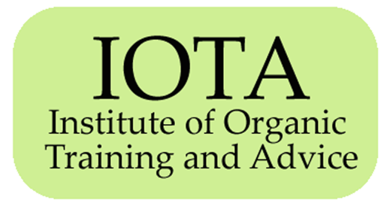
Institute of Organic Training & Advice
IOTA office tel: 0044 (0) 1547 528 546 : Email: iota@organicresearchcentre.com
www.organicadvice.org.uk

New Member Application Form

Name _______________________________________________________________

Organisation or Company (if appropriate) __________________________________

Address _____________________________________________________________

________________________________ Postcode ____________________________

Telephone ________________ Fax ________________ Mobile ________________

Email _______________________________________________________________

Your profession (farmer, adviser, trainer, researcher, other – please state):

____________________________________________________________________

Type of Membership applied for (please tick one box below):

- I am applying for Subscription @ £175.00 (= £210.00 incl 20% VAT)

- I am applying for Accredited Membership @ £175.00 + one off Accreditation fee of

£150.00 = Total £325.00 (= £390.00 incl 20% VAT)

- I am applying for Corporate Membership @ £250.00 (= £300.00 incl 20% VAT)

I am paying by cheque credit card bank transfer (see page 2 for how to pay)

Note: Soil Association component:

IOTA subscription includes the Soil Association Producer Package but does not include Membership of Soil Association.
► If you would like to upgrade to full Soil Association Membership (member of Soil Association, receiving Living Earth magazine, etc) as part of your IOTA Membership, this is an additional £24.00 (£28.80 incl 20% VAT). Please tick this box if you wish to upgrade

►If you are already in receipt of the Soil Association Producer Support package (eg. because you are a Soil Association Licencee) this can be removed from the IOTA services and reduce your IOTA membership fee to £100 plus 20% VAT (= total: £120). Please tick this box if you want the Soil Association component to be removed from your IOTA services

If you select this option, please provide your Soil Association Licencee number here ____________

Continued >>

IOTA Membership Application form continued

I agree to my name and contact details being retained on the IOTA and Organic Research Centre databases and to receiving regular information and updates from the IOTA office, normally via email.

My details will be passed on to Organic Research Centre, Soil Association, Organic Centre Wales, Organic Farmers and Growers and SOPA solely in order to receive benefits in connection with my IOTA membership.

I agree to abide by the Constitution and Rules of IOTA and its Code of Conduct (http://www.organicadvice.org.uk/conduct.htm)

Signed _______________________________ Date _______________________________

I am applying for Accreditation and am enclosing a completed copy of the Accreditation Registration Form with this application

PAYMENT METHODS

You can pay for your IOTA membership by cheque, credit card or bank transfer.
Please send the completed form to IOTA c/o Gillian Woodward at the address below.

Payment by CHEQUE: please make your cheque out to Organic Research Centre.

Payment by CREDIT CARD: please telephone Gillian Woodward, Organic Research Centre (01488 658298 x 554) with card details.

Payment by BANK TRANSFER: please e-mail Gillian Woodward (Gillian.w@organicresearchcentre.com) for account details.

Please return this form once complete to: IOTA, c/o Gillian Woodward, Organic Research Centre, Elm Farm, ead Marshall, Newbury, Berkshire RG20 OHR

[updated April 2013]

