Reduced tillage and green manures on organic farms - making it work!
As part of a new research project, ORC and The University of Newcastle are interested in your experiences with Reduced Tillage and Green Manures on organic farms.
Are you a:
Farmer | Organic | Conventional
Grower | Researcher | Other

Do you use any of the following techniques?

No tillage (the crop is sown directly into soil not tilled since the harvest of the previous crop). | YES / NO
Minimum tillage (any tillage practice with a depth shallower than the conventional practice and/or a non-inversion method such as chisel ploughing). | YES / NO
Green manure techniques (any crop that is grown to:  - increase soil N supply to the subsequent crop  - increase soil organic matter  - reduce populations and incidence of pests and diseases  - reduce competition from weeds in subsequent crops  - minimize soil erosion).  If you grow a clover and/or grass ley in a rotation and use it as a fodder or grazed crop, do you leave at least one harvest in the field as a mulch, prior to incorporation? | YES / NO  YES / NO

Crops Grown (please list the types of crop you grow with estimate of area)

Crop | Ha/Ac | Crop | Ha/Ac


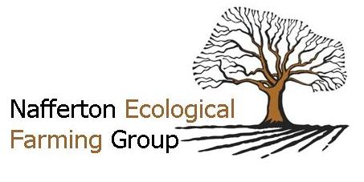
Would you be interested in taking part in a more in-depth interview about your use of these techniques? YES / NO

Name
Address

Email
Telephone
Mobile

Please provide comments on the back of this sheet. We are interested in the reasons why you use or might consider using minimum tillage and green manures, and what challenges you have experienced or might expect when using them.
Thank you very much for your time.

