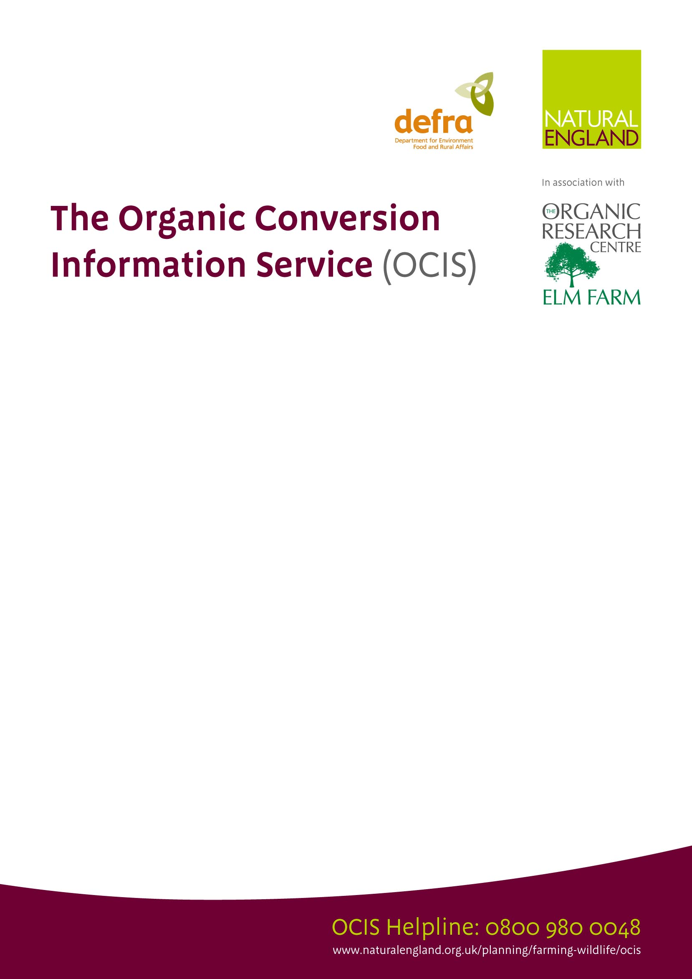
FREE organic conversion advice is available under a new Service provided by Natural England, to help farmers and land managers in England consider the practical implications of converting their business to organic production. The Service aims to provide farmers and land managers with clear, accurate and targeted information and advice on the practicalities that need to be considered when converting their farm business to organic farming.

Who provides it?
The Organic Research Centre (ORC) based at Elm Farm, with support from the Scottish Agricultural College (SAC) will deliver the new service.

What support and advice is available?
- a telephone helpline and information pack
- an on farm visit lasting half a day (of approx. 3 and a half hours duration)
- an on farm visit lasting a full day (of approx. 7 hours duration)

Am I eligible to receive an on-farm visit?
- You must be a farmer or land manager in England;
- Your farm must have a CPH number;
- You must manage the core farming business of the holding for which conversion aid is being considered;
- You may be a farm owner, tenant or land manager;
- Your agricultural holding must be greater than 10 hectares or you must derive at least 50% of your income from the holding you are looking to convert;
- You must not have previously benefited from conversion advice from OCIS, or its predecessor at any time after May 2005;

How do I apply for the Service?
Please contact the Organic Conversion Information Service on 0800 980 0048

Lines will be open from 8.30 am to 17:00pm Monday to Friday. A dedicated answer phone is available outside office hours and during busy periods.

HELPLINE number
0800 980 0048

