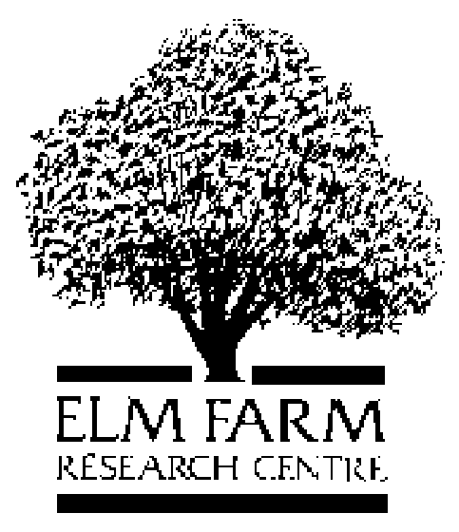
Article added on: 17/06/05
Category: Research: Project Summary
Key words: Bi-cropping, Clover, Composite cross population, Competition, Ecological, Interactions, Inter-cropping, Nutrient management, Organic, Seed density, Spatial arrangement, Sustainable, Varieties, Weed management, Wheat

Project Title: Sustainable Production of Organic Wheat

Short Title: WheatLINK

Project Code: SA 297

Project Leader: Prof. Martin Wolfe

Project Partners: To be confirmed

Start Date: 1st October 2005

End Date: 31st December 2008

Funder: Defra LINK

Key Words: Bi-cropping, Clover, Composite cross population, Competition, Ecological, Interactions, Inter-cropping, Nutrient management, Organic, Seed density, Spatial arrangement, Sustainable, Varieties, Weed management, Wheat

EFRC Programme: Arable

Project Aim: The main aim of the project is to use an ecological approach to analyse the interactions of a range of key variables in organic wheat production (wheat genotype, spatial arrangement of seed, seed density and sowing date) including the major factor of wheat/white clover inter-cropping, so as to determine an optimal approach to improved and stabilised production.

The wheat genotypes will include a conventional control, one variety selected for low input conditions and samples of composite cross populations selected under organic conditions. Each of these genotypes will be subjected to the range of agronomic treatments.

A subsidiary aim will be to compare the organic weed management systems of mechanical hoeing and/or harrowing with the potential suppression of weed populations by competition for resources from wheat (drilled in a spatially effective manner) and from clover occupying potential weed space.

The main outcomes from the project will be disseminated widely in the organic farming industry to provide an opportunity for generally enhanced, and more reliable, productivity and quality in winter wheat production. This should help organic farmers in the UK towards meeting the increasingly high demand for organic milling wheat. Furthermore, it should also help with recruitment to organic farming, in line with EU and Government policy.

Abstract of Research: Conversion to and development of organic farming in the UK is hindered by the central problem of winter wheat production which is low in both yield and quality. Demand for organic wheat is high, and increasing, but the supply of home-grown milling wheat fulfils less than one third of this demand. Critical deficiencies are a lack of appropriate varieties and inadequate information on basic field establishment criteria for those varieties that are suited to organic production. There is also a need to improve nitrogen supply to wheat crops during both early stages of development and grain establishment. Recommendations are needed in these directions not only to improve yield and quality but also to provide adequate buffering against environmental variation.

The main objective therefore is to undertake a multifactorial analysis of different wheat genotypes, with or without clover bi-cropping, planted at different seed rates in a range of different spatial patterns. This will allow a comparison of weed management and nutrient flow through bi-cropping or mechanical control and an overall assessment of environmental stability of the optimal system.

Rapid and widespread dissemination of the outcomes will encourage existing and new producers to modify their own systems towards improved production and quality. Potentially, this could have a major impact not only in relation to import substitution but also environmentally, and for farmer and consumer assurance.

Organic farming has been, and should be regarded as a form of ecological farming, making optimal use of interactions among plants, soil and other factors. However, previous work in this area has tended to examine parts of the problem, e.g. seed rate, in isolation as single factors. It is essential, however, that as many relevant factors as possible should be analysed together in order to understand the interactions among the components. Here, we propose to use the LINK system to integrate the experience of EFRC in organic production with expertise offered by SAC in the management of soil nutrients and with innovative Stanhay machinery for precision drilling of cereals for cereal yield optimisation.

The work plan is divided into seven integrated work packages. The first, overarching package is the central field trial at three sites over three years which integrates variety choice, seed rate and five spatial arrangements, with or without clover bi-cropping. The next three work packages evaluate the main component effects (variety, seed rate and spatial arrangement) including the question of varietal stability. The fifth work package will focus on the comparison of weed management and nutrient flow by the use of the clover bi-crop versus mechanical weeding. The sixth work package will evaluate the relative economics of the major options. The seventh work package is a major dissemination exercise covering all aspects from science to farming to public awareness of the main issues.

Objectives: The main objective is to undertake a multifactorial analysis of different wheat genotypes, with or without clover bi-cropping, planted at different seed rates in a range of different spatial patterns. This will allow a comparison of weed management and nutrient flow through bi-cropping or mechanical control and an overall assessment of environmental stability of the optimal system.

Expected Benefits:
- To analyse the interactions among a range of key components involved in the establishment of organic wheat crops under a range of environmental conditions
- To identify the optimal drilling arrangement, including precision drilling, for low and high input wheat varieties, with or without white clover, for optimal grain yield and quality;
- To determine whether bi-cropping is more economically viable, in terms of weed and nitrogen management, compared to mechanical weeding;
- To determine the optimal seed density consistent with drilling arrangement and wheat varietal variation for grain yield and quality;
- To determine the optimal spatial arrangement of wheat and white clover for weed suppression;
- To determine the effect of different bi-cropping arrangements on pest and disease incidence;
- To have a number of farmer-consultation meetings to ensure farmer involvement in problem solving in the project;
- To integrate wheat composite crosses into optimised bi-cropping systems to investigate the yield, quality and adaptability of the evolved populations;
- To provide high quality research for the integration of novel technology for organic cereal growers in the UK and conversely, for a major agricultural machinery company to develop future markets;
- To provide the UK organic sector with a better opportunity to substitute quality, home-grown wheat for current imports; and
- To add value to presently funded Defra projects.

