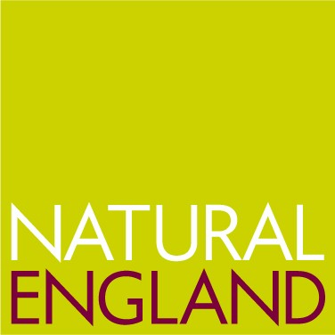

Introduction to FREE advice service.

Natural England is promoting the new Organic Conversion Information Service (OCIS) - which provides free on-farm advice -around its regions and is pleased to announce a series of meetings.

These meetings are aimed at bringing key advisers, stakeholders, farmers and producers up to speed on the new service.

These will be half-day events that will include presentations on what the service and the Organic Entry Level Stewardship (OELS) can offer. These will be combined with a farm walk to illustrate the kinds of issues that are covered as part of an on-farm visit.

Copies of the very detailed OCIS information pack will be available to all who attend these events - which are free of charge. Light refreshments will also be available

Monday 24th November Manor Farm, Loughborough, Leics
Tuesday 25th November Commonwork, Chiddingstone, Kent
Wednesday 26th November Higher Hacknell Farm, Devon
Thursday 27th November Wakelyn’s Agroforestry, Suffolk
Friday 28th November Holme Lacey College Farm, Hereford

More information on the farm (and directions) can be found on the Organic Inform website www.organicinform.org and going to the Events section.

To register for any of these events contact Gillian Woodward on 01488 658279 or email gillian.w@organicresearchcentre.com

To request a FREE visit without attending an event contact the Helpline on
0800 980 0048 or go to www.ocis.org.uk for further details.

