Young Organic Farmer/Grower of the Year Award 2021
Nomination Form
You can enter yourself, or nominate someone you know.

Nominee Contact Details
Name
Date of birth
Address
Email
Telephone

Nominator Contact Details (if applicable)
Name
Address
Email
Telephone

We will use the information that you provide so that we can keep you up to date with the progress and result of the nomination. We would also like to keep you up to date with our emails so that we can invite you to events, communicate with you about the ORC and Agricology activities, and inform you about appeals.

Please tick here if you would like to receive emails from us
The Organic Research Centre will always treat your personal details with the utmost care and will never sell or swap with other organisations for marketing purposes. We will keep your data safe, holding the information you provide for communication, marketing, analysis and administrative purposes. For more information of what information we hold and how we process your data, please visit our privacy policy www.organicresearchcentre.com/privacy-policy/
Nominations should be:
- Age limit: nominees must be less than 40 years old on 30th September 2021
- Nominees must be able to clearly demonstrate that they are producing or working according to IFOAM organic principles (health, ecology, fairness, care - see https://www.ifoam.bio/why-organic/shaping-agriculture/four-principles-organic ) but there is no requirement to be organically certified in order to enter
- Nominees should be working in and for the organic community; they may be employed by farmers/growers or organisations within the sector even if they do not class themselves as farmers/growers
Application Questions
Please submit answers to the following questions in a Microsoft Word (or equivalent) format along with the signed Nomination Form. Both must be sent to YOFY@organicresearchcentre.com
Q1. Please provide a brief description of the Nominee, for example describing their current role, training and background (Maximum 500 words)

Q2. Please attach a photograph of the Nominee as a jpeg file (for example this will be used for publicity purposes)

Q3. We are looking for individuals who have gone above and beyond in some way. Maybe they have worked on a particular project that they are proud of or designed a system that worked well on their farm? Maybe they are the unsung heroes of the community?
Please use the space below to describe why you feel that [the nominee] should be named as Young Organic /Grower of the Year 2021, referencing:
- their commitment to organic principles
- their ability to innovate and drive change
- their leadership skills and ability to inspire others – for example within their own network or to advocate the uptake of organic principles amongst their peers
(Maximum 1000 words). Please feel free to include examples of exciting projects that they have been involved in, with photographs, diagrams etc.
Alternatively if you would prefer to submit a media (e.g. video) application to answer Q3 then this will also be accepted. The video should be no more than 3 minutes long and must be submitted via a link using your preferred cloud based file sharing system so that it can be easily downloaded.

Q4. What are the nominee’s priorities for the year ahead in terms of their journey with organic principles, or what key challenges are they seeking to overcome to further implementation? (Maximum 500 words)

Q5. Although there are no restrictions as to how the winner must use the prize money, please indicate how [the nominee] might plan to use the award. (Maximum 200 words)

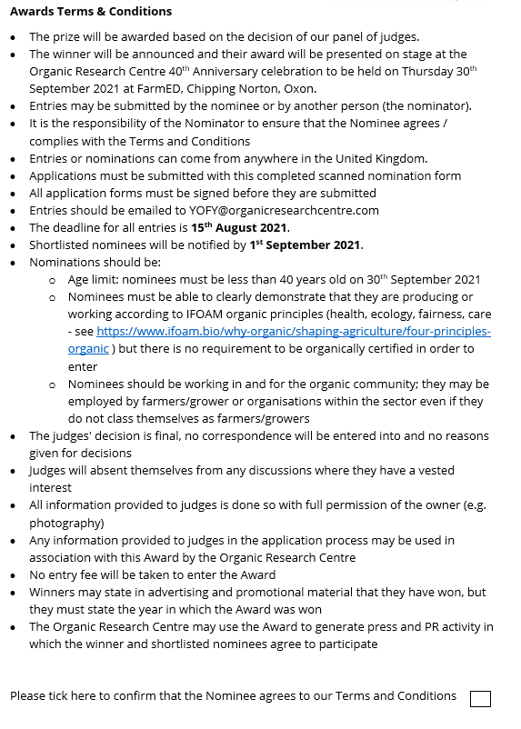

Signature of Nominee: Date:

Signature of Nominator (if applicable): Date:

