# **Principal Researcher – Crop Diversity and Agronomy (G8)**

## Salary range £36,000 - £45,000 depending on experience

## **REF 2203**

Are you an experienced researcher with an **interest in organic and agroecological cropping systems**? Are you committed to **innovative, inclusive and trans-disciplinary research approaches based on systems thinking**? Are you a pragmatic, creative and forward-thinking scientist ready to lead **participatory research and experimentation with real farms and businesses?** Then, this might be the opportunity for you.

**ORC seeks to employ a Principal Researcher to lead its Crop Diversity and Agronomy research area into the future.**

In the past two decades, the ORC’s crops team has pioneered at a European level the development of **alternative breeding approaches**, namely evolutionary plant breeding, the improvement and agronomic use of **fertility-building leys and subsidiary crops**, and the integration of arable/horticultural rotation into agroforestry systems. More recently, we have developed **original experimental approaches** based on working directly with networks of farmers. These approaches are currently being adopted to meet different challenges in the design and development of seed and cropping systems.

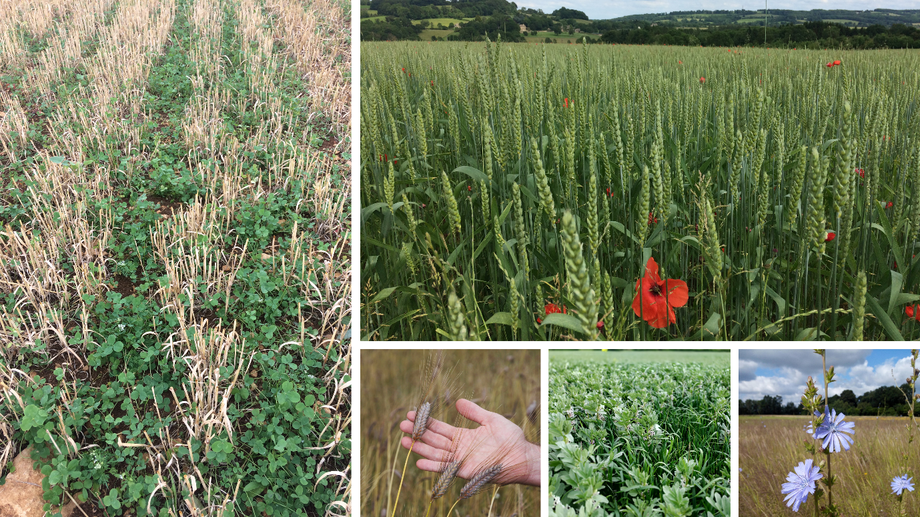

You will have the opportunity to **build on this legacy** by getting involved in **newly awarded multi-year research and innovation projects**. At the same time, you will have the room to **shape the future strategy** of organic crops research based on **your expertise and vision**, and on your ability to capitalise on the research demand of the sector to create tangible research opportunities. You will develop the research area with **an excellent team, a very active network of farming and industry collaborators and a wide range of academic partners**.

You will need to prove significant knowledge and experience in **at least one of the following areas:** **(i) plant breeding and seed systems, (ii) agronomy and crop science (arable and/or horticultural), (iii) soil science, (iv) integrated pest/weed management**. You will have a significant advantage if you prove that your specialism in one of these areas does not limit a **generalist understanding** of the others. Your **experimental design and data analysis skills** will be advanced and flexible to respond to the challenges of participatory and decentralised research approaches.

We are looking to recruit the right candidate for this pivotal role, which is full-time and home-based. A job description and details of how to apply are available at <https://www.organicresearchcentre.com/about-us/working-with-us/> .

The closing date for applications is 12 August 2022. Initial interviews will be held online on 18-19thAugust 2022 (although alternative dates will be offered if this date clashes with holidays).