News Release
For release from 28/01/25
Press Contact:
Philippa Hall
Impact Delivery Officer
Organic Research Centre
philippa.h@organicresearchcentre.com
01488 646235

Supporting media
Publication: https://link.springer.com/article/10.1007/s13593-024-00979-z
App: https://www.organicresearchcentre.com/resources/tools/agrobox-sandbox/
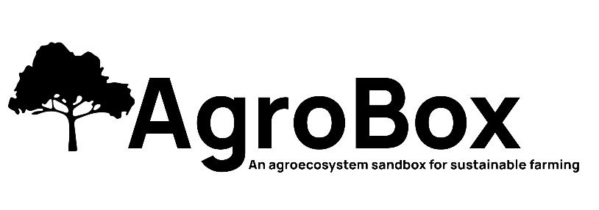

New free online tool predicts big reductions in pesticide use for farmers planting trees alongside crops
Exciting news for farmers and anyone interested in sustainable agriculture! A new free online tool called AgroBox has been released by the Organic Research Centre (ORC). Developed by Dr Colin Tosh, ORC Senior Agroforestry Researcher following his recent publication. This tool allows users to experiment with an artificial arable agroecosystem, allowing different farming scenarios to be run to see how they impact factors like crop yield and pesticide use.
Reduced pesticide use with in-field trees
One of the most interesting findings from AgroBox is that the presence of trees in fields can significantly reduce the need for pesticides. The model predicts that farmers using in-field trees would need to apply pesticides six times against pests, three times against disease, and three times against weeds over a growing season. This is compared to eleven applications for pests, six for disease, and one for weeds in fields without trees.
Exploring a multitude of scenarios
AgroBox allows users to explore an almost infinite number of scenarios. This makes it a valuable tool for farmers, growers, and researchers alike. Farmers can use AgroBox to test out different planting strategies and see how they might impact their crops. Researchers can use the tool to study the complex interactions between different elements of an agroecosystem.
Who can benefit from AgroBox?
• Farmers and growers looking to reduce pesticide use, improve crop yields, and better understand how their arable agroecosystem function.
• Agriculture and ecology lecturers looking for a tool to demonstrate agroecosystem dynamics in lectures and practical classes.
• Policy researchers interested in reducing agrochemical use and studying the ecosystem services provided by trees.

Get started with AgroBox today!
The AgroBox tool is free to use and is available online at the following link: https://www.organicresearchcentre.com/resources/tools/agrobox-sandbox/
The ORC is excited to see how AgroBox is used to improve agricultural practices and promote sustainable farming.

Notes to editors:

About ORC
https://linktr.ee/orgrescent
The Organic Research Centre (ORC) is an independent research charity working for better and more sustainable farming systems that protect the environment and provide good food for everyone. It drives its own research agenda to tackle global issues by acting locally and finding community-based solutions for farmers and their supply chains. Its vision is that, together, we’ll deliver the transition to naturally healthy and resilient farming systems by:
- Leading change by connecting and collaborating internally and externally across our networks of researchers and farmers.
- Bringing new thinking to the mainstream by developing nature positive solutions through pioneering and rigorous independent research.
- Empowering people to embrace different ideas by translating our research into practical application and advice, influencing policymakers, farming communities and wider society.
- Demonstrating the economic as well as the environmental rationale for an alternative approach to improve livelihoods and social impact.
Established in 1980, for over 40 years the charity has played a central role in the development of organic food and farming research, knowledge exchange, policy and standard setting through:
- Participatory research
- Sharing knowledge
- Influencing policy

About Colin Tosh
Principally responsible for project delivery and development in the area of agroforestry, online profile.

