
Organic apple production is very reliant on a few essential plant protection agents allowed in organic farming. The loss of one of these products by registration problems can create enormous problems as seen in the case of the use of copper compounds. It is possible that resistance problems may be the long-term consequence of this dependency. The reduction of this dependency on those pesticides permitted in organic farming is a very important step for the long-term sustainability of organic fruit growing systems.
Co-Free: Innovative strategies for copper-free low input and organic farming systems
Thus, there is urgent need for cultivars of low susceptibility, for cropping systems of high resilience, and for optimized ecological support functions that enhance biological control in limiting pests and diseases.
-TP Organics Strategic Research Agenda 2009
Background
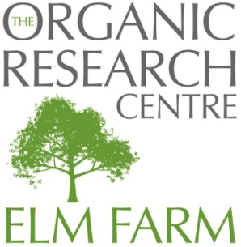
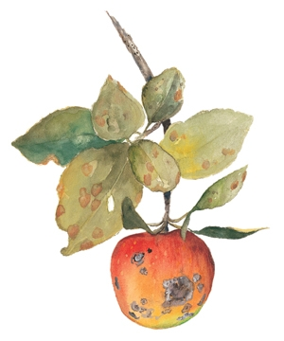
Apple scab is caused by the fungus Venturia inaequalis which results in dark spots on infected leaves and fruit and can lead to defoliation. If severe enough, this reduction in photosynthetic capability will decrease yield. However, even with a very low incidence of scab a grower may experience dramatic losses because it only takes one mark on a dessert apple to render it unmarketable. Copper compounds are used extensively in organic apple production to control Venturia inaequalis and a range of secondary diseases (e.g. cankers, fruit rots, and foliar diseases). However, its use can have detrimental effects on ecosystems including reduced earthworm populations, a decrease in beneficial mycorrhizal interactions, and high levels of toxicity to aquatic organisms and the EU foresees the complete banning of copper use by 2016. When searching for a replacement for copper sprays one of the problems that arises is concerned with the secondary diseases that copper takes care of in addition to scab. These include apple canker, fruit rot, and various foliar diseases.

Project aims
Co-Free is an EU-FP7 funded project to develop innovative methods, tools and concepts for the replacement of copper in European organic and low-input fruit, grapevine, potato, and tomato production systems. The 4.5-year project, started in January 2012, is led by Julius Kühn-Institut (JKI), Bundesforschungsinstitut für Kulturpflanzen (Germany) and has 11 partners across 10 EU countries. Copper-free production systems will be achieved by:
- Providing alternative compounds including products of microbial and plant extracts
- Developing ‘Smart’ application tools
- Integrating these tools into traditional and novel copper-free crop production systems.
- The copper-free apple, grapevine, potato and tomato production systems will be evaluated in a multi-criteria assessment with respect to agronomic, ecologic and economic performance.
- CO-FREE will also develop strategies to develop ‘smart’ breeding goals by development of crop ideotypes
- Foster consumer acceptance of novel disease-resistant cultivars by consumers and retailers.
By involving farmers, advisors, plant protection industry, policy makers and researchers as well as the stakeholders of the European organic and low input sector (food supply chain, retailers, producers associations), CO-FREE will ensure a rapid development, dissemination and adoption of the copper replacement strategies.

ORC's role
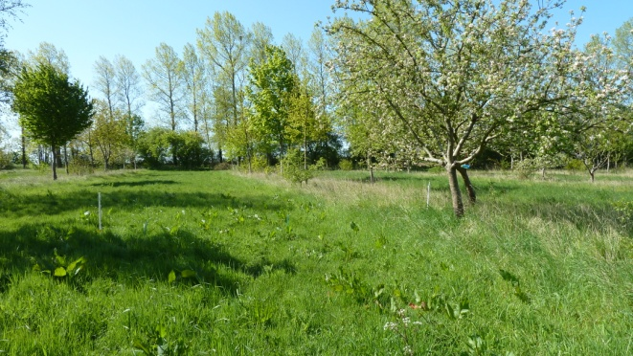
On a long-term perspective, apple production systems need to be developed towards more sustainability and less dependency on external inputs. Truly innovative production systems that reduce the overall dependency on external inputs will be explored and further developed in order to offer more sustainable production systems in the foreseeable future. ORC will evaluate the potential and the limits of agro-forestry based apple production systems as a sustainable strategy for replacing copper inputs in organic and low input systems.
Mixed organic apple and timber agroforestry at Wakelyns Agroforestry, Suffolk
Integrating top fruit production into an agroforestry system, where woody species are integrated with crop production may have a beneficial effect on the control of plant pathogens such as scab (Venturia inaequalis) due to a number of mechanisms:
- A greater distance between tree rows in agroforestry systems, with crops in the adjoining alleys, is likely to reduce the spread of pathogens (this may be enhanced by increasing the distance between apple trees within the tree rows).
- Lower densities of trees favour increased air circulation which has been shown to reduce the severity of scab by reducing leaf wetness duration.
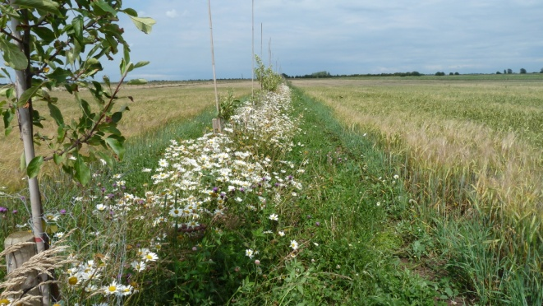
- Regular cultivations within the crop alleys will incorporate leaf litter into the soil, thus enhancing decomposition and reducing the risk of re-inoculation from overwintered scabbed leaves the following spring.

Organic arable and apple agroforestry at Whitehall Farm, Cambridgeshire
We are looking at apple production in two agroforestry case studies: Wakelyns Agroforestry (Suffolk, UK) and Whitehall Farm (Cambridgeshire, UK). Local organic apple growers will act as a benchmark for comparison.
Research will focus on four elements that are likely to be impacted by an agro-forestry systems approach to no-copper use;
(i) yield and quality of apple and arable crops (including profit margins),
(ii) impact on management activities,
(iii) emergence of primary and secondary pests and diseases,
(iv) impact on ecosystem services (biodiversity, soil health, microclimate) and functionality.

For more details, contact Jo Smith: jo.s@organicresearchcentre.com www.organicresearchcentre.com
www.co-free.eu

This project is funded by the European Union's Seventh Framework Programme (FP7/2007-2013) under Grant Agreement no 289497

