

Project Report No. xxx Month Year

Harnessing new technologies for sustainable oat production and utilisation (QUOATS)


Month Year

Project Report No. xxx

Harnessing new technologies for sustainable oat production and utilisation (QUOATS)

Athole H. Marshall¹, Sandy Cowan¹, Irene Griffiths¹, Jon Moorby¹, Catherine Howarth¹, Tim Langdon¹, Derek Stewart², Simon Edwards³, Nick Fradgley⁴, Sarah Clarke⁵

¹ Institute of Biological, Environmental and Rural Sciences, Aberystwyth University, Gogerddan, Aberystwyth, Ceredigion, SY233EB;
² The James Hutton Institute, Dundee DD25DA;
³ Harper Adams University, Newport, Shropshire TF10 8NB;
⁴The Organic Research Centre, Wakelyns Agroforestry, Fressingfield, Suffolk, IP21 5SD;
⁵ ADAS UK Ltd

This is the final report of a 60 month project (RD-2008-3556) which started in April 2009. The work was funded by the UK Department for Environment, Food and Rural Affairs (Defra, Project Code LK09124) and industry partners, including a £225000 cash and £22,000 in-kind contribution from HGCA. Total project cost: £4,920,377.

While the Agriculture and Horticulture Development Board, operating through its HGCA division, seeks to ensure that the information contained within this document is accurate at the time of printing, no warranty is given in respect thereof and, to the maximum extent permitted by law, the Agriculture and Horticulture Development Board accepts no liability for loss, damage or injury howsoever caused (including that caused by negligence) or suffered directly or indirectly in relation to information and opinions contained in or omitted from this document.

Reference herein to trade names and proprietary products without stating that they are protected does not imply that they may be regarded as unprotected and thus free for general use. No endorsement of named products is intended, nor is any criticism implied of other alternative, but unnamed, products.
HGCA is the cereals and oilseeds division of the Agriculture and Horticulture Development Board.
CONTENTS (right-click and select ‘update field’ and ‘update entire table’ to update table of contents)
1. Abstract 6
2. Introduction 7
2.1. Aims and objectives 7
2.2. Scope and technical approach 9
3. Materials and methods 9
3.1. Overview 9
3.2 Oat crossing and the development of new oat varieties 10
3.3 Multi-site trials 10
3.4 Phenotyping of the Buffalo x Tardis Mapping Population 10
3.5 Metabolomics analysis. 11
3.6 QTL analysis 11
3.7 Determination of phenolic compounds in oat 11
3.8 Volatile analysis 12
3.9 Sensory analysis. 13
3.10 Phenotype assisted selection for β-glucan 13
3.11 Grain shape analysis 14
3.12. Grain quality assessments (industrial assessment) 15
3.13 Pilot milling 16
3.14 Near Infra-Red Spectroscopy for grain quality traits 16
3.15 Mycotoxin analysis 17
3.16 Fatty acid analyses of oat grains 17
3.17 Gas production from a range of oat lines 18
3.18 Use of the Rumen Simulation Technique (Rusitec) to investigate promising oat lines and compare with barley. 19
3.19 Methane production from a range of oat varieties consumed by mature ewes 20
3.20 Dairy cow experiment 22
3.21 Nitrogen Use Efficiency of winter oats varieties 23
3.22 Development of a model of the lodging process for oats 24
3.23 Organic Agronomy trials 24
4. Results 25
4.1. Develop the core underpinning molecular technologies for the identification of specific genes and markers associated with key traits that will increase the use of oats in sustainable production systems (WP1). 25
4.1.1. Background 25
4.1.2 Diploid A-genome assembly and mapping 26
4.1.2. Buffalo x Tardis Mapping Population 28
4.1.3. QTL analysis of the Buffalo x Tardis Mapping Population 29
4.1.4. Buffalo x Tardis QTL-NILs 29
4.1.5. CDC Sol-Fi x Hi-Fi 29
4.1.6. AC Assiniboia crosses 30
4.1.7. Marker assisted selection 30
4.1.8. MAGIC population development 31
4.2. Apply genomics tools in conjunction with high throughput phenotyping to breed oats that have the required health, consumer quality and microbiological safety traits and enhance genetic variation in high value compounds for advanced fractionation (‘biorefining’) (WP2). 31
4.2.1. Overview 31
4.2.2. Oat crossing 33
4.2.3. G x E study 33
4.2.4. Single oat variety in oatcakes 39
4.2.5. Grain shape analysis 39
4.2.6. Grain quality analysis 40
4.2.7. Mycotoxin analysis 44
4.3. Develop oats for sustainable livestock agriculture that will reduce greenhouse gas emissions and provide a high quality feed (WP3) 47
4.3.1 Background 47
4.3.2 Breeding of improved oat varieties for animal feed 49
4.3.3. Fatty acid analyses of oat grains 52
4.3.4 Gas production from a range of oat lines 55
4.3.5 Use of the Rumen Simulation Technique (Rusitec) to investigate promising oat lines and compare with barley. 57
4.3.6 Methane production from a range of oat varieties consumed by mature ewes 59
4.3.7 Dairy cow experiment 61
4.4. Increase the sustainability of the oat crop through improved nitrogen use efficiency and lodging resistance 65
4.4.1. Background 65
4.4.2. Nitrogen Use Efficiency of winter oat varieties in conventional systems 68
4.4.3. Oats in organic rotations 73
4.4.4. Modelling the lodging process of oats 80
5. Discussion 83
6. Conclusions 88
7. Output and dissemination Record 90
7.1. Publications 90
7.2. Variety development 92
7.3. Technology Interaction 95
8. Acknowledgements 105
9. References 106
10. Appendices 113
10.1. Appendix 1 113
10.1.1. Summary of oat crossing procedures 113
10.2. Appendix 2 114
10.3. Appendix 3 115
10.4. Appendix 4 116
10.4.1. ORC Trials 116

Abstract
Oats are recognised as a valuable break crop in cereal rotations, nevertheless there is a need to improve key traits that will increase the production and utilisation of oats whilst also mitigating climate and environmental change via reduced agricultural inputs. This project aimed to address these issues by developing and applying state-of-the-art genomic and metabolomic tools for targeted oat genetic improvement of key traits that will enhance the value of oats in human health improvement, realise the potential of oats as a high value animal feed and develop new opportunities for using oats through advanced fractionation.
The project was organised in 4 workpackages that focused on the core underpinning molecular technologies for the identification of specific genes and markers associated with key traits (WP1), the development of oats for human consumption and industrial uses combined the application of molecular tools and phenotyping to the development of high quality milling oats (WP2), the development of oats for ruminants and monogastrics (WP3) and the agronomy of oats with an emphasis of the nitrogen use efficiency of oats in conventional and organic systems with the development of an oat lodging model (WP4).
The project has successfully developed an oat genomics programme and has also developed the appropriate molecular marker technology for selection of key traits that combined with high throughput phenotyping is now being integrated into IBERS oat breeding programme. This includes grain quality traits associated with milling quality and composition for human consumption as well as for animal feed with improved agronomy, particularly disease resistance. Central to the project was the analysis of new oat varieties in coordinated field trials that were carried out over the five years of the project incorporating analysis of grain quality and composition alongside mycotoxin analysis to quantify the genetic and environmental effects on the quality of oats and how they meet end user requirements. This has also been supported by the validation of improved grain quality by oat millers in both ring tests and in large scale pilot milling.
The impact of selection of oat varieties with modified grain quality on the value of oats in livestock diets has been studied in large scale poultry feeding trials as well as in small scale feeding trials with sheep and dairy cows. These studies have reinforced the value of oats as a high quality animal feed but also highlighted the undervaluation of oats as an animal feed in feed formulations. The potential of oats with high oil and a low lignin husk was demonstrated in feeding trials. The response of husked and naked oats to nitrogen in conventional and organic systems was studied showing the value of oats as a low input cereal that is suited to both conventional and organic systems.

Introduction
Increasing global demand for cereals coupled with the increased cost of energy and fertiliser is impacting directly upon the profitability and competitiveness of UK cereal growing. Responding to these challenges, there has been a trend towards continuous wheat rotations which increases soil borne diseases and weed problems impacting on profitability. Producers are endeavouring to optimise their overall farm return which has led many to grow crops on less fertile soils or in more marginal situations. At the same time the increased cost of fertiliser N and environmental concerns emphasises the need for crops that use N more efficiently (HGCA Research review No. 63) so reducing the main environmental burden in arable crop production (Nemecek, 2004). For the livestock sector the high cost of imported concentrates has increased the opportunity for a high quality feed that can be grown and fed “on-farm” in an environmentally sustainable manner. The high Actual Metabolisable Energy (AME) in oat grains and the lower fertiliser and pesticide input when growing the crop means that oats have a lower environmental footprint per AME delivered.
Oats are a valuable break crop in cereal rotations reducing disease and weed problems, a lower input crop than wheat, perform well in marginal areas and are a high value feed that grows well in grassland based rotations. Nevertheless there is a need to improve key traits that will increase the production and utilisation of oats whilst also mitigating climate and environmental change via reduced agricultural inputs. Research also needs to anticipate changes in the market as consumers shift towards healthier diets of which oats are a key component. Discussions with end-user groups from the milling and livestock sectors as well as processors identified the priority areas and where genetic improvement can make quantifiable improvements. These areas have formulated the key objectives of this project.
An important target for previous Defra funded research was to integrate molecular marker technology with conventional selection and trait analysis and to demonstrate the value of molecular based approaches by applying markers to specific traits. This has been achieved successfully. However, as various approaches to marker discovery have been tested and high density oat maps established, it has become clear that there is relatively little polymorphism in cultivated oats. There is therefore a pressing need to understand underlying genetic processes in order to maximise use of available polymorphism and also to be able to select precisely for novel polymorphisms from non-UK adapted germplasm if it is to be used effectively by plant breeders.
This project therefore sought to integrate conventional and molecular methods of selection with high throughput analysis of grain composition in relation to the development of oats for human and livestock production and industrial uses.

Aims and objectives
The project aimed to develop state-of-the-art genomic tools for oat genetic improvement. In collaboration with academic partners and industrial end-users across the whole production chain, the objective was to develop and use breeder -friendly tools to incorporate traits that will enhance the value of oats as a major factor in human health improvement, enhance the value of oats as a low input cereal, increase the environmental and economic sustainability of cereal based rotations, realise the potential of oats as an environmentally friendly high value animal feed and develop new opportunities for using oats through advanced fractionation techniques. Harnessing the unique properties of oats both as a plant and a grain we can address some of the emerging problems with cereal cultivation and at the same time deliver an environmentally benign crop which offers considerable health benefits for human and livestock consumption. This project sought to translate fundamental research into practical solutions to ensure the supply of sufficient healthy nutritious food.
The specific objectives of the study were:
- To develop the core underpinning molecular technologies for the identification of specific genes and markers associated with key traits that will increase the use of oats in sustainable production systems (WP1). Specifically,
  - To address long term breeding goals by developing experimental populations which are polymorphic for agronomically important traits but more amenable to mapping and forward genetic approaches than conventional agronomic lines. In particular this will be achieved by greater use of diploid progenitor species as models for the improvement cultivated hexaploid oats.
  - Genomic resources (EST sequences, BAC libraries) will be created for species which have already been subjected to extensive phenotypic and genetic analyses and used to elucidate the genetic basis of key traits.
  - Develop novel second generation mapping resources derived from breeder-relevant cultivated germplasm which will incorporate a far larger portion of genetic and phenotypic variation available than current bi-parental mapping populations using a multi-parent intercross (MAGIC) strategy.
  - Validate and apply molecular markers to assist selection in oat breeding.
- To apply the genomics tools in conjunction with high throughput phenotyping to breed oats that have the required health, consumer quality and microbiological safety traits (WP2) with the aim of
  - focusing on the selection of lines with appropriate grain composition and grain quality traits that are required by the milling and food sectors.
  - enhancing genetic variation in high value compounds for advanced fractionation ('biorefining').
- To use a combination of molecular and phenotypic selection to develop oats for sustainable livestock agriculture that will reduce greenhouse gas emissions and provide a high quality feed (WP3). This will focus on the development of high oil, low lignin husked oats and high oil naked oats, conduct in vitro assessment of greenhouse gas emissions as well as suitability as a high quality feed for ruminants and poultry.
- To increase the sustainability of the oat crop through improved nitrogen use efficiency (NiUE) and lodging resistance.
  - It will quantify variation in NiUE efficiency in oats and use the densely mapped Buffalo x Tardis winter oat mapping population to provide detailed understanding of the genetic basis of NiUE in oats and molecular markers for use in breeding programmes.
  - Advanced lines will be tested in conventional and organic systems.
  - The wheat lodging model will be adapted to oats and traits associated with lodging resistance identified.

Scope and technical approach
There were amendments made to the initial scope and direction of the project, particularly in WP1 in light of the developments in molecular genetics and increased effectiveness of the technology, which was inevitable during a 60 month project. Where relevant these modifications have been highlighted in the text.

Materials and methods

3.1. Overview
The project was organised in 4 work packages. The molecular work within WP1 was a distinct component of the project. This was highly complex and details of the methodology are summarised briefly in appendix 1. In the other work packages the breeding lines and varieties of winter and spring oats (husked and naked) that were grown in different environments and management systems within WP2 and WP4 were used to analyses the impacts on grain quality and composition as well as mycotoxin analysis (WP2) in Figure 1.
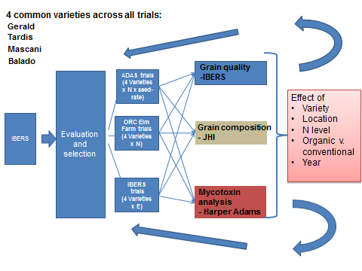
Figure 1. Material flow within the QUOATS project

3.2 Oat crossing and the development of new oat varieties
The development and phenotypic analysis of breeding material for new winter and spring oat varieties was a major objective of this project. Full details of the methodology used to cross oat plants are detailed in appendix A.

3.3 Multi-site trials
During the QUOATS project, the same four husked winter oat varieties (Balado, Mascani, Tardis, Gerald) have been grown at Rosemaund (by ADAS), in IBERS trials at a wide range of locations and by ORC (under organic conditions). A summary of all trials is indicated in Table 1. As well as the different locations, two seed rates have been used at ADAS Rosemaund and two nitrogen regimes at ADAS Rosemaund and ORC. This makes a total of 32 different environments in total.

Table 1 Summary of sites where the 4 varieties Balado, Mascani, Tardis and Gerald have been grown during QUOATS
 | Organic Research Centre |  | ADAS Rosemaund |  | Gogerddan | Bidney |  | Rosemaund |  | Devon |  | Fulbourn |  | Glenrothes
N treatments |  | 2 |  | 2 | 1 |  | 1 |  | 1 |  | 1 |  | 1 |  | 1
seed-rates |  | 1 |  | 2 | 1 |  | 1 |  | 1 |  | 1 |  | 1 |  | 1
system |  | organic |  | conv | conv |  | conv |  | conv |  | conv |  | conv |  | conv
2010-11 |  | y |  | y |  |  | y
2011-12 |  | y |  | y | y |  | y |  | y |  | y |  | y |  | y
2012-13 |  | y |  |  | y |  |  |  | y |  | y |  |  |  | y
2013-14 |  |  |  | y | y |  | y |  | y |  | y |  | y |  | y

In addition to the analyses conducted by individual partners at each site, grain was sent to IBERS for analysis (specific weight, kernel content, hullability, thousand grain weight, grain composition, Marvin seed size and shape analysis) and a sub-sample supplied to JHI for metabolomic analysis and to Harper Adams for mycotoxin testing. Selected samples have also been analysed for grain quality by the different millers collaborating in QUOATS.

3.4 Phenotyping of the Buffalo x Tardis Mapping Population
Phenotyping of the Buffalo x Tardis mapping population has been conducted over 5 years. In 2010 and 2011 the population was sown in both autumn (in the field) and spring (in a polytunnel) and in 2012, 2013 and 2014 an autumn sown 3-replicated field trial was conducted. Traits scored include growth habit, flowering time, height, panicle extrusion, winter hardiness, mildew susceptibility, crown rust incidence, lodging yield and nitrogen use efficiency. Grain samples from the 2012 and 2013 harvest have been analysed for quality traits including mycotoxin content (Tijana Stancic), grain composition (oil protein and β-glucan content), kernel content, thousand grain weight and grain size and shape using Marvin. Nitrogen use Efficiency traits have also been scored and mapped as part of WP4. In 2013, spectral analysis of the Buffalo x Tardis population in the field was conducted using an unmanned aerial vehicle (UAV) along with standard field phenotyping determinations. In 2013 the population was also grown in the Aberystwyth phenomics facility where in addition to detailed non-destructive image analysis, numerous traits have been scored including tillering, height and its components, flowering time, panicle characteristics, harvest index etc.

Metabolomics analysis.
Oat samples were initially ground to a fine powder in order to extract polar and non-polar fractions. A range of polar and non-polar solvents were used to obtain the two fractions, which were separately derivatised and analysed by GC-MS. Data were processed with a specific software before being statistically analysed.

QTL analysis
QTL analysis was carried out on polar and non-polar data collected from a mapping population : ‘CDC Sol-Fi’ x ‘Hifi’. Hifi was developed by North Dakota State University, while CDC Sol-Fi was developed by the University of Saskatchewan (Canada) with the pedigree N979-5-1/OT366. This population was primarly developed to study the range of β-glucan (3-7%) content in the resultant lines, but also crown rust resistance (McCartney et al., 2011). Diversity Arrays Technology (DArT) markers were used to build the linkage map. A permissive threshold level of ≤ 0.05 was chosen to test for significant variability.

3.7 Determination of phenolic compounds in oat
Phenolic compounds in oat, and in cereals in general, are either in a free or a bound form. The extraction procedure of free and bound phenolic compounds of oat was adapted from Verardo et al. (2011) and is schematically represented in Figure 2. Extraction of free phenolic compounds was carried out using 80% methanol; whereas the bound fractions were extracted using ethyl acetate, after alkaline hydrolysis. Both fractions were analysed by LC-MS-MS using a Thermo Scientific Accella LC system (Thermo Fisher Scientific, San Jose, CA) coupled to an LTQ-Orbitrap-MS (Thermo Fisher Scientific, Bremen, Germany) with electrospray ionisation (ESI). Data were processed using the Xcalibur software (Thermo Finnigan, Manchester, UK). In parallel, total phenolic content of the two fractions was determined using the Folin-Ciocalteu assay with some modifications.
2h hydrolysis period with NaOH 2M, acidification with HCl 3.6M, extraction with ethyl acetate 100%, solvent removal, residue resolubilised in methanol/water (1:1).
Fractions analysed individually by LC-MS
Free Phenolic compounds
Bound Phenolic compounds
Oat/Oatcakes (milled)
Methanol 80% extraction, filtration, solvent removal and re-suspension in methanol/water (1:1).
Residue 1
Residue 2

Figure 2. Flowchart of the extraction procedure of free and bound phenolic compounds in oat Avena sativa.

3.8 Volatile analysis
To understand the impact of single varieties in oatcakes, a plain oat-based product with no added flavourings available within the United Kingdom was used for this investigation. Three types of oatcakes were tested:
- oatcakes made from a single spring oat cultivar ‘Firth’ (referred as Firth oatcakes in this chapter);
- oatcakes made from the single winter oat cultivar ‘Gerald’ (referred as Gerald oatcakes);
- oatcakes made from a mix of spring and winter oat cultivars, including predominantly the two cultivars ‘Firth’ and ‘Gerald’ in the blend (referred as Blend oatcakes).
Volatiles analysed were performed on three replicate packages of seven oatcakes from a single production batch using headspace analysis over 26 weeks for the three types of oat products, at weeks 2, 6, 10, 14, 18, 22 and 26 after production.

3.9 Sensory analysis.
A quantitative descriptive sensory analysis was carried out according to ISO 4121 (Anon, 2003), starting two weeks after production. Firth and Gerald oatcakes were analysed at week 2, 10, 18 and 26 after production by six to eleven panellists, previously trained to detect fresh and rancid odour and flavour in fresh and stored samples. Five sensory parameters were used for the analysis: aroma, flavour, aftertaste, texture and appearance. Fatty acids analysis of raw materials and phenolic analysis of oatcakes were also carried out.

3.10 Phenotype assisted selection for β-glucan
In 2011 2 beta glucan crosses were selected for marker assisted selection (MAS). For these crosses one F1 plant was selected and 96 seeds from this plant were sown in the glasshouse in January 2012. Leaf material was taken from each plant and DNA analysed using markers appropriate for the cross. These plants were harvested as F2 seeds in the summer. The harvested seeds were sown in the field in 1 metre rows in March 2013. The DNA was analysis using markers appropriate for the type of cross. For example, cross 072_SO2011 was a cross for beta glucan but one of the parents also had the crown rust resistance gene Pc68, so this marker was used to identify plants with the resistance allele.
For each cross the heading date, height and maturity was recorded for each of 96 rows per cross. At harvest agronomy selections were made. Heads were taken from all rows at harvest to provide a bulk grain sample for megazyme beta glucan analysis. Results from both assessments (agronomy, marker and chemical) were used to decide which selections were going to proceed in the breeding program.
From cross 072-SO2011, 3 rows were selected for progressing in the breeding program. These selections combined good agronomy with high beta glucan (table 3). Three selections were also grown for use as parents in the breeding program. From cross 074-SO2011, 6 rows were selected for progressing in the breeding program (Table 2). These selections were grown in the polytunnel and harvested in July 2014 ready for being sown out in the field in March 2015.

Table 2. Summary of crosses used for marker assisted selection for enhanced beta-glucan content. Combined selections sown in the field in 2014 as F4s.
Cross | Reason | Agronomy selection | Marker selection | Combined selection | Status 2014
072-SO2011 | Beta glucan | 29 | 14 | 3 | 3 in polytunnel with agronomy and high BG  3 in polytunnel with high BG for parents
074-SO2011 | Beta glucan | 29 |  | 6 | 6 in polytunnel for agronomy and high BG

3.11 Grain shape analysis
Grain shape and size are critical factors in determining milling quality and thus the suitability of varieties for commercial exploitation. Oat grain develops on a many branched panicle with each spikelet containing between two and three florets. All of these florets can mature to produce grain. The architecture of both the panicle and spikelet directly influences both quality and yield. For example, the arrangement of grain within the spikelet results in a bimodal distribution in grain size.
Non- destructive image analysis tools have been developed at IBERS to accurately quantify grain and kernel size parameters. These have been used to characterise both varietal differences and also within panicle differences in grain size, shape and weight. This method was initially developed on a small scale using seed dissected from single panicles and images generated using a flatbed scanner. These techniques helped further define the oat grain dimensions. The method has been developed and the grain analyser MARVIN purchased to allow high throughput screening of the oat grains. The difference between grain shape parameters of dissected panicles and ex-trial samples is being researched. The possibility of producing unique grain shape signatures which can be used to assess milling quality of individual cultivars is being explored.
Initial results from one season’s data have shown that the cultivars could be separated on the basis of grain length. The results gave rise to three questions.
- Are the grain shape distributions for samples the same in each field season?
- Can we produce ‘cultivar signatures’ for the different lines?
- Can we relate this to kernel content, thousand grain weight and overall grain quality?
Grain samples from three field seasons have been analysed using MARVIN. The samples used were the control varieties from the spring oat breeding trials. These varieties Ascot, Firth and Husky were grown at multi-locations in each field season (table).
A 25 g sample of clean grain was taken from each plot. Every grain in the sample was measured using MARVIN to get a length, width and area of each individual grain. The grain dimensions were then used separately, for each of the three dimensions a bimodal distribution was fitted to the data. The bimodal distribution has five parameters, two means and two standard deviations (one for each population) and the proportion in the first population. Due to the unique development of oat grain in the spikelet the first population is equivalent to secondary grain and the second population is equivalent to primary grain. The bimodal distribution is fitted using MATLAB. The program begins by using the upper and lower quartiles as the means of the two populations. The program then uses an iterative process to find the best fit to the data. The outputs of the program give the five parameters of the distribution.

Table 3 List of oat samples from field trials used in grain shape analysis
Year | Site | Ascot samples | Firth samples | Husky samples
2010 | Aberdeen | 6 | 6 | 3
2010 | Morfa | 13 | 11 | 5
2010 | Perth | 8 | 8 | 1
2011 | Aberdeen | 3 | 3 | 3
2011 | Cowlinge |  | 3 | 3
2011 | Morfa | 6 | 6 | 6
2011 | Perth | 6 | 6 | 6
2012 | Aberdeen | 3 | 3 | 3
2012 | Cowlinge | 3 | 3 | 3
2012 | Morfa | 12 | 12 | 12
2012 | Perth | 6 | 9 | 6
Totals |  | 66 | 67 | 51

3.12. Grain quality assessments (industrial assessment)

Ring testing
From IBERS yield trials, selected lines and varieties were used to set up ring test for kernel content and then latterly specific weight. The ring tests were completed by IBERS, AFBI Northern Ireland who complete the grain quality analysis for HGCA RL and NL and various members of BOBMA- Pepsico, EOM and Grampian Oats. Grain samples from multi-locational yield trials were cleaned to a set standard at IBERS, Aberystwyth. 1 kg samples were sent to individual companies for analysis. The specific weight was analysed using a Dickey John or chondrometer (site equipment depending). The KC was conducted using a laboratory dehuller (Figure 3), using a method as set by IBERS Aberystwyth. Results from the companies were sent back to IBERS for analysis and comparison.
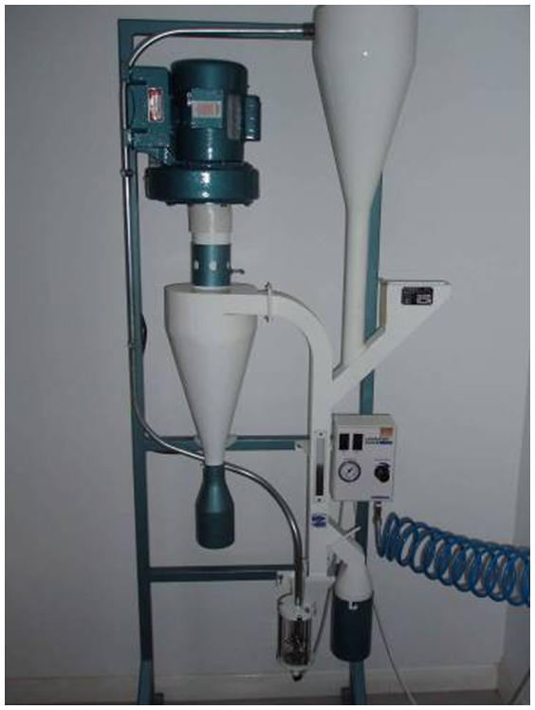
Figure 3 Codema Laboratory oat dehuller LH5095

3.13 Pilot milling
Discussion in the subcommittee identified the most commonly grown winter and spring oat. Four varieties were identified, Gerald, Mascani and Balado as winter oats and Firth as spring oats. Each variety was paired with a mill to conduct the pilot milling. The Quaker mill in Cupar milled Gerald. European oat millers, Bedford milled Mascani. Whites, Northern Ireland milled Balado. Grampian oats, Banff milled Firth. Around 60 tonnes of grain of each variety was supplied for analysis. Milling assessment parameters were recorded.

3.14 Near Infra-Red Spectroscopy for grain quality traits
NIRS calibrations are being developed at IBERS, Aberystwyth for a number of grain quality traits. This is a high- throughput method for analysis of early generation material and analysis of multi-location yield trials. NIRS can be conducted on a whole grain for the determination of KC and husk lignin content. These calibrations are in the early stage of development.
NIRS analysis of groat samples can provide information on grain nitrogen and protein content, ß-glucan content, total oil content.
Samples from replicated yield trials or breeding nurseries were prepared by dehulling to provide whole groat samples to be analysed by NIRS. After NIRS ~5-10% of samples were analysed by wet chemistry using to validate the NIRS calibrations.

3.15 Mycotoxin analysis
Harvested grain samples from selected field experiments were analysed for the fusarium mycotoxins, HT2 and T2 using the Ridascreen T2 ELISA assay kit (R-Biopharm Rhone, Glasgow). Samples (0.5 – 1 kg) were despatched to Harper Adams University were they were milled in a ZM200 Mill (Retsch UK Ltd, Leeds) with a 1 mm screen. Milled samples were mixed in a tumbler mixer for 5 minutes before a 200 g laboratory sample was removed and stored at -20°C. Samples were analysed using the Ridascreen T2 ELISA assay according to the manufacturer’s instructions. The combined concentration of HT2 and T2 (HT2+T2) was estimated based on the known antibody cross-reaction with HT2 and the ratio of HT2 and T2 within UK oat samples as previously described (Edwards et al., 2012). A preliminary screen of control varieties was conducted for each experiment using the variety Gerald with a dilution of pure, 10-fold and 100-fold. Samples were diluted as required to occur within the standards provided in the kit based on the results obtained from the screen. All results for HT2+T2 were log10 transformed to normalise the distribution of the residuals prior to statistical analysis.

3.16 Fatty acid analyses of oat grains
Fatty acid concentrations of oat samples were determined from approximately 1 g of freeze-dried material using heneicosanoic acid methyl ester (C21:0) as an internal standard (Sigma-Aldrich Co, St Louis, MO) and a one-step extraction-transesterification procedure (Sukhija and Palmquist, 1988). Fatty acid methyl esters (FAME) were separated and quantified using a gas chromatograph (CP-3800; Varian Inc., Walnut Creek, CA) equipped with a flame ionization detector, automatic injector, split injection port and a 100-m fused silica capillary column (i.d., 0.25 mm) coated with 0.2-μm film of cyanopropyl polysiloxane (CP-Sil 88; Varian Inc) using hydrogen as the fuel and helium as the carrier gas. The total FAME profile in a 1-μL sample at a split ratio of 1:30 was determined using a temperature gradient programme described by Lee et al. (2005). Peaks were identified by comparison of retention times with authentic FAME standards (ME61; Larodan fine chemicals, Malmo, Sweden; S37; Supelco, Poole, Dorset, UK).
Fatty acid data were presented as relative proportions, i.e. as a proportion of total fatty acid (FA) in the sample. All data were analysed by principal components analysis. The oat varieties were grouped into the following categories: winter naked (WN), winter low-lignin husked (WH) and spring low-lignin husked (SH), for subsequent analysis by analysis of variance.

3.17 Gas production from a range of oat lines

Figure 4. Gas analysis equipment and two incubation bottles for the gas production technique

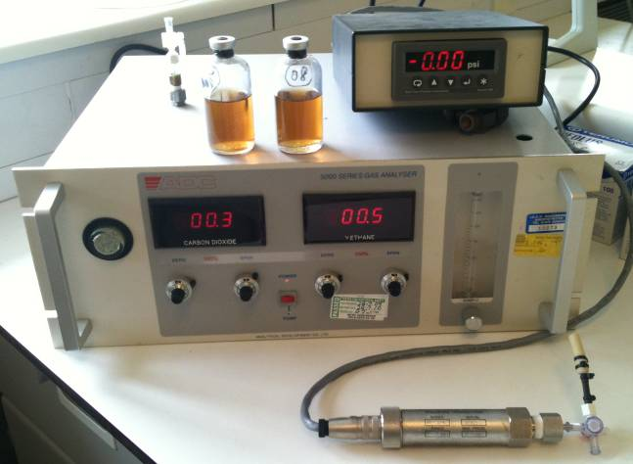

The gas production technique was carried out using a semi-automated method as outlined by Theodorou et al. (1994) and Davies et al. (2000). Briefly, in triplicate, approximately 1 g of sample material was incubated at 39C in bottles with rumen fluid, and the volume and composition of gas produced over the course of 3 to 4 days was recorded (Figure 1).Gas production was measured for each of the oat lines in triplicate. The chemical composition of the oat lines used was analysed using standard laboratory methods.The relationships between methane production (both in terms of ml/g DM ml/g apparently digested DM) and a) chemical components, and b) fatty acid composition, were explored.

3.18 Use of the Rumen Simulation Technique (Rusitec) to investigate promising oat lines and compare with barley.
In brief, feed samples were incubated in small fermenters primed with rumen fluid, and these were maintained for approximately 10 days. Feeds were incubated for 48 h in nylon bags, after which they were replaced with fresh feeds. Two sets of bags allowed fresh feed to be introduced to each fermenter every day by swapping out one set each day. Fermentation gases were collected and analysed, and effluent, produced as a result of the infusion of artificial saliva, was analysed for microbial protein content. Characterisation of feed sample residues after incubation allowed feed degradability to be estimated. Experimental treatments tested were:
- Rolled barley
- High oil/low lignin composite oat, cv. Racoon and SO-I in a 4:1 ratio
- Gerald
- Breeding line 05-46Cn14
- Breeding line 05-44Cn18
The chemical composition of the 5 treatment feeds is provided in Table 4.

Table 4. Chemical composition of the cereals investigated in the Rusitec experiment. Values in % DM unless otherwise specified.
Treatment | 1 | 2 | 3 | 4 | 5
 | Rolled Barley | Racoon/SO-I (4:1) | 05-46Cn14 | 05-44Cn18 | Gerald
Crude protein | 10.8 | 8.6 | 11.9 | 10.9 | 11.1
Water soluble carbohydrates | 3.1 | 3.1 | 3.1 | 2.96 | 2.6
Ash | 2.1 | 2.5 | 2.5 | 2.4 | 2.2
Neutral detergent fibre | 27.6 | 31.4 | 30.3 | 31.1 | 27.6
Acid detergent fibre | 6.2 | 16.4 | 15.0 | 16.8 | 16.3
Neutral cellulase/gamanse digestibility | 88.7 | 78.7 | 74.8 | 76.0 | 71.1
Starch | 60.3 | 42.3 | 42.4 | 43.9 | 43.3
Total Oil | 2.9 | 9.7 | 10.8 | 8.5 | 7.1
Acid detergent lignin | 1.3 | 1.6 | 3.8 | 3.6 | 3.5
Metabolisable energy (MJ/kg DM) | 13.1 | 13.5 | 13.2 | 12.8 | 11.7
To replicate potential animal diets, the oats were incubated as part of a diet based on grass silage. Approximately 50% of the diet DM was from a standard grass silage that was the same throughout the experiment on all treatments, and the remaining 50% diet DM comprised chopped grains (barley or oats). All feeds were incubated as fresh material (i.e. not freeze dried).

The Rusitec experiment was run for 10 days total, with 5 days for adaptation and 5 days for measurements. Two Rusitec systems were used, each with 8 incubation vessels, with 3 replicates of each treatment distributed across the two machines. Fermentation gases were collected quantitatively and analysed for methane concentrations. On the final day of the experiment, microbial protein production was estimated by labelling microbial proteins with ¹⁵N.

Data collected were analysed statistically using analysis of variance.

3.19 Methane production from a range of oat varieties consumed by mature ewes
Eight mature ewes, four each of two breeds (Welsh Mountain and Welsh Mule) were fed diets comprising ryegrass silage and oats in a 1:1 ratio (on a dry matter (DM) basis) in a Latin square changeover design experiment. Feed was offered at rates designed to supply metabolisable energy requirements for maintenance (according to AFRC 1992 guidelines), i.e. at restricted rates.

Diets offered
The same grass silage was used throughout the experiment, and was fed with one of four oats:

- Husked oat, cv Balado
- Naked oat, cv Racoon
- New breeding line oat, 14355Cn
- 50:50 (fresh) mixture of new breeding line oat (14355Cn) and Racoon

The pre-experimental determined chemical composition of the three oats (A to C) and the mixture (D) is given in Table 5.

Table 5 Chemical composition of the three oats and calculated composition of a 1:1 mix of 14355Cn:Racoon to be fed to mature ewes (values in % of DM)
Oat | CP | OM | NDF | ADF | Oil | Total Oil | ADL
Balado | 10.5 | 97.9 | 23.1 | 12.2 | 4.5 | 5.6 | 2.2
Racoon | 10.5 | 98.2 | 6.1 | 2.4 | 8.5 | 10.2 | 1.1
14355Cn | 10.9 | 97.7 | 19.7 | 9.5 | 3.7 | 4.9 | 1.1
1:1 mix | 10.7 | 97.9 | 12.9 | 6.0 | 6.1 | 7.5 | 1.1

All experimental animals were drenched with anthelmintic prior to the experiment commencing.

The experiment consisted of four three week periods; the first two weeks of each period was used for diet adaptation, and the final six days were used for feed intake, diet DM digestibility and methane emission measurements. Diets were fed according to the schedule listed in Table 6.

Table 6 Experimental design used in the experiment
Breed | Welsh Mountain |  |  |  | Welsh Mule
Chamber group | 1 |  | 2 |  | 2 |  | 1
Chamber | 1 | 2 | 3 | 4 | 2 | 1 | 4 | 3
Sheep | 1 | 2 | 3 | 4 | 5 | 6 | 7 | 8
Period 1 | A | B | D | C | A | B | D | C
Period 2 | B | C | A | D | B | C | A | D
Period 3 | C | D | B | A | C | D | B | A
Period 4 | D | A | C | B | D | A | C | B

The sheep were weighed two times per week at the same time of day, and feed was allocated to individual animals according to maintenance requirements.

Feeds was allocated according to AFRC (1992) energy requirement recommendations for mature barren ewes, assuming a gross energy density of 18.8 MJ/kg DM for both silage and oats, and ME densities of 11.75 MJ/kg oat DM and 10.5 MJ/kg silage DM. It is recognised that the energy densities of husked and naked oats differ, but for the purposes of this experiment it was assumed that their chemical compositions are similar.

Sheep were penned individually within the sheep unit throughout the experiment. Feeds were offered in two equal meals (at approximately 09:00 and 16:00, with feeding times recorded each day) with silage and oats being fed in separate feeders.

During the adaptation period any silage and/or oat grain refusals were weighed and the fresh weights were recorded.

At the end of each experimental period, sheep were individually housed in methane chambers and methane emissions were measured for 3 days. Feed intakes, and pre- and post-chamber measurement live weights were recorded. Faeces produced was collected, dried, and weighed, for determination of apparent whole tract digestibility of feed DM.

Data were analysed using analysis of variance, investigating the effect of dietary treatment, sheep breed, and the interaction.

3.20 Dairy cow experiment
A dairy cow experiment was carried out March to May 2014, using 9 lactating dairy cows in a 3 x 3 Latin square changeover design experiment with three 5-week periods.

Each experimental period consisted of 3 weeks for diet adaptation (including 1 week for diet change), 1 week for whole body N partitioning measurements, and 1 week for methane measurements. Feed intake and milk yields were recorded throughout, and samples for standard milk composition (fat, protein and lactose) and milk fatty acid analysis were taken at the end of each period.

Dietary treatments consisted of ad libitum access to ryegrass silage plus 1 of 3 concentrate treatments:
  - A – including 40% wheat grain, rolled (control)
  - B – including 40% oats to replace wheat (nothing else changed)
  - C – wheat replaced with oats, AND other ingredients changed to give same composition as A

The concentrates were fed at a 12 kg (fresh) per cow per day split into 3 feeds, 4 kg at each milking (twice daily) and 4 kg at around midday. The oats fed as part of the concentrate portion of the diet comprised naked oat grains (cv ????) and oat husk (from oat cv ????) mixed in the ratio of 3:1. For each of the treatments, 5 kg of cereal fresh matter was offered mixed with 7 kg of concentrate premix; therefore 5 kg of wheat was fed as part of diet A, and 3.75 kg oat grains plus 1.25 kg of oat husk were fed as parts of diets B and C. The cereal grains were rolled before feeding, to crack the seed coat.

The diets were formulated by Mole Valley Feed Solutions assuming a 650 kg cow yielding 40 kg of standard milk per day (Table 7). Feed intakes and milk yields were recorded throughout the experiment. Milk samples were collected for analysis of fat and protein concentrations. Nitrogen partitioning was measured over 6 days at the end of each period by collection of total outputs of faeces and urine, which together with feeds and milk were subsampled for N analysis. Methane emissions were measured for 3 days in each experimental period after measuring N partitioning.

Table 7. Diet formulations
FEEDS |  | A - Wheat | B - Oat 1 | C - Oat 2
G. Silage Aber. 1 est. | (kg/d) | 40 | 40 | 40
Wheat-rolled | (kg/d) | 5 | 0 | 0
Oats Aber. 30114 | (kg/d) | 0 | 5 | 5
Premix Oat 2 | (kg/d) | 0 | 0 | 7
Premix Oat 1 | (kg/d) | 7 | 7 | 0
NUTRIENTS
Fresh Weight | (kg/d) | 52 | 52 | 52
Dry matter | (%) | 41.9 | 41.7 | 41.6
DMI | (kg) | 21.8 | 21.7 | 21.6
Forage DMI | (kg) | 11.2 | 11.2 | 11.2
ME Ruminants | (MJ) | 259.6 | 252.6 | 255.3
ME Adequacy | (%) | 99 | 96 | 97
Energy density | (MJ/kgDM) | 11.9 | 11.7 | 11.8
NDF:DM | (%) | 35.2 | 38.6 | 35.4
Forage NDF:DM | (%) | 25.7 | 25.9 | 25.9
Starch+sugar:DM | (%) | 21.4 | 17.2 | 22.4
Crude Protein:DM | (%) | 17.8 | 17.6 | 17.7
Met.Prot.Supply | (g) | 2499.1 | 2295.7 | 2373.7
MP Adequacy | (%) | 104 | 95 | 98
Data were analysed using analysis of variance with orthogonal contrasts to compare between wheat and the two oat treatments, and between the two oat treatments.

3.21 Nitrogen Use Efficiency of winter oats varieties
Identifying oats varieties which use Nitrogen (N) more efficiently was a key objective of this project. To this end trials were established near ADAS Rosemaund, Herefordshire, in the growing seasons 2010-11 and 2011-12. Four varieties (Balado, Gerald, Mascani and Tardis) were tested at contrasting seed rates and N regimes. Treatments were chosen to satisfy the project objectives on lodging (see below) as well as those on Nitrogen. Nitrogen treatments in each experiment were 0 kg N/ha and 140 kg N/ha (Fertiliser Manual Recommendation) and seed rates were 100 seeds/m2 and 400 seeds/m2 (375 seeds/m2 in 2011). Yield and yield components as well as N partitioning and yield were determined at the end of each season. Full details of the methods used and assessments made can be found in Appendix XX.

3.22 Development of a model of the lodging process for oats

Wind tunnel testing
In order to better understand the interaction of oat plants with wind a wind tunnel was built at the University of Birmingham which was capable of producing strong maximum wind speeds of 12 m/s (27 mph). The wind induced movement of oat plants grown individually in pots, or in groups in trays, was investigated by painting a tracking marker on part of the oat canopy and videoing the plant’s movement. This was used to quantify the natural frequency and damping ratio. The wind tunnel tests showed that the stem displacement was proportional to the square of the wind velocity up to a velocity of 6 m/s. Greater wind speeds did not cause more displacement. These experiments were used to better specify the relationship between wind speed and the force exerted by the plant on its stem and root system. A general observation was that, compared with isolated plants in pots, groups of plants grown in trays oscillated more when the tunnel was turned on, generally following the turbulence of the wind, and were swifter to return to their natural position when the wind died down. This work formed part of a Masters Thesis ‘Numerical modelling of the interaction between oat plants and realistic wind loading’ for Ms Y Cheng carried out at the University of Birmingham under the supervision of Prof M. Sterling.

3.23 Organic Agronomy trials
Field trials were conducted with modern winter oat varieties over four trial seasons (2009-10, 2010-11, 2011-12 and 2012-13) at Wakelyns Agroforestry, Suffolk, UK (52°21'37.64"N, 1°21'28.98"E). The soil type is a medium-clay loam. The farm is managed under organic conditions (Soil Association certified, 1997) and trials were positioned in a different field every season in the first cereal position of the rotation following a three year fertility building ley which was ploughed prior to the creation of a seed bed. Dominant weed species in all trial years included Speedwell (Veronica persica spp), Black grass (Alopecurus myosuroides), Annual meadow grass (Poa annua), Creeping and Black bent (Agrostis spp), Common couch (Agropyron repens), Docks (Rumex spp.), and Charlock (Sinapis arvensis). All of which varied in abundance. Mechanical weed control was applied in all trial years which included cultivations to control weeds in a false seed bed before drilling as well as comb harrowing and inter-row harrowing through the growing season when appropriate. Dates of field operations and soil fertility each year are shown in Appendix 4. Details of the experimental design and statistical analysis are shown in Appendix 5.

Results

Develop the core underpinning molecular technologies for the identification of specific genes and markers associated with key traits that will increase the use of oats in sustainable production systems (WP1).

Background
An important target of the OatLINK project (2004-2009) was to integrate molecular marker technology with conventional selection and trait analysis in the Aberystwyth oat breeding programme and to demonstrate the value of molecular based approaches by applying markers to specific targets. This was successfully achieved with over 500 markers placed on the IBERS winter oat reference map and selections being made, for example, on the basis of favourable oil or β-glucan allele combinations. However, as various approaches to marker discovery have been tested and high density oat maps established, it has become clear that there is relatively little polymorphism in cultivated oats (for example while 40-50% of polymorphic wheat markers could potentially be transferred to Lolium/fescue as SSCPs, the figure for oat was less than 10%; BBSRC project BBE0235761). This is particularly true of winter varieties which form the largest proportion of the UK crop (the UK is unusual among major oat growing countries in the high proportion of winter varieties grown). There is therefore a pressing need to understand underlying genetic processes in order to maximise use of available polymorphism and, even more importantly, to be able to select precisely for novel polymorphisms from non-UK adapted germplasm, including wild relatives and exotic materials. Such material has already been used for major traits such as disease resistance and will increasingly be the key to developing sustainable crops. Much available germplasm in the primary genepool, and certainly in the secondary and tertiary genepools, is not in a form that most breeders can currently access, and radical improvements are needed in the relevance and quality of the data available on these genetic resources if this material is to have the needed impact on agricultural sustainability and mitigation of agricultural greenhouse gas (GHG) emissions.
This project sought to address long term breeding goals by developing experimental populations which, while still polymorphic for agronomically important traits, are more amenable to mapping and forward genetic approaches than conventional agronomic lines. Central to this approach is the greater use of the two diploid progenitor species which have been developed at Aberystwyth as models for the improvement of cultivated hexaploid oats. A mapping population derived from these species has been the subject of extensive phenotypic and genetic analyses, and the next step is to create genomic resources (EST sequences, BAC libraries) to identify genes and alleles which determine desirable traits. The results derived from diploid studies will be translated to hexaploid phenotypes both by comparative genetics and by direct transfer of diploid germplasm into cultivated oat backgrounds. Molecular dissection of key hexaploid QTL will be conducted by the development of near-isogenic lines with and without QTL of interest using results obtained under existing funding. In addition we will develop novel second generation mapping resources derived from breeder-relevant cultivated germplasm which will incorporate a far larger portion of genetic and phenotypic variation available than current bi-parental mapping populations.
WP1 Milestones
Development of molecular tools and resources
1. Validate QTL identified in Buffalo x Tardis population
2. Continue MAS in breeding programme
3. Develop markers from DArTs associated with key traits.
4. Sequence analysis of diploid parents, BAC library construction
5. Identification of relevant polymorphisms in hexaploid oats
6. Construct MAGIC mapping population.

Buffalo x Tardis Mapping Population
Genotyping methodologies have rapidly developed since the start of the QUOATS project. At that time, microsatellites and DArT markers were the method of choice. Although the application of DArT technology in oat has been very successful, an inadequate density of markers shared between populations has made it difficult to allow accurate comparison of genetic loci. Advancements in high-throughput sequencing have enabled a number of high-throughput SNP based genotyping assays to be developed. We have been involved in the development of the recently-published SNP assay for oat (Oliver et al., 2013) that provides more precise and well-characterized gene-based predictions that are more uniformly distributed throughout the genome and amenable to comparative mapping than DArT. This has recently been expanded into a 6k SNP assay using Infinium technology. Currently, costs for DArT analysis and Illumina-based SNP assays range from $US 50.00 to 60.00 per sample.
New genotyping platforms have made it possible to obtain high-density markers at very low cost using methods referred to as genotyping-by-sequencing (GBS). This method utilizes one or more restriction enzymes to digest the genome into fragments that are then sequenced by parallel high throughput methods. High efficiency, and reduction in cost, in GBS is achieved by multiplexing samples from many (e.g. 48, 96, or 384) different genetic lines simultaneously through the use of short specific ‘barcodes’ ligated to each sample prior to sequencing. Thus, it is possible to reduce the cost per sample to a fraction of the cost of a single lane of sequence analysis. For example, if 96 samples are sequenced in a reaction costing $960, the cost per sample would be $10 over and above the costs of sample preparation and bioinformatic analysis. In a collaboration between IBERS, Jesse Poland (Kansas State University) and Nick Tinker (Agriculture & Agri-Food Canada, Ottawa), GBS has been used on the Buffalo x Tardis population and we now have a new linkage map of over 7000 SNPs linked to the new oat consensus map. This data also permits detailed identification of regions of homology with the A genome diploid map and with our C and D genome sequence databases. This provides much better coverage of the oat genome than previously, helps elucidate the correct genome designation of each chromosome and is currently being used to improve QTL analysis.

QTL analysis of the Buffalo x Tardis Mapping Population
QTL analysis of all traits scored so far has been completed and revealed some fascinating results. For example, from previous data we knew that a major flowering time QTL in which the Tardis parent provided the early flowering allele co-located with the dwarfing gene on linkage group 17. However we have now identified that the expression of QTL associated with flowering time is dependent on both photoperiod and vernalisation; if the population is sown in the spring, no significant QTL on LG17 for flowering time is obtained. However, a major QTL on linkage 13 is found in which the Buffalo parent provides the early flowering allele. This QTL on linkage group 13 is not expressed when the population is sown in the autumn. This region of the genome is also associated with winter-hardiness. We have now developed near-isogenic-QTL introgression lines with these 2 QTL which are currently being genotyped and phenotyped to dissect this QTL further. In addition, a major QTL associated with mildew and crown rust resistance has been identified on linkage group 2 and diagnostic alleles determined. These are now being used routinely in the breeding programme. QTL associated with milling quality traits, plant height, components of yield and NUE have also been identified.

Buffalo x Tardis QTL-NILs
Initial QTL analysis identified regions of the genome associated with height, mildew and crown rust resistance, flowering time, vernalization and winter hardiness. A marker assisted backcrossing scheme has been used to produce near-isogenic lines in either the Buffalo or Tardis background containing the individual QTL of interest. Selfed seed has now been produced of all backcross populations and preliminary phenotyping conducted confirming the presence of QTL in progeny selected on the basis of markers only. Selected populations were grown in 2014 for detailed phenotype analysis and will be grown in the field as part of a new HGCA funded project.

Diploid A-genome assembly and mapping
This workpackage planned to use the best methods available at the time of submission to begin an oat genomics programme. Diploid parents were chosen as the most accessible material, with a large insert (BAC) cloning library intended as a means to gradually develop sequencing resources (1.1.3). Single BACs can be identified relatively easily by hybridisation, allowing recovery of a few specific candidate genes or marker regions (1.1.4). The process can be repeated to allow recovery of neighbouring genes or even relatively large contiguous genomic regions (‘contigs’) as sets of clones which can then be used as conventional sequencing templates. However, recovery of every region of the genome for comprehensive clone-by-clone sequencing is extremely laborious and expensive and was outside of the scope of the original WP1. Some sequencing of expressed genes (cDNAs) from seedlings was planned to begin high-throughput marker development (1.1.1).
The cost of new Next Generation Sequencing (NGS) technologies dropped rapidly in the first years of QUOATS and in March 2011 the BAC library and cDNA approaches were changed, with the agreement of the consortium and funders, to allow representative whole genome sequencing to be carried out instead (1.0.0). This has been successful enough that we have expanded the original revised goals of recovering most gene space from the parents to include low coverage sequencing of a few informative RIL progeny, allowing mapping of contigs to ‘bin’ intervals defined by regions of common parent-of-origin polymorphisms within each RIL. Using the Illumina short-read platforms we now have >40x coverage of the A. atlantica (wild) diploid parent, and >30x combined coverage of the A. strigosa (domesticated) parent and 15 RILs (8x coverage is generally taken as full coverage of the genome, with the additional coverage guaranteeing correction of sequencing errors). The N50 of the A. atlantica assembly is ~12kb (ie the combined length of all contigs over 12kb is equal to the combined length of all contigs below 12kb) allowing the great majority of genes to be recovered intact on single contigs. Some 1.5Gb of A. atlantica contigs have been placed in ordered bins, each on average representing 6cM or 1% of the total map. Bioinformatic screens with sets of barley or Brachypodium genes indicate that well over 90% of corresponding oat genes in the total assembly have now been mapped. ‘Binned’ contigs contain >1 million short indel or single nucleotide polymorphisms which can be converted into markers, giving a reasonable expectation that any gene of interest could be followed in the mapping population. Currently a fine map of this population is being created using RAD markers. Some NGS sequencing of other species related to the cultivated hexaploid has been initiated, allowing assignment of previously anonymous hexaploid markers to likely genomes of origin. Annotation of the assemblies has begun, which will allow systematic gene discovery and improved prediction of candidate genes from hexaploid QTLs.
Sequencing for version 1 of the diploid Avena zipper is complete, and work has concentrated on improving annotation of the assembly, and on making comparisons with other genomes. A number of different gene prediction methods have been used (including Augustus, GlimmerHMM, Genemark, EvidenceModeller), leading to high confidence prediction of 30,500 'genes'. The integrity of these 'genes' was assessed based on comparisons with a subset of conserved eukaryotic genes (CEGMA analysis), which indicated that the great majority of our predicted genes are intact. The actual gene number is therefore expected to be about 28,000. Work is underway to link gene fragments by bioinformatic means; a further round of sequence will also be carried out in the coming months using longer mate pair libraries prepared on a Blue Pippin that was recently provided by BBSRC. The gene annotation allows us to identify the most informative polymophisms in the 11 million single nucleotide differences (SNPs) found so far between the diploid parents – 608,000 SNPs lie within genes, with 223,000 being in protein coding regions. These will be examined for possible functional consequences in genes of interest, and association with known phenotypes.
Following the BBSRC-sponsored visit of Dr Nick Tinker (Agriculture & Agri-Food Canada, Ottawa), leader of the North American CORE consortium, we are aligning our genic sequences with CORE's genotyping-by-sequence (GbS) tags, anonymous GbS tags into gene-based markers which are more suitable for use in breeding programmes which improves alignments between the model and the crop maps, and provides a more efficient means to convert.

CDC Sol-Fi x Hi-Fi
Analysis of this RIL population is a collaboration with scientists in Canada. The parents are both high β-glucan varieties but with contrasting genetic origins. The population segregates for a number of other traits including crown rust resistance and has been grown over 3 field seasons in Aberystwyth. Grain has been analysed for oil, protein and β-glucan at Aberystwyth and detailed metabolomic analysis conducted at JHI. The study of this mapping population revealed that GC-MS metabolomics was a useful tool to describe the primary and a selection of secondary metabolites present in the grain of the mapping population. A wide range of compounds was found in the present mapping population, which demonstrated a strong potential of oat for breeding purposes. QTL analysis applied on the dataset obtained from this two-year study resulted in 14 QTLs found for both years from the polar and non-polar composition of oat detected by GC-MS, as well as a common QTL detected for oil and β-glucan contents on the same locus. However, the QTLs found were wide and in order to confirm them, further work would need to be undertaken to confirm the positions of these QTLs as well as their effects.
Genotyping of the population initially used DArT markers and part of the population was used for the development of the consensus map in Oliver et al 2013. The entire population has now been genotyped with the new 6K oat SNP Chip. This provides better genome coverage and a new linkage map has now been produced. QTL analysis is being repeated both at IBERS and JHI. SSR and SNP markers closely linked to the Pc 91crown rust resistance gene have been developed and are now in routine use in the breeding programme.
The Megazyme method for β-glucan analysis has been modified so as to cope with small sample sizes and has been successfully used to screen the diploid mapping population as well as hexaploid crosses including CDC Sol-Fi x Hi-Fi.

AC Assiniboia crosses
A number of populations have been used to identify and validate QTL associated with disease resistance and low lignin husk using the AC Assiniboia source of these traits. SNP markers closely linked to the low-lignin husk trait and to Pc 68 have been developed and tested in a wide range of advanced breeding lines, parental lines and in early generation segregating populations. These SNP markers are highly diagnostic and have been incorporated into the breeding programme. Unlike conventional phenotypic screening which must take place after the crop has been harvested, DNA can be extracted from young seedlings and the genotype rapidly ascertained.

Marker assisted selection
We are now routinely using markers in both the spring and winter breeding programmes for a wide range of traits including mildew resistance, crown rust resistance, low-lignin husk, dwarfing, flowering time, grain quality traits and DUS traits such as waxy/ non-waxy leaves. Markers are used at a number of stages in the breeding programme:
- Assessment of genetic diversity of breeding programme
- Selection of appropriate parents to use in the crossing programme
- Back-cross introgression of disease resistance alleles into a UK adapted background
- Fixing multiple disease resistance alleles at an early stage in the breeding programme
- Identification of individuals at an early stage in breeding programme containing desired allele combinations
- Checking uniformity of advanced breeding lines
- A sub-set of 14 SSRs that show good genome coverage has been identified and used to distinguish genotypes both on the winter and spring recommended lists and within the breeding programme. Markers have also been used to verify that F1s from the 2011 winter and spring oat crossing are true crosses.

MAGIC population development
The final generation of crossing for the spring MAGIC population was successfully completed in 2011 16 seeds from each of the final 42 crosses were selected for single seed decent (SSD) making a population of 672 individuals. Leaf material has been taken from plants throughout the breeding process of this population and SSR analysis has been completed confirming that crosses have been made and indicating the range of segregation of alleles within the population. Following 6 generations of single seed descent, the MAGIC population is ready for sowing in the field in 2015. Preliminary phenotyping and genotyping has been conducted indicting segregation in a number of traits. DNA is available for detailed genotyping.

Apply genomics tools in conjunction with high throughput phenotyping to breed oats that have the required health, consumer quality and microbiological safety traits and enhance genetic variation in high value compounds for advanced fractionation (‘biorefining’) (WP2).

Overview
There is increasing demand across the UK for safe, high quality healthy food that is produced sustainably and economically. Oats and oat products are increasingly important in meeting that demand due to β-glucan, the major endospermic cell wall polysaccharide in the grain which can lower cholesterol, and attenuate post-meal blood glucose levels and insulin responses making it useful for treating diabetes. Because β-glucan content in oats is both expensive and difficult to measure accurately, is influenced by the environment and is controlled by several genes it represents an excellent example of a trait for molecular quantitative trait dissection and manipulation in a marker assisted selection breeding programme. Results from WP1 feeds directly into this workpackage.
As well as β-glucan, oats also contain many classes of phenolic compounds, and a unique class of polyphenolic compounds, the avenanthramides which are effective antioxidants implicated in the cardioprotective benefits of oats via suppression of proinflammatory cytokines associated with the development of arterosclerosis (Liu et al., 2004, Guo et al., 2008).
It is also known that there is a considerable variation in both the content and specific composition of total lipid content and specific fatty acid composition in oat (Brindzova et al 2008). The lipid is also directly responsible for the durability (shelf-life) of oat products with the unsaturated fatty acids becoming oxidised over time to produce deleterious aldehydic components, such as hexanal, giving a perceived rancidity. Furthermore the lipid component also contains several beneficial lipid components such as the aforementioned unsaturated lipids and the Vitamin E components, the tocopherols. The plant breeding challenge is to use phenotypic, metabolomic and molecular technologies to simultaneously select these high value compounds such that they can be incorporated into new innovative oat varieties.
Fusarium head blight is a disease of cereal species that can result in reduced yields, reduced grain quality and the presence of fungal toxins, mycotoxins, in grains and processed cereal products for feed and food. Mycotoxins are of concern as at high concentrations they can impact negatively on the health of animals and humans. At lower concentrations mycotoxins can reduce animal productivity (eg reduced feed conversion rates). Historically oats as a species have been considered moderately resistant to Fusarium Head Blight (FHB) with relatively low infection levels compared to wheat and barley. During studies in the UK and Nordic countries in the early 2000s it was identified that oats were particularly susceptible to Fusarium langsethiae, a newly identified species that is a potent producer of the mycotoxins HT2 and T2 (Edwards et al., 2009; Edwards et al., 2012). There is currently no legislative limits for these mycotoxins within Europe, however they are of concern and the European Commission (EC) published a recommendation in 2013 that Member States should monitor these mycotoxins and where they exceed indicative levels (1000 µg/kg combined HT2+T2 for unprocessed oats) then investigation should be conducted as to why these exceedances have occurred and what mitigation measures can be used to reduce the levels of these mycotoxins (EC, 2013). On average, 16% of UK oat samples have exceeded 1000 ug/kg HT2+T2 in previous studies (Edwards, 2007; Edwards 2012). These studies also identified that there are limited options for growers to reduce HT2+T2 in UK oats with one been the observed differences between varieties. As part of the QUOATS project genotypes within the breeding program will be monitored to identify their relative resistance to HT2+T2 producing Fusarium species. The stability of this resistance will be analysed over different years and locations.
WP2 MIlestones
Consumer quality, health benefits and advanced fractionation
7. Complete 100 winter oats and 30 spring oats crosses to incorporate or improve upon target traits (high yielding, lodging resistance, disease resistant with high kernel content, good hectolitre weight and beta glucan content) (Repeated annually)
8. Sow pure stock nurseries (F2-F7 generations) and evaluate for desired agronomic and quality traits.
9. Evaluate lines from (8) for milling quality to determine if they meet end user requirements.
10. Industrial assessment of ~ 50 advanced trial lines by BOBMA (repeated annually)
11.Analysis of levels of T2 and HT2 mycotoxin on advanced oat lines
12. Evaluation of advanced oat lines for bioprocessing.
13. Economic assessment of oat fractionation

Oat crossing
On average 195 and 100 crosses were completed annually in the winter and spring oat breeding programmes throughout the project (Table 8). These crosses were designed to meet specific breeding targets and to provide genetic material for use in the different work packages. For ease they are reported within WP 2 but are also relevant to work in WP3 and WP4. This is summarised in Table 9.
Table 8. Number of crosses completed in the winter and spring oat breeding programmes in each year of the project

Year | Winter oat crosses | Spring oat crosses | Total
2010 | 195 | 75 | 270
2011 | 211 | 96 | 307
2012 | 191 | 121 | 312
2013 | 214 | 108 | 322
2014 | 164 | 102 | 266

Table 9. Major breeding targets of the winter and spring oat breeding programmes

Low lignin husk
High oil groat
High grain yield and grain quality
Crown rust resistance
Mildew resistance
High beta glucan
Low lignin husk combined with high oil groat
Avenanthramide content

G x E study
This combined dataset of the 4 oat varieties grown across multiple sites over many years provides an invaluable resource to understand the impact of environment on the yield and quality of these 4 varieties and to compare organic and conventionally grown oats. The 4 growing seasons were very different climatically. 2010-11 was characterised by a warm dry spring and cool summer, 2011-12 was memorable for a very wet and dull summer which led into a very wet autumn making the 2012-13 crop difficult to establish and delaying some planting until the spring. 2013-14 again was characterised by a wet winter but a warm summer.

Overall there was not a significant difference in yields between varieties but there was a significant difference in yields between environments with the lowest yielding site (4.5 t/ha) being at ADAS Rosemaund in 2012 and the highest yielding site in Devon in 2013 (10.52 t/ha). Grain number per m² not thousand grain weight (TGW) was found to determine yield whereas TGW affects milling quality (Figure 5).

Thousand grain weight (TGW) was positively related to kernel content (KC) (Figure 6) but no relationship was found between specific weight and kernel content (Figure 7).

Detailed examination of grain size and shape data revealed that grain width (Figure 8), not grain length was related to TGW whereas grain length and roundness was related to hullability (Figure 9).

Figure 5. Relationship between grain yield and grain number/m² of 4 common oat varieties

Figure 6. Relationship between 1000 grain weight (g) and kernel content (%) of 4 oat varieties grown in multi-site trials.

Figure 7. Relationship between specific weight (kg/hl) and kernel content (%) of 4 oat varieties grown in multi-site trials.

Figure 8. Relationship between grain width and 1000 grain weight (g) grown in multi-site trials

Figure 9. Relationship between grain length and hullability of 4 oat varieties grown in multi-site trials

A very wide range in T2+HT2 levels across sites was detected with very low levels under organic conditions for all varieties. Overall, Mascani had the lowest T2+HT2 and Balado the highest T2+HT2. Even at sites with a high incidence of T2+HT2, Mascani had significantly lower T2+HT2 (Figure 10). Considerable variation in mycotoxin levels was found between replicates at some of the sites suggesting a need for greater understanding of the infection process.

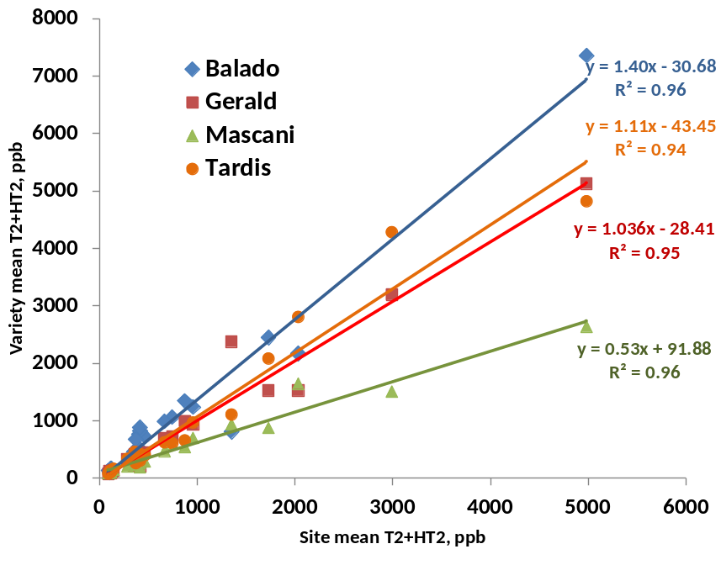
Figure 10. Relationship between site levels of T2 and HT2 and variety means at those sites of 4 oat varieties grown in multi-site trials
To summarise the results from the G x E study on the four varieties:
Mascani
- Highest and most stable KC, best and most stable hullability, large round grain (highest TGW, widest grain), highest specific weight, lowest grain oil content, lowest T2+HT2
Tardis
- Highest grain protein, longest grain
Gerald
- Small round grain (lowest TGW, narrowest, shortest grain), lowest β-glucan content
Balado
- Highest β-glucan, widest range in KC, large, many-grained panicles, lowest panicles per m², highest T2+HT2, highest avenanthramide levels

Grain Composition
The G X E study that focused on four oat cultivars grown at different sites and managments demonstrated the important effect of genotype on the metabolite distribution of oats (Figure 11), affecting the nutritional quality of oats, on top of the environmental conditions (locations and N input).
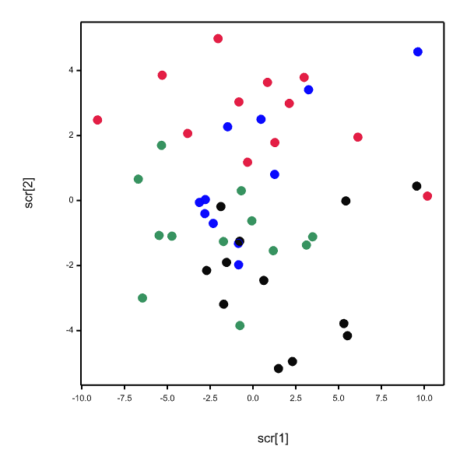
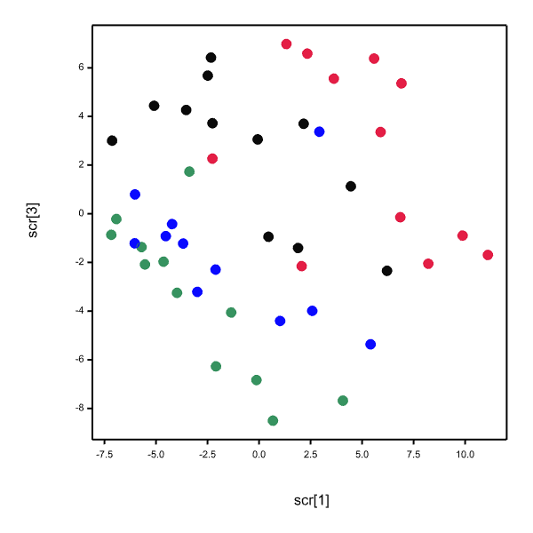
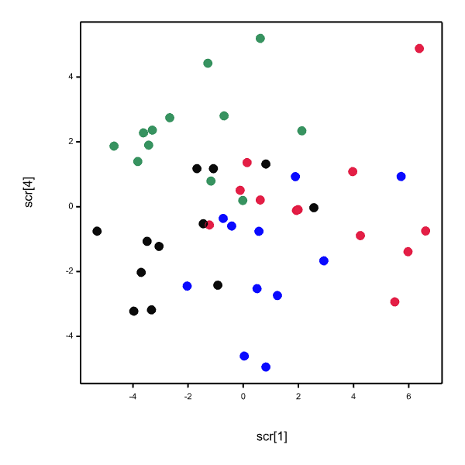
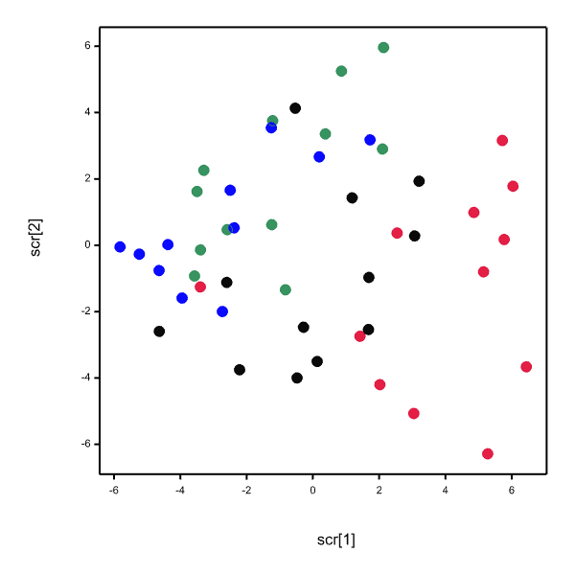

Figure 11 PCA of all metabolites (a), all polar compounds (b), all non-polar compounds (c) and all polyphenols (d) detected in four oat varieties grown in 2012 in Rosemaund, coloured by varieties (l, Balado, l, Mascani, l, Tardis and l, Gerald).

The organic farming system increased the levels of avenanthramides in oat in general; however, the present study could not distinguish between the organic farming system and the possible factors such as the geographical location of this farm and the climatic and/or soil conditions. The oat cultivar Balado demonstrated high levels of this class of phenolic compounds, as well as high amino acid content, regardless of the growing conditions. Seed rate did not have an impact on the distribution of metabolites in the four oat cultivars studied (except on oil and β-glucan in 2011 and 2012, respectively), while N input modified the levels of certain classes of metabolites (amino acids and phenolics) of oat grown in the field as well as β-glucan and protein content in specific cultivars. The level of non-polar compounds, including the lipid levels, was not affected by location, N input and seed rate, but mainly exhibited significant cultivar differences. This indicates the great potential of oat breeding programmes to develop cultivars with desired lipid profile.

Single oat variety in oatcakes
Several chemical analyses were utilised to describe the shelf-life characteristics of oatcakes, including volatile analysis and sensory analysis. In oatcakes, it was found that specific volatiles correlated with off-flavours perceived by trained sensory panellists over the shelf-life. These volatiles are primarily products of lipid oxidation. Linoleic and oleic acids were found to be the main contributors to their presence. The use of two different single oat cultivars in oatcakes did not trigger major differences between the two biscuits in terms of volatile composition and sensory perception; however, the phenolic content was shown to have an effect between the three types of products, with Firth oatcake being separated from the two other products because of its avenanthramide level. The present study showed that only a few phenolics from the bound fraction were correlated to sensory parameters, but the oat cultivar difference in terms of bound phenolic compounds was not significant.

Grain shape analysis
The grain length data shows little variation between sites and seasons (Table 8). Ascot had the highest amount of variation. Firth had the lowest. The means of the bimodal distributions for lengths shows that it is possible to separate Ascot from Firth and Husky (Figure 12). It was not possible to separate Firth from Husky based on lengths. However, this was just one grain dimension. The aim now is to combine area, length and width on one graph to get a better overview of grain dimensions.

Table 8. The results of the MATLAB analysis of grain length. Results are an average across samples at each site and year.
Year | Site | Ascot | Ascot | Firth | Firth | Husky | Husky
 |  | Mean 1 (mm) | Mean 2 (mm) | Mean 1 (mm) | Mean 2 (mm) | Mean 1 (mm) | Mean 2 (mm)
2010 | Aberdeen | 9.60 | 11.90 | 8.28 | 10.48 | 9.21 | 10.54
2010 | Morfa | 9.58 | 12.30 | 8.16 | 10.79 | 10.03 | 11.34
2010 | Perth | 8.77 | 11.25 | 8.08 | 10.49 | 9.71 | 10.82
2011 | Aberdeen | 10.11 | 12.52 | 8.89 | 10.94 | 8.70 | 11.06
2011 | Cowlinge |  |  | 8.61 | 11.48 | 8.45 | 11.33
2011 | Morfa | 10.05 | 12.91 | 8.51 | 11.20 | 9.12 | 11.74
2011 | Perth | 9.37 | 11.95 | 8.43 | 10.69 | 8.79 | 11.03
2012 | Aberdeen | 9.11 | 11.28 | 8.39 | 10.53 | 8.91 | 10.83
2012 | Cowlinge | 10.18 | 12.40 | 8.81 | 11.22 | 8.82 | 11.35
2012 | Morfa | 9.96 | 12.46 | 8.83 | 11.23 | 9.09 | 11.48
2012 | Perth | 8.75 | 11.05 | 7.99 | 10.28 | 8.23 | 10.44

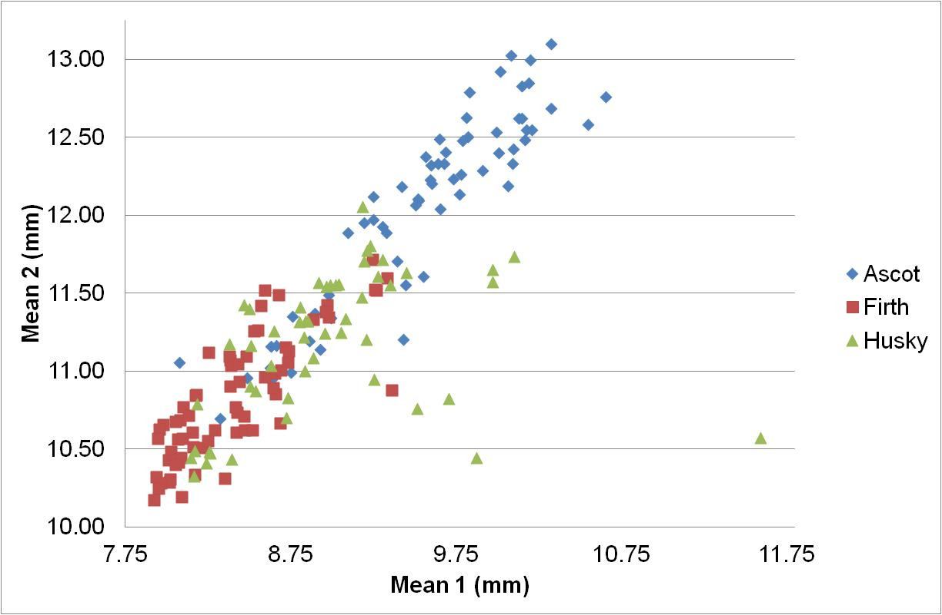
Figure 12. The grain length means of all samples (3 varieties) from all field seasons.

Grain quality analysis
One of the key features achievements of Quoats was formation of the sub committees which were based along the lines of the workpackages. Discussion within the milling subcommittee, which comprised of the main end users (BOBMA), identified main criteria for milling quality. This included, in the order they would be measured, specific weight, admixture, screenings, kernel content and hullability. Level of mycotoxin content in the grain also increased in priority over the course of the project.
An ideal milling oat would be one which has high yield and good grain quality. Specifically it would meet the minimum quality criteria of the miller which usually is specific weight of 50 kg/hl and kernel content of 70%. Oats which fall below these criteria may still be used but purchased at a reduced rate. Kernel content has clear implications for milling yield. Essentially this is the amount of groat remaining after the husk has been removed. There is no rapid test for this.
Specific weight (alternatively known as test weight or hectolitre weight) is a measurement of grain density. It is an easily conducted test used by the grain traders to assess grain quality. However, there is little direct evidence how it relates to a variety’s performance in the oat mill. It is now one of the criteria for variety assessment on the HGCA RL List.
The ring testing of KC showed varietal differences. There was a very good agreement between KC determined by IBERS and AFBI, whilst the other millers were more erratic in results (Figure 13). Generally the ranking of kernel content was consistent for the varieties by the individual testing sites. Similar results were observed with the ring test for specific weight, again a good relationship between IBERS and AFBI but not as good between IBERS and the millers (Figure 14). A critical component in measurement of specific weight is what measurement device is used and cleanliness of the grain sample. All of IBERS trials were combined using a trial plot combine. This has some differences compared to a commercial combine in terms of settings and volume of grain which is harvested.

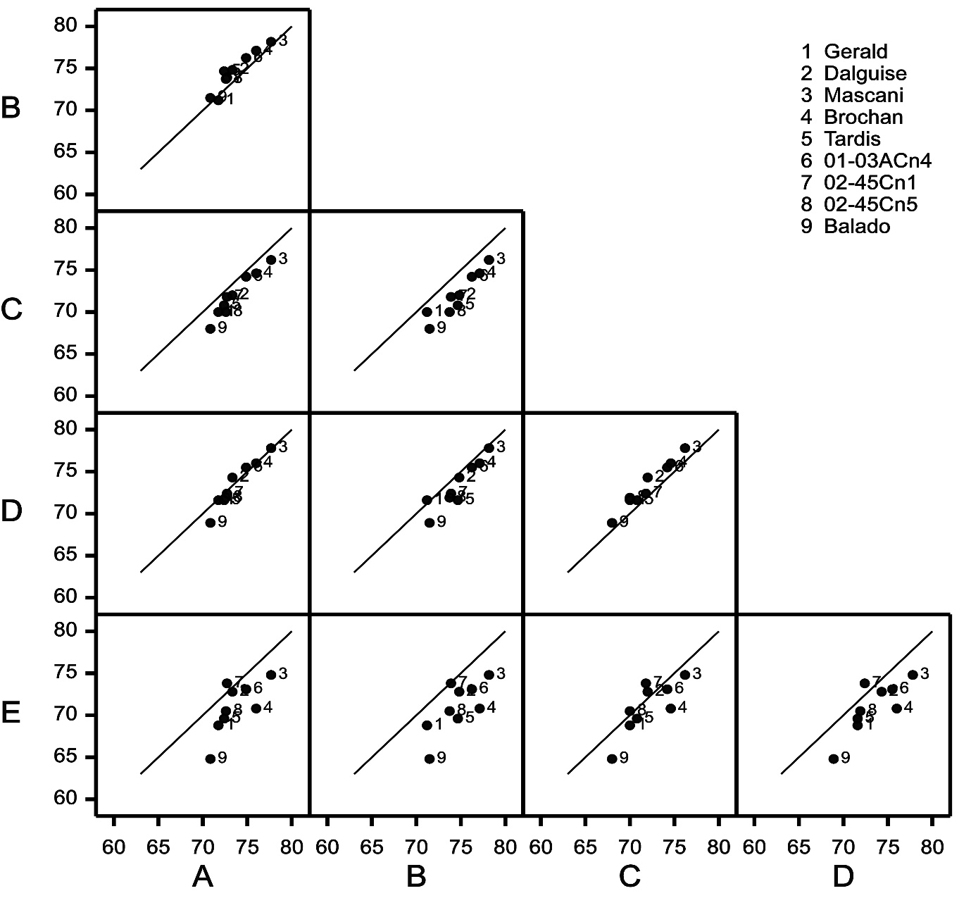
Figure 13. Comparison of Ring test Kernel Content determination by industrial partners (C, D and E) and research institutes (A, B) for 9 winter oat lines and varieties. (Results are anonymous)
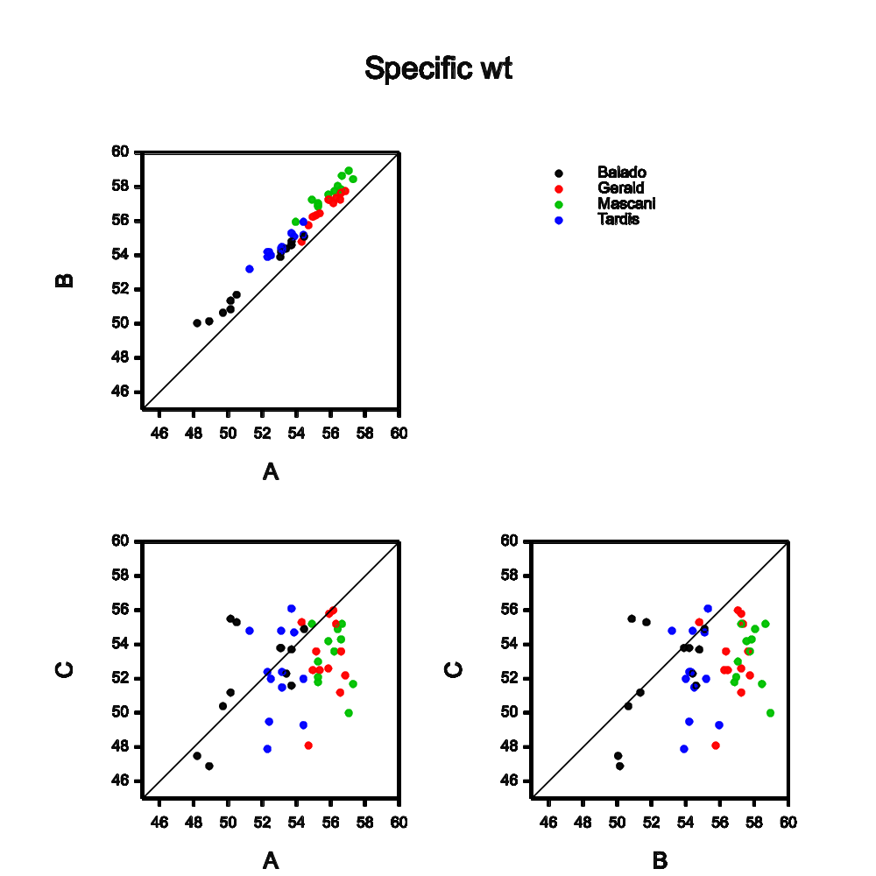
Figure 14 Comparison of industrial partner and research institute on determination of specific weight of named winter oats.

Pilot milling of the newer varieties was also completed during the project. One of the issues with identifying a new milling oat variety is having sufficient quantities on which to complete tests. Modern mills work 24/7 so large volumes of grain (80-100 tonnes) are necessary to provide reliable data. This required considerable logistical planning to have oat varieties available at the right time and quantity for the mill to run them. A baseline was established with the winter oat Gerald and spring oat Firth. At the start of the project, Gerald and Firth were the most widely grown winter and spring oat respectively. Subsequent tests were completed on Gerald, Mascani, and Balado. Samples from these lines were retained by the mill and sent to IBERS for quality analysis. One of the issues identified is currently there is no working small scale mill which would allow testing of kg of new varieties. Blind- testing by IBERS using various quality parameters (kernel content, hullability, thousand grain weight and grain roundness) correctly identified samples which millers had categorised as good, fair and poor mill samples. There was 100% correlation with the poor samples in each case (Table 9).

Table 9. Blind testing of millers samples by IBERS quality assessment against mill run comments
Sample no. | Grain roundness | Kernel  Content % | Hullability % | TGW (g) | IBERS  score | Milling  Score (1=good,5=bad)
1 | 3.25 | 72.8 | 95.5 | 39.5 | Medium | 2
2 | 3.50 | 75.0 | 91.4 | 35.3 | Medium | 2
3 | 3.25 | 75.0 | 93.7 | 29.3 | Medium | 3
4 | 3.41 | 75.6 | 97.2 | 33.3 | Medium | 2
5 | 3.34 | 74.3 | 90.0 | 40.5 | Medium | 4
6 | 3.34 | 75.4 | 96.0 | 42.8 | Good | 2
7 | 3.32 | 76.7 | 95.7 | 44.6 | Good | 1
8 | 3.34 | 75.8 | 95.6 | 43.3 | Good | 4
9 | 3.49 | 71.4 | 85.1 | 33.5 | Poor | 5
10 | 3.59 | 68.1 | 69.4 | 35.4 | Poor | 5
11 | 3.51 | 69.5 | 84.4 | 35.5 | Poor | 5

Results from 2014 harvest examined the effect of cleaning the grain samples and its relationship on specific weight between cleaned and uncleaned grain samples (see Figure 15). The formula for the fitted line was cleaned specific weight=0.847 uncleaned specific weight +8.36. It is clear that the difference between uncleaned and cleaned specific weight lessens at higher uncleaned specific weights.
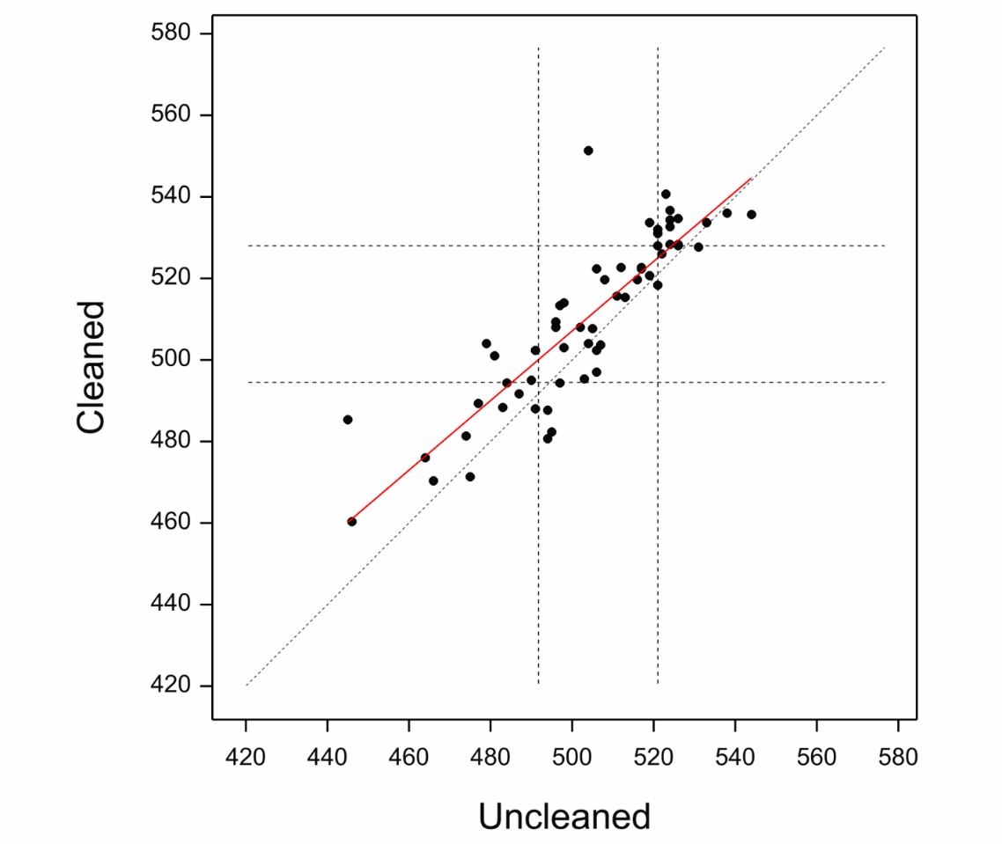
Figure 15. Effect of cleaning the grain sample on measured specific weight (g/hl)

In conclusion we can be confident that the quality assessments completed at IBERS are consistent and appropriate for selection of newer varieties. It would be ideal to develop a “pilot milling “ facility which could replicate the mill but only need kg rather than 60 tonnes to assess new lines.

Mycotoxin analysis
In total mycotoxin analysis was completed on over 1000 samples. These samples were from two main datasets. Firstly, 66 genotypes were monitored at several sites across the UK from 2009 to 2013 as part of the breeding program screen (Workpackage 2), secondly the variety x nitrogen rate experiments conducted at ADAS Rosemaund and the Organic Research Centre in 2011 and 2012 (Workpackage 2) were also analysed. For the breeding program various lines were analysed in each year and results reported within the QUOATS meetings. This dataset was highly unbalanced as genotypes varied across the years. To allow analysis of the genotype x environment interaction all varieties with more than 20 samples were included in a modified joint regression analysis (Genstat v14). Results show that both environment and variety were highly significant (P<0.001) with environment accounting for the majority of the variance (82%). There was no significant sensitivity (P=0.211) and therefore resistance to HT2+T2 producing Fusarium species is stable between environments for the varieties selected (Figure 16).

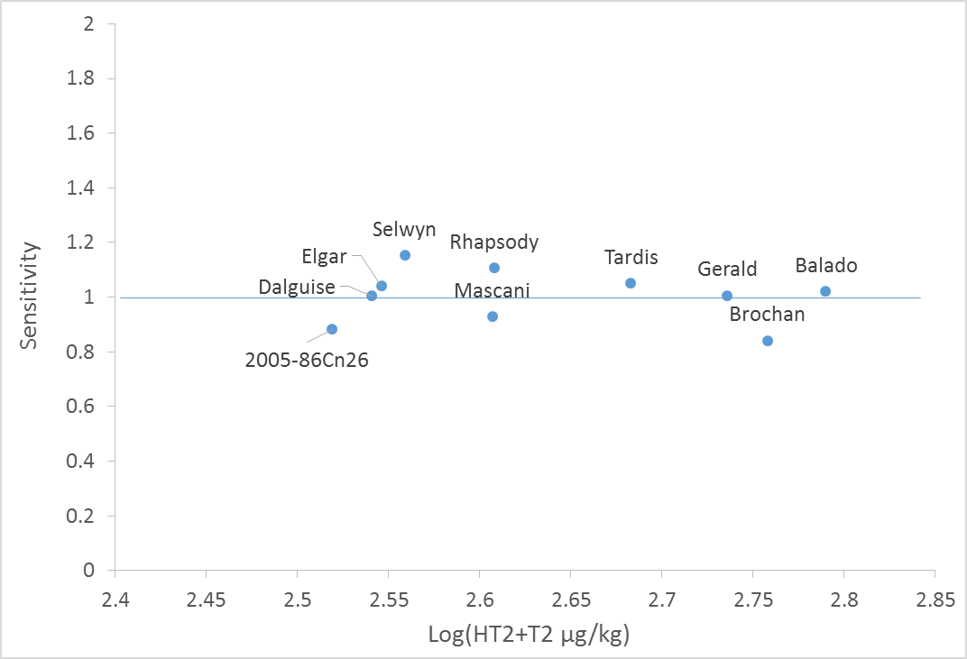

Figure 16 HT2+T2 concentration of ten varieties plotted against environmental sensitivity. A variety with a sensitivity value close to 1.0 is stable.

The concentration of HT2+T2 for the varieties previously monitored for HT2+T2 as part of the HGCA studies of Recommended List samples are as expected with the varieties in the same order from Dalguise at the low end to Balado at the high end as previous reported (Edwards, 2012). The new varieties, released during the period of the QUOATS project (Elgin, Selwyn and Rhapsody) are all at the lower end of the HT2+T2 range.

At Rosemaund the experiment was conducted as a full factorial randomised block design with 4 Varieties x 2 Nitrogen rates (Nil and RB209) x 2 Seed Rates (Low and High). HT2+T2 concentrations were log10 transformed to normalise the distribution of residuals and analysed by ANOVA with blocks nested within year. Results indicated that there were no significant interactions and that seed rate had no significant impact. There was a significant effect of variety and nitrogen rate as detailed in Figure 17 and 18. Gerald, Mascani and Tardis had a similar HT2+T2 content of ca. 350 ppb. Balado had a significantly higher mean HT2+T2 of ca. 670 ppb compared to the other three varieties; equivalent to 85% higher levels. Oats treated with nitrogen at the RB209 rate had a significantly lower HT2+T2 compared to the oats that had a nil application of nitrogen. The difference was about 30% lower.

Figure 17 HT2+T2 concentration of winter oat varieties from field experiments at ADAS Rosemaund. Bars with the same letter are not significantly different based on the LSD (p=0.05).

Figure 18 HT2+T2 concentration of winter oats at two nitrogen rates from field experiments at ADAS Rosemaund. Bars with the same letter are not significantly different based on the LSD (p=0.05).

At the Organic Research Centre the experiment was conducted as a full factorial randomised block design with 4 Varieties x 2 Nitrogen rates (Nil and 60 N kg/ha (chicken manure)). HT2+T2 concentrations were log10 transformed to normalise the distribution of residuals and analysed by ANOVA with blocks nested within year.

Results indicated that there were no significant interactions and that application of an additional 60 kg/ha nitrogen in the form of chicken manure had no significant impact. There was a significant effect of variety as detailed in Figure 19. As with the experiments at ADAS Rosemaund; Gerald, Mascani and Tardis had a similar HT2+T2 content (ca. 100 ppb) and Balado had a significantly higher mean HT2+T2 (ca. 130 ppb) compared to the other three varieties. At this site the overall concentration of HT2+T2 was lower than at Rosemaund and Balado was only 28% higher than the other varieties.

Figure 19 HT2+T2 concentration of winter oat varieties from field experiments at the Organic Research Centre. Bars with the same letter are not significantly different based on the LSD (p=0.05).

Develop oats for sustainable livestock agriculture that will reduce greenhouse gas emissions and provide a high quality feed (WP3)

Background
Livestock production is a significant source of UK greenhouse gas emissions (GHG) including methane (CH₄) and nitrous oxide (N₂O) and of ammonia (NH₃). To put in context, around 18% of UK GHG emissions are related to food production and consumption and livestock production is a significant source of these. In 2005, over 35% of the UK emissions of methane came from agriculture, with 749.5 kt (approximately 80%), from enteric sources (mainly from ruminants) (Climate Change, the UK programme 2006) and 119.5 kt from waste (mainly manures and slurries) (Defra report AC0206). Poultry producers are also faced with meeting environmental legislation. A major concern is to comply with IPPC requirements for poultry emissions (ammonia) which are strongly correlated with the amount of nitrogen excreted by the birds, which is dependant upon how closely the amino acids in the protein of the diet fit the bird’s requirements.
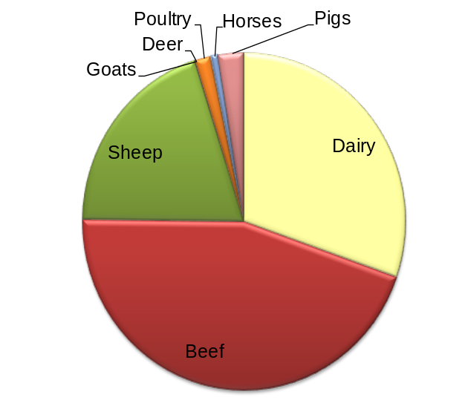
The amino acid profile and high oil content make oats a valuable livestock feed, with high metabolizable energy (Cuddeford, 1995). High oil naked oats (with up to 16% oil) have been developed and molecular markers associated with oil content. There is good evidence that high oil content can reduce methane emissions from ruminants. Preliminary studies at IBERS, using an in vitro system, showed that high oil oats decrease methane production by 35.4% compared to wheat without reducing digestibility (Cowan et al., 2008). Although oil can be added as a supplement in the feed ration, a strategy that included high oil oats within a feed ration provides a realistic and practical approach to reducing methane emissions. As oats grow well in the west and fit well into grassland rotations more oats could be grown “on-farm” with the added benefit of reducing the CO₂ emissions associated with transporting grain and providing a sustainable solution to reducing GHG.
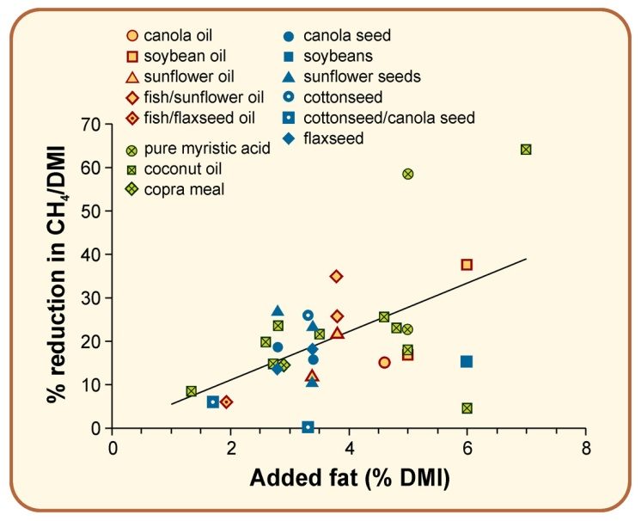
While naked oats are more suited to poultry, ruminants can use fibre as an energy source. Therefore husked oats are more appropriate for feeding to ruminants. A key factor influencing the feeding value of oats for ruminants is the digestibility of the husk and in particular the lignin content. Development of a high oil low lignin husked oat will have a quantifiable benefit to the UK. Based on 2005 UK data, and wheat comprising 25% of the diet, high oil/low lignin oats could reduce UK methane emissions from enteric fermentation from 749.5 kt to 702.4 kt, roughly 6%. It will also remove the limitations derived from the lower yield of naked oats. Although qualitative tests provide a relatively quick indication of ‘high-lignin’ or of ‘low-lignin’, quantitative phenotypic evaluation of lignin is difficult which makes this trait an excellent candidate for molecular marker based breeding. At present commercial oat varieties with combinations of high oil and low lignin are not available.
Figure 21. Effect of added fat in ruminant diets on reduction of methane emissions
Figure 20. Proportions of methane emissions from UK livestock (2008 data).

Ruminant animals are major source of methane in UK agriculture (Figure 20), losing an average of about 6% of their gross energy intake as methane. It is well known that dietary manipulation can modify the output of methane from the gut and from manures produced by livestock, one method of which is to increase the fat content of the animals’ diet (Figure 21).

WP3 Milestones
Oats as an environmentally friendly animal feed
14. Cross 100 winter oats and 30 spring oats to incorporate desired target traits for improved animal feed. (Repeated annually)
15. Sow purestock nurseries (F2-F7 generations) to allow for selection and evaluation of material for appropriate agronomic characteristics as well as desired quality traits (improved oil content or low lignin husk or combination of both)
16. Produce stocks of oat types to quantify GHG emissions in vitro as proof of concept
17. Produce large stocks of appropriate lines and conduct feeding trials for ruminants and quantify feed efficiency
18. Conduct feeding trials on poultry and quantify GHG emissions from manures

Breeding of improved oat varieties for animal feed
Two approaches are being applied. Breeding of 1) naked oats and 2) low lignin husked oats with high oil groats.
Figure 22 a) from left to right, husked oat spikelet with glumes, two florets in spikelet with glumes removed, primary floret with husk removed and groat visible b) naked oats - effectively whole groats c) husked oats whole grain
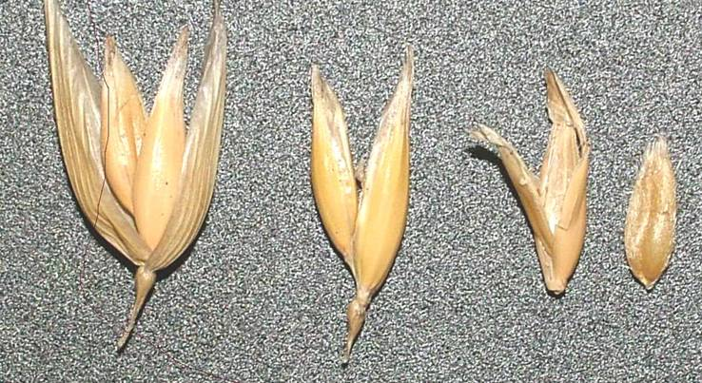 (a)
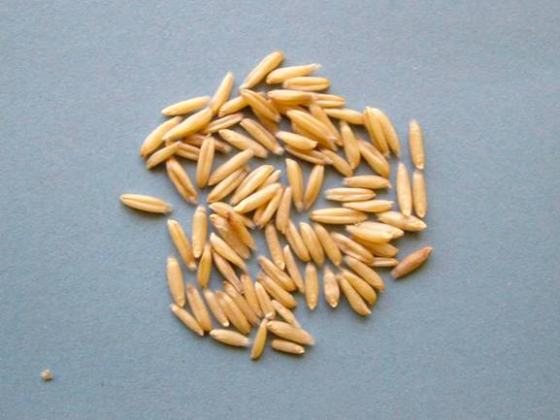 (b) 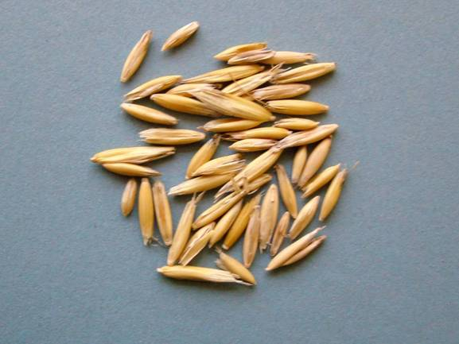 (c)

Naked oats have been bred at IBERS for animal feed. They have similar agronomic requirements to husked oats with a slightly higher sowing rate; however yield is lower due to lack of husk, 70-80% of the husked varieties. The target for the breeding programme has been for higher yielding lines with improved oil content. The high oil and good protein content especially the sulphur containing amino acids (Table 10, Figure 19) make oats an ideal animal feed. In Quoats the naked oats have been concentrated on poultry. High oil sources from the Iowa State recurrent selection process have been used as parents in the crossing program to bring high oil in to UK adapted lines. NIRS calibrations developed at IBERS have been used to screen material and select for naked oats with higher oil content e.g. Mason.

Table 10. Variation in levels of crude protein, oil content and metabolisable energy of oat lines and varieties compared to feed wheat.
Selection | Crude Protein | Oil (B) | TME MJ/kg as fed
Gerald | 11.6 | 8.1 | 11.5
Brochan | 11.0 | 7.7 | 12.4
Hendon | 11.3 | 10.2 | 15.3
Racoon | 14.8 | 13.6 | 16.2
01-126Cn1 | 12.2 | 12.8 | 15.8
Mason | 13.4 | 12.7 | 15.5
01-146Cn5 | 12.6 | 13.2 | 15.8
Zuton | 14.0 | 9.0 | 15.4
Lennon | 13.7 | 8.9 | 15.7
Frontier (wheat) | 12.3 | 2.5 | 13.9
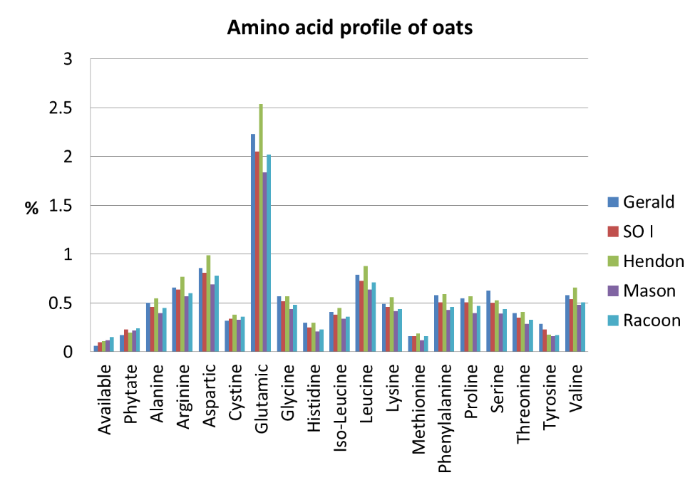

Figure 23. The range of amino acids found in various oat lines note the high levels of sulphur containing amino acids

Low lignin high oil husked oats
Over the project there has been increasing emphasis on the breeding of low lignin high oil husked oats. Sources of low lignin husk AC Assiniboia and the Australian line Mitka have been used to incorporate low lignin husk in to the breeding programme. Initial lab studies have shown low lignin husk to be 66% more digestible than conventional husk coat. Initially lignin was tested using colorimetric pholoroglucinol staining method (Figure 20). Conventional husk stains a deep purple colour and low lignin husk does not stain. SNP markers have now been develop to screen for low lignin.
The ultimate aim is to produce an oat variety with a low lignin husk and high oil groat. This combination would make an ideal ruminant feed, it would also overcome some of the negative comments associated with naked oats in terms of lower yield and ease of handling.
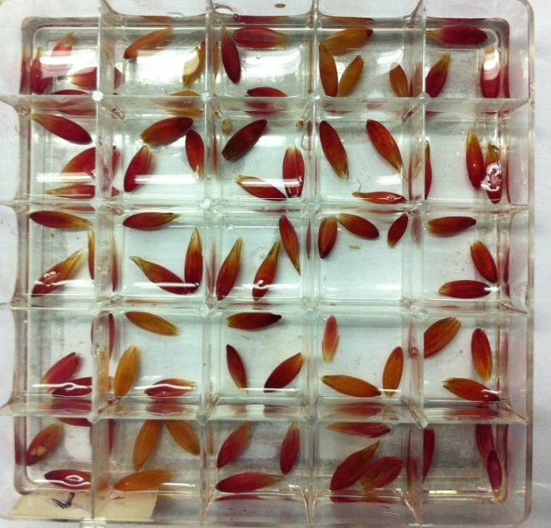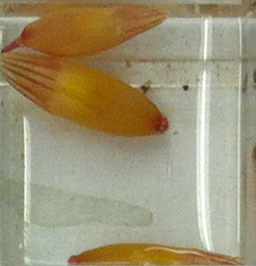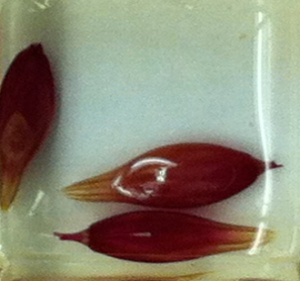
Figure 24. Effect of phloroglucinol staining on lignin content of oat husks

4.3.3. Fatty acid analyses of oat grains
Fatty acid analyses of 33 novel oat line grain samples, together with 6 control grain samples, found total FA content to range from 74 to 158 g/kg DM (mean 102 g/kg DM). The main FA of the grains were C16:0 (palmitic acid), C18:1 (oleic acid) and C18:2 n-6 (linoleic acid), between them accounting for an average of 97% of the total fatty acids. Principal components analysis of the fatty acid data (Figure 24) indicates a major proportion (about 97%) of the variation in oat grain fatty acid proportions (g/kg total fatty acid) was explained by the first principal component, which is appears to be related to the variety and/or growing conditions (spring versus winter) of the crop.

The highest total FA content was found in WN oats (Table 11) and the lowest was found in SH, although some spring lines had a reasonably high content (110.4 g/kg DM). Some individual lines within the WH group also had a total high FA content (140 g/kg DM). For all groups FA C16:0, C18:1 and C18:2 together comprised about 95% of the total FA. There was some variation in the FA proportions with the highest value of C16:0 for SH, which also had the lowest proportion of C18:1 and highest proportion of the more beneficial FAs C18:2 and C18:3. The WH group had lower proportions of C16:0 and increased proportions of the beneficial FAs C18:1, C18:2 and C18:3 than the SLLH group.

Table 11. Mean fatty acid (FA) proportions (values as % of total FA except for Total FA in g/kg DM).
 | Winter naked | Winter low lignin husked | Sprint low lignin husked
 | n=4 | n=16 | n=18 | SEM | Sig.
Total FA g/kg DM | 137.6ª | 105.7^{b} | 90.5^{c} | 12.97 | ***
%C16:0 | 14.8ª | 16.8^{b} | 17.5^{C} | 0.40 | ***
%C16:1 | 0.16ª | 0.18ª | 0.22b | 0.010 | ***
%C18 | 1.30ª | 1.03^{b} | 0.97^{b} | 0.100 | **
%C18:1 | 45.5ª | 40.1^{b} | 35.9^{c} | 0.98 | ***
%C18:2 | 36.8ª | 40.4^{ac} | 43.6c | 1.640 | ***
%C18:3 | 0.78ª | 0.92ª | 1.20^{b} | 0.069 | ***
Values in rows with different superscript letters indicate significant differences (P < 0.05). Sig. = significance of treatment effect, NS = not significant, ** = P < 0.01, *** = P < 0.001.

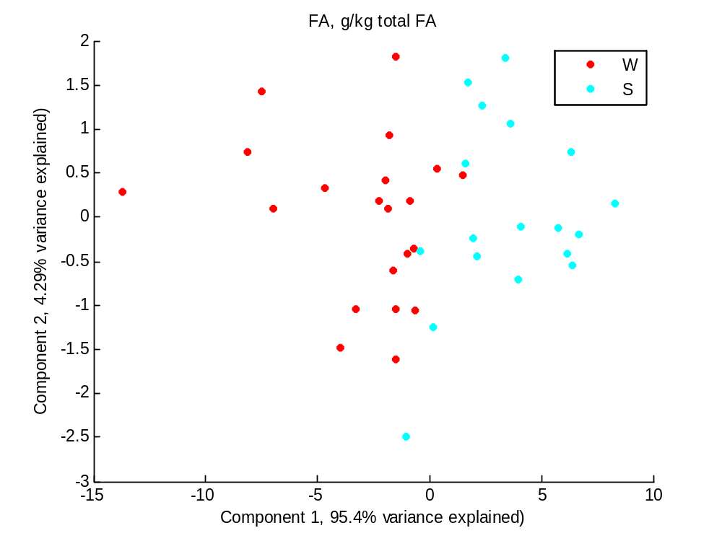
Figure 25. Principal components (1 vs 2) plot of oat grain fatty acid proportions. Red dots (W) are winter oat varieties, blue dots (S) are spring varieties.

Samples of the whole grain (including husk if present) of 4 commercial varieties of winter naked (WN) oats, together with several novel low lignin breeding lines of spring husked (SLLH; n=5) and winter husked (WLLH; n=8) oats, were analysed for standard chemical composition.

Data were analysed by ANOVA, with multiple comparisons when the effect of treatment (SN, SLLH and WLLH) was significant (P<0.05). Grain oil and CP concentrations were significantly lower in the novel husked oats than the conventional naked oat varieties (Table 12), while fibre concentrations were higher, leading to lower ME densities in the husked oats than the naked oats, as expected.

In conclusion, although the apparent feeding value of the novel husked oats was not as good as naked oats in some areas, some values of novel spring varieties in particular were similar to naked oats and show promise as ruminant feeds.

Table 12. Chemical composition of oat varieties, values in % DM unless otherwise indicated.
Oat varieties: | WN | WH | SH | SEM | Sig.
DM, % | 89.4 | 90.9 | 90.9 | 0.49 | NS
OM | 97.7ª | 97.4ª | 97.0^{b} | 0.09 | ***
Oil | 13.8ª | 7.5^{b} | 6.3^{b} | 0.74 | ***
CP | 12.7ª | 8.3^{b} | 11.1ª | 0.49 | ***
ADF | 3.8ª | 16.0^{b} | 13.3^{b} | 1.06 | ***
NDF | 8.1ª | 29.7^{b} | 27.5^{b} | 1.30 | ***
ME, MJ/kg DM | 16.7ª | 12.4^{b} | 13.0^{b} | 0.30 | ***
Starch | 54.6ª | 47.7^{b} | 48.4^{b} | 1.40 | **
ADL | 1.2ª | 2.9^{b} | 1.8a^{b} | 0.49 | *
Values in rows with different superscript letters indicate significant differences (P < 0.05). Sig. = significance of treatment effect, NS = not significant, * = P < 0.05, ** = P < 0.01, *** = P < 0.001.

4.3.4 Gas production from a range of oat lines
The chemical constituents of the oat samples used in this study are presented in Table 13.

Table 13. Chemical composition (mean and range) of the oats used in the gas production analysis. Figures in g/kg DM.

 | Mean | Minimum | Maximum
Crude protein | 82 | 60 | 109
Organic matter | 974 | 967 | 978
Neutral detergent fibre | 203 | 54 | 277
Acid detergent fibre | 104 | 26 | 161
Acid hydrolysis ether extract | 71 | 39 | 131
Acid detergent lignin | 18 | 7 | 36

The cumulative gas production of the oats lines during the study is shown in figure 26.

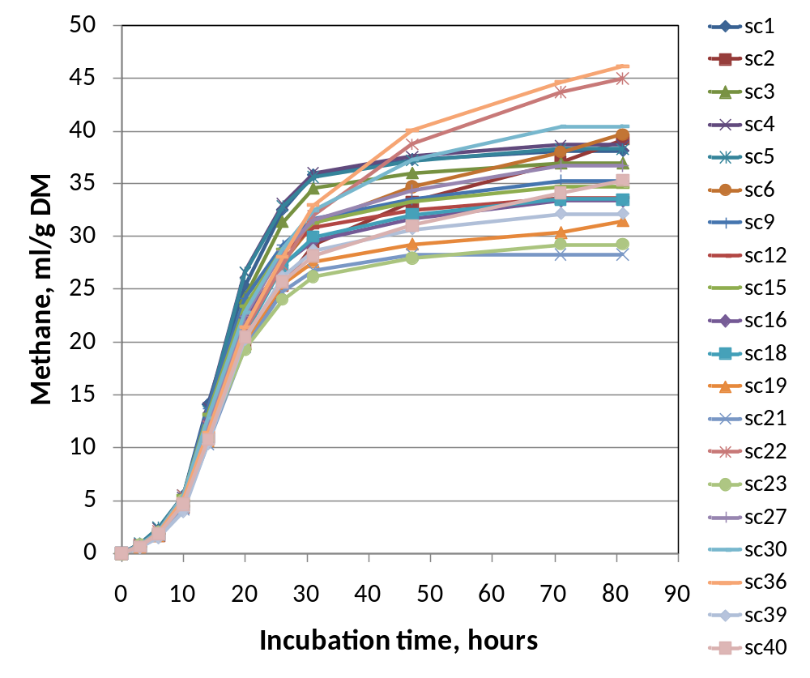
Methane production varied from 28.3 to 46.1 (mean = 35.4, SD = 4.73) ml per g grain DM incubated (Figure 2), and 39.7 and 52.2 (mean = 46.3, SD = 3.68) ml per g of apparently digested DM (dDM).

Figure 26. Cumulative methane production (ml/g DM) of the 20 oat lines over the course of approximately 80 hours.

Methane production was negatively related to grain ADL content (r = -0.86; P < 0.001) but was positively related to DM loss (r = 0.78; P < 0.001) (Figure 27). Methane production per g dDM was also negatively related to grain total fatty acid (FA) content (r = -0.77; P < 0.001). As the relative proportion (g FA/100g total FA) of some of the unsaturated FA increased, methane production per g adDM decreased (e.g. C18:1, r = -0.76; P < 0.001) (Figure 28). However, because the relative proportions of individual FA did not vary greatly among the different oat lines, the relationships with methane emissions were similar to those of total FA, particularly for those FA in greatest abundance (C16:0, C18:1, C18:2 n-6).

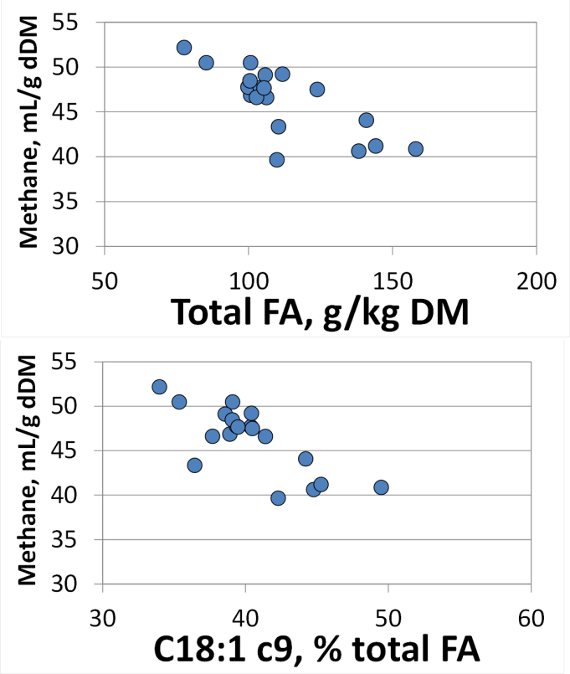
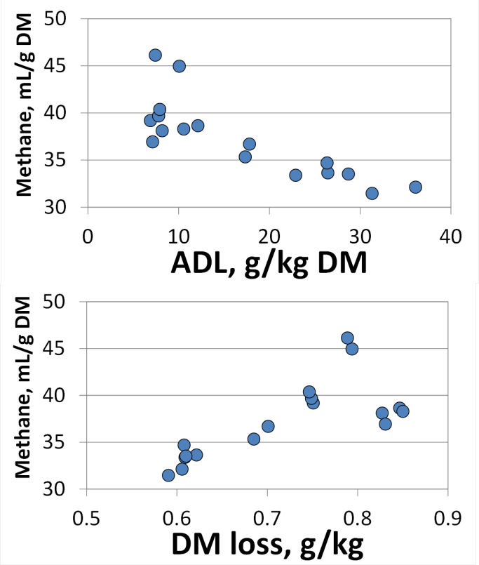

Figure 27. Methane production (g/kg DM) from oat grains in relation to ADL concentrations and total DM loss
Figure 28. Methane production (g/kg dDM) from oat grains in relation to total FA concentrations and oleic acid proportion

Use of the Rumen Simulation Technique (Rusitec) to investigate promising oat lines and compare with barley.

Apparent digestibility of the 5 samples was not affected by treatment (Table 14). Similarly, methane production was not significantly affected by treatment, although microbial N production was. The greatest microbial N production was on the barley diet, the least was on the Cn18 diet, both in absolute terms (g/d) and in terms of grams produced per g of apparently digested DM.
Previous results from the gas production experiment, which found an inverse relationship between oat oil content and methane production (ml per g apparently digested DM) (Figure 25), was not replicated with the Rusitec experiment. However, there are a number of reasons why this could be. The first is that this study used diets comprising grass silage and grains, whereas the previous gas production experiment studied grains only. This may have affected the gas profile, masking the effects of the grain component of the diet.

Table 14. Mean effects of treatments on diet degradability, methane production, and microbial N production in the rusitec effluent.
 | Treatment
 | Barley | Cn14 | Cn18 | Composite | Gerald | SED | P
Digestibility, g/g | 0.57 | 0.62 | 0.62 | 0.62 | 0.58 | 0.029 | 0.31
Methane, ml/d | 115 | 146 | 116 | 115 | 109 | 17.3 | 0.30
Methane, ml/g apparently digested | 19.4 | 22.3 | 17.8 | 17.8 | 18.0 | 1.8 | 0.16
Microbial N, g/d | 0.31^{b} | 0.26^{ab} | 0.22ª | 0.27^{ab} | 0.28^{ab} | 0.019 | 0.013
Microbial N, g/g DM apparently digested | 0.053^{b} | 0.040^{ab} | 0.035ª | 0.043^{ab} | 0.046^{ab} | 0.0046 | 0.040

A second possible reason is a potential change in the microbial population in the fermenter. There is limited potential for microbial population change in a batch system like the gas production system, which lasts for 2-3 days. With the much longer time course of a continuous culture system such as Rusitec, there is greater opportunity for population changes – it is well known that there are species losses in Rusitec fermenters over prolonged periods (e.g. Moumen et al, 2009). Therefore, despite being a system that allows microbial N production quantification, the methanogen population may have changed; protozoa in particular tend to be eliminated from Rusitec during the course of a study, and a relatively large proportion of methanogenic archea are associated with rumen protozoa.

4.3.6 Methane production from a range of oat varieties consumed by mature ewes
The chemical composition of the oats offered during the experiment is listed in Table 15.

Table 15. Mean (n=8) chemical composition of the oats offered during the experiment. All values in g/kg DM.
 | Balado (A) | Racoon (B) | 14355Cn (C)
Crude protein | 94 | 114 | 133
Organic matter | 979 | 983 | 973
Water soluble carbohydrates | 26 | 34 | 30
Neutral detergent fibre | 315 | 83 | 375
Acid detergent fibre | 139 | 19 | 168
Crude fibre | 142 | 20 | 154
Starch | 467 | 598 | 385
Total oil | 68 | 130 | 54
Gross energy, MJ/kg DM | 19.9 | 20.9 | 19.9
Acid detergent lignin | 26.8 | 9.0 | 12.7

There were no treatment effects on DM intake, because sheep were fed to requirements and intake was therefore restricted (Figure 26). However, there were significant treatment effects on daily methane emissions, methane emissions per unit DM intake, per unit metabolic live weight, and as a proportion of gross energy intake (Table 16). There were no significant breed × treatment interaction effects

Table 16. Mean treatment effects on feed intake (restricted), and methane emissions (g/d, g/kg DM intake, and g/kg metabolic live weight). Means within rows with different superscripts differ significantly (P<0.05)
 | Oat treatment
 | Balado | Racoon | 14355Cn | Mix | SED | P
DM intake, g/d | 632 | 639 | 637 | 639 | 5.23 | 0.510
CH₄, g/d | 15.2ª | 14.7ª | 17.2^{b} | 14.7ª | 0.60 | 0.002
CH₄/DMI, g/kg | 24.1^{ab} | 23.0ª | 26.9^{b} | 23.9ª | 0.96 | 0.003
CH₄/LW^{0.75}, g/kg | 0.78ª | 0.74ª | 0.88^{b} | 0.75ª | 0.031 | 0.002
CH₄E/GE intake, % | 7.3^{ab} | 6.9ª | 8.1^{b} | 6.9ª | 0.29 | 0.003

The effect of DM intake on methane emissions is clearly seen in Figure 29, with clear groups of the two breeds being evident. Variation within each breed group cluster is due to difference between the dietary treatments.

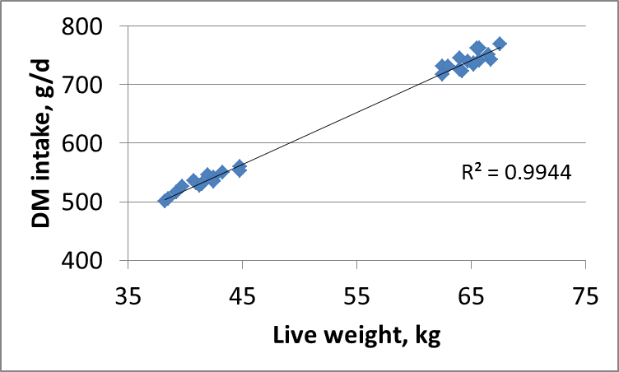

Figure 29. Effect of live weight on DM intake, which was allocated according to estimated metabolisable energy requirements. The solid line is a linear regression through all data points
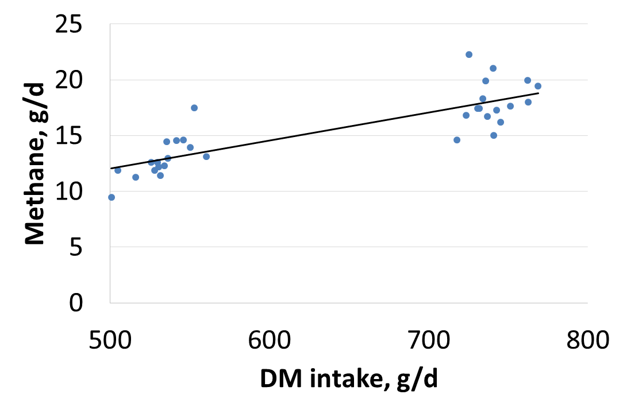
Figure 30. Effect of DM intake on methane emissions from the sheep. The solid line is the linear regression through all data (R² = 0.7).

4.3.7 Dairy cow experiment

The chemical composition of the feeds offered during the experiment is listed in Table 17.

Table 17. Mean (n=6) chemical composition of the feeds offered during the experiment. All values in g/kg DM.
 | Rolled Wheat | Rolled Oats | Oat Husk | Premix A | Premix B | Conc mix A | Conc mix B | Conc mix C | Silage
Crude protein | 121 | 142 | 34 | 311 | 316 | 248 | 229 | 229 | 155
Organic matter | 980 | 977 | 964 | 893 | 899 | 919 | 924 | 929 | 926
WSC | 38 | 33 | 7 | 119 | 104 | 93 | 82 | 76 | 82
NDF | 123 | 93 | 848 | 221 | 103 | 177 | 205 | 250 | 543
ADF | 38 | 29 | 405 | 235 | 62 | 89 | 109 | 73 | 339
Oil | - | - | - | - | - | - | - | - | TBD¹
Total oil | TBD | TBD | TBD | TBD | TBD | TBD | TBD | TBD | -
Starch | 655 | 614 | 48 | 59 | 208 | 231 | 241 | 335 | -
¹ To be determined.

Treatment mean feed intakes and milk yields are presented in Table 18. There was no effect of concentrate treatment on ad lib silage intakes nor on milk yields. Milk fat was significantly affected by diet, with lower concentrations and yields from cows offered the Oat 2 diet. Milk protein and lactose were unaffected. Milk urea concentration tended to be lower in cows offered the Oat 1 diet. The in vivo whole tract organic matter digestibilities expressed as a proportion of DM intake (DOMD) did not differ significantly between treatments, which meant that the overall diet metabolisable energy density was estimated at 9.76 MJ/kg DM. This is somewhat less than the originally predicted energy density of approximately 11.8 MJ/kg DM of the formulated diet, and it likely due to differences between assumed and actual composition of the grass silage used in the experiment. The digestibility of dietary N was significantly greater as part of the wheat-based concentrate diet compared with the oat-based diets.

Table 18. Mean effects of concentrate treatment on feed intakes, whole tract apparent digestibilities of feed, and milk yields and milk composition.
 | Concentrate treatment |  |  |  | P
 | A - Wheat | B - Oat 1 | C - Oat 2 | SED | A v B+C | B v C
Silage intake, kg DM/d | 10.9 | 10.7 | 10.6 | 0.14 | 0.106 | 0.612
Total intake, kg DM/d | 21.2 | 21.1 | 21.0 | 0.14 | 0.041 | 0.719
DM digestibility, g/g | 0.66 | 0.65 | 0.66 | 0.006 | 0.213 | 0.216
N digestibility, g/g | 0.75 | 0.70 | 0.72 | 0.016 | 0.018 | 0.196
OM digestibility, g/g | 0.68 | 0.67 | 0.67 | 0.006 | 0.278 | 0.338
Milk yields, kg/d | 28.9 | 29.0 | 28.8 | 0.52 | 0.908 | 0.670
M yield/DMI, kg/kg | 1.35 | 1.38 | 1.37 | 0.025 | 0.403 | 0.738
Fat, g/kg | 43.2 | 43.6 | 41.4 | 0.49 | 0.325 | 0.002
Protein, g/kg | 33.3 | 32.7 | 32.7 | 0.37 | 0.114 | 0.798
Lactose, g/kg | 45.1 | 45.1 | 45.3 | 0.14 | 0.307 | 0.065
Fat yield, g/d | 1497 | 1511 | 1437 | 17.0 | 0.325 | 0.002
Protein yield, g/d | 1155 | 1133 | 1136 | 13.0 | 0.114 | 0.798
Lactose yield, g/d | 1564 | 1563 | 1573 | 4.9 | 0.307 | 0.065
Urea, % | 0.029 | 0.027 | 0.029 | 0.0010 | 0.202 | 0.031

Daily methane emissions from the dairy cows did not differ significantly between treatments (Table 19). Methane yields, i.e. g methane per kg feed DM intake, also did not differ between treatments.

There were no significant treatment effects on the outputs of N in milk, faeces and urine, nor in the apparent partitioning of dietary N to milk or urine. However, cows offered the wheat-based concentrate had significantly lower partitioning of dietary N to faeces, which reflects the increased digestibility of N on that diet.

Table 19. Mean effects of concentrate treatment on methane emissions and whole body apparent N partitioning.
 | Concentrate treatment
 | A - Wheat | B - Oat 1 | C - Oat 2 | SED | A v B+C | B v C
Methane, g/d | 371 | 351 | 370 | 16.9 | 0.490 | 0.293
Methane yield, g/kg DM intake | 17.2 | 16.7 | 17.5 | 0.82 | 0.880 | 0.320
Milk N out, g/d | 173 | 167 | 172 | 5.4 | 0.512 | 0.366
Faeces N out, g/d | 171 | 192 | 177 | 10.4 | 0.160 | 0.186
Urine N out, g/d | 265 | 244 | 259 | 10.5 | 0.153 | 0.183
Milk N/N In, % | 25.2 | 25.9 | 26.8 | 0.76 | 0.112 | 0.250
Faeces N/N in, % | 24.9 | 29.9 | 27.7 | 1.57 | 0.018 | 0.196
Urine N/N in, % | 38.7 | 37.9 | 40.5 | 1.53 | 0.715 | 0.125

Table 20. Mean effects of concentrate treatment on proportions of major milk fatty acids.
 | Concentrate treatment
 | A - Wheat | B - Oat 1 | C - Oat 2 | SED | A v B+C | B v C
C12:0 | 3.3 | 2.6 | 3.0 | 0.08 | <0.001 | <0.001
C14:0 | 11.3 | 10.1 | 11.0 | 0.16 | <0.001 | <0.001
C14:1 cis-9 | 1.13 | 0.96 | 1.05 | 0.027 | <0.001 | 0.008
C16:0 | 31.0 | 28.5 | 29.7 | 0.53 | 0.003 | 0.045
C16:1 cis-9 | 1.51 | 1.42 | 1.44 | 0.073 | 0.225 | 0.735
Phytanic acid iso-1 | 0.31 | 0.26 | 0.28 | 0.005 | <0.001 | <0.001
C18:0 | 9.3 | 11.5 | 10.3 | 0.24 | <0.001 | <0.001
C18:1 cis (all isomers) | 20.3 | 23.5 | 21.8 | 0.57 | 0.001 | 0.015
C18:1 trans (all isomers) | 2.01 | 2.36 | 2.00 | 0.046 | 0.002 | <0.001
C18:1 cis-9 | 19.5 | 22.6 | 20.9 | 0.55 | <0.001 | 0.013
C18:2 n-6 | 1.53 | 1.51 | 1.56 | 0.049 | 0.889 | 0.389
C18:3 n-3 | 0.37 | 0.34 | 0.35 | 0.018 | 0.206 | 0.538
C20:0 | 0.15 | 0.16 | 0.15 | 0.004 | 0.011 | 0.011
Short chain FA¹ | 11.7 | 11.0 | 11.6 | 0.16 | 0.006 | 0.004
OBCFA² | 3.17 | 2.99 | 3.00 | 0.051 | 0.007 | 0.769
Long chain FA³ | 0.24 | 0.22 | 0.23 | 0.006 | 0.130 | 0.395
¹ < C12, ² Odd- and branched-chain fatty acids, ³ > C20
Previous analysis of the fatty acids profiles of a range of different oat varieties and breeding lines indicated that the most significant FA in oats are palmitic acid (C16:0), oleic acid (C18:1) and linoleic acid (C18:2). These 3 FA accounted for approximately 97% of the FA in the oats analysed. In milk fat of cows offered the 3 different concentrate diets, there were significant effects of treatment on several FA, the most abundant of which are presented in Table 20.

The effects of fatty acids in the human diet and their effects on cardiovascular disease are complicated (Mensink, 2003), although it is generally accepted that a reduced consumption of saturated FA such as lauric (C12:0), myristic (C14:0) and palmitic (C16:0) acids and replacement with cis unsaturated fatty acids has potential health benefits. In this experiment, the proportions of C12:0, C14:0 and C16:0 were all reduced on the oat-based diets compared to the wheat-based diet, probably as a consequence of an increased proportion of C18:1 (both cis and trans isomers, and trans FA are generally considered to be detrimental to human health). However, the proportion of the cis isomers of C14:1 was also lower, and the proportion of C18:0 was significantly increased. There were no treatment differences in the proportions of linoleic or α-linolenic acids in total milk fat.

Increase the sustainability of the oat crop through improved nitrogen use efficiency and lodging resistance

Background

Nitrogen use efficiency
Nitrogen fertilisation is a recognised tool for enhancing crop yield yet nitrogen is the main environmental burden in arable crop production (Cowell and Clift 1997; Brentrup et al., 2001, 2004: Nemecek et al., 2004). Moreover little is known of the genes controlling the response of oats to nitrogen. Improving nitrogen recovery and utilisation by cereals is seen as essential to protect water quality and ensure that the UK complies with the EU Water Framework Directive and is increasingly a target for plant breeders (HGCA Research review No. 63). Oats require significantly less nitrogenous input (Goodlass et al., 2003), are considered to be effective sequestrators of nitrogenous compounds (Sylvester-Bradley, 1993) and grow well on land less suitable for wheat, and leave less of an ecological footprint when compared with other arable crops. Oats which use nitrogen more efficiently whilst maintaining output would lower nitrogen inputs, reduce the environment impact of oat production and increase the economic attractiveness of the crop. Identifying the traits associated with the ability to grow well in organic systems where nitrogen is supplied through fertility building crops or animal manures is also essential in the development of varieties that will be used in both conventional and organic systems.
Nitrogen use Efficiency (NiUE) comprises two independent components: uptake efficiency and utilisation efficiency. N uptake efficiency (NUpE) is the percentage of soil available N found in the plant at maturity and describes the ability of the source plant to mine and assimilate N from the soil. Alternatively, N utilization efficiency (NUtE) is the ratio of grain yield to plant N and indicates sink capacity for using acquired N. Experiments to assess nitrogen uptake (NUpE) and utilisation (NUtE) are typically large scale and complex. Identification of surrogate traits for improved NiUE e.g. grain yield (Le Gouis et al., 2000), harvest index (Le Gouis et al., 1999) or improved vegetative allocation (Bertholdsson, 2006) are alternative approaches. The use of high throughput screens to enable the rapid assessment of NiUE and the partitioning of N in different forms to root, shoot and grain also needs to be quantified. These traits will then be used to identify QTL and genetic markers associated with both NUpE and NUtE that will be used for the rapid assessment of large numbers of plants, a prerequisite for incorporation of traits into enhanced germplasm (Agrama et al., 1999; Gallais and Hirel 2004).
The ability to quantify to what extent applied N (in any and all formats) is used by the plant is difficult and often relies on high level specific labelling experiments thereby reducing the scale of the experiments to be undertaken. However developments in stable isotope technologies now mean that we can, following the application of a trace spike of a stable nitrogen isotope to the fertilizer inputs, determine the real level of nitrogen uptake and utilisation.

Oats in organic systems
Oats can make a positive contribution to organic systems particularly in relation to the forthcoming changes to organic regulations to increase the organic proportion within livestock rations and to derive more of this ration on-farm. Oats already have a proven value in organic arable rotations as a main cereal as well as a break crop. They generally perform well in organic systems, with yields averaging 80% of non-organic, helped by their beneficial weed competitiveness and pest and disease resistance. New lines of oats developed within this project with increased NiUE will be assessed for their performance and value in organic systems. Nutrient management in organic systems is based on fertility building leys to fix atmospheric nitrogen (N), combined with recycling of nutrients via bulky organic materials, such as farmyard manure (FYM) and crop residues. A two-year grass-clover ley will be the basis for fertility building. Ley decomposition following cultivation can lead to significant quantities of nitrate being released during the autumn and unless taken up by the growing crop, that nitrate is at high risk of leaching over winter (Stopes et al, 2002). Varieties with enhanced nitrogen uptake efficiency (NUpE) will minimise this potential loss of N in organic systems.

Development of a model of the lodging process for oats
Lodging is a major problem in oats, and has been shown to reduce yield by up to 50%. Severe lodging years occur in cereals, on average, once every three to four years. In severe lodging years it has been shown that approximately 16% of the wheat area lodges (Berry et al. (1998): HGCA Report No 169). Oat lodging is generally more widespread than wheat lodging, so it is conservatively estimated that about 20% of the oat area lodges in a widespread lodging year. Plant growth regulators (PGRs) are used on approximately 73% of oats (Pesticide Usage Survey Report 250). Chlormequat results in residues in oat grain (although seldom above the maximum residue limit) (Spink et al., 2004) and as a result of this oat processors can restrict the use of PGRs. These factors mean PGRs must be targeted as carefully as possible to oats. Lodging resistance is one of the highest priority traits for oat breeders as a result of the prevalence of lodging in this cereal species and restrictions on PGR use.
It is known that the lodging risk of oats can be reduced by using lodging resistant varieties, PGRs, lower plant populations and less N fertiliser. However, there is no method currently available for oats that allows the net effect of several agronomic and environmental factors to be quantified to allow farmers to develop strategic crop management programmes to minimise lodging risk. In wheat a quantitative risk assessment method has been successfully developed (HGCA Guide ‘Avoiding lodging in wheat – practical guidelines’) which takes account of a range of agronomic factors. This allows farmers to plan lodging resistant strategies at sowing as well as allowing lodging risk to be assessed in spring so that the most appropriate remedial measures (e.g. delayed N fertiliser, PGRs) can be chosen. It should be possible to develop a similar guide for oat lodging if a better understanding of how factors affect the lodging risk of these crop species can be developed. A further benefit of this work will be to identify the key traits that plant breeders must improve to increase lodging resistance.
Oats can lodge by root lodging or stem lodging any time from panicle emergence to grain maturity (Figure 31a and b).The process of lodging in oat crops have several fundamental differences to wheat which mean that the wheat lodging model (Baker, 1995; Berry et al., 2003) cannot be applied directly to oats. The fundamental differences include; i) the crop changing from a group of shoots that behave independently to inter-locking canopies during grain filling, ii) stem buckling is possible at any point along the stem of oats, rather than just at the stem bottom as for wheat and iii) different morphology of the oat panicle compared with a wheat ear which will affect wind loading. The fact that the panicles of oats inter-lock during grain filling causing adjacent plants to move together when impacted upon by wind means that a substantially different modelling approach is required to describe the lodging process.
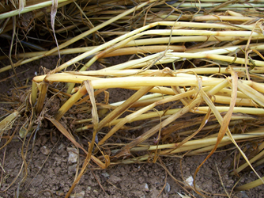
Figure 31a. Oat lodging
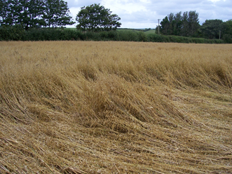
Figure 31b. Oat lodging.

WP4 Milestones
Increased sustainability of the oat crop
19. Select advanced oat lines with improved NUE through phenotypic analysis
20. Assess agronomic performance of advanced lines with improved NUE in conventional and organic rotations
21. Assess yield and quality from 20 including industrial assessment of milling quality.
22. Analysis of Fusarium langsethiae infection and levels of mycotoxin from samples produced in 21.
23.Determine lodging resistance of varieties and advanced lines at ADAS Rosemaund under different levels of N

Nitrogen Use Efficiency of winter oat varieties in conventional systems
There were large differences in the two field harvest seasons in terms of weather. Average temperatures were similar to the long term means throughout both seasons but the monthly rainfall amounts were very different. In 2010-11, the overall average rainfall amount was 50% of the long term mean (640 mm; Source: Met. Office). In 2011-12 rainfall was 120% of the long term mean, with very high amounts of rain falling between April and August. This led to very different results from the varieties in each season.
The overall average yield of the trial in 2011 was 8.8 t/ha, significantly (P<0.001) higher than in 2012 (4.83 t/ha; Table 21). There were significant (P<0.001) effects of all the treatments (variety, seed rate, N rate) on yield but treatments also significantly interacted in many cases (Table 21).
Table 21. The yields (t/ha @ 15% mc) of four winter oats varieties grown at two seed rates and two nitrogen rates in the 2010-11 and 2011-12 field seasons near ADAS Rosemaund, Herefordshire.

Year | Variety | Seed rate (seeds/m²) |  | Total N applied (kg N/ha) |  | Mean
Year | Variety | 100 | 400 | 0 | 140 | Mean
2011 | Balado | 8.91 | 9.67 | 8.54 | 10.04 | 9.29
 | Gerald | 8.16 | 8.77 | 7.61 | 9.32 | 8.47
 | Mascani | 8.46 | 9.14 | 7.79 | 9.81 | 8.80
 | Tardis | 8.02 | 9.26 | 6.98 | 10.30 | 8.64
 | Mean | 8.39 | 9.21 | 7.73 | 9.87 | 8.80
2012 | Balado | 4.38 | 4.76 | 4.29 | 4.86 | 4.57
 | Gerald | 4.63 | 4.59 | 4.85 | 4.24 | 4.61
 | Mascani | 5.12 | 4.67 | 4.68 | 5.1 | 4.89
 | Tardis | 5.19 | 5.25 | 4.60 | 5.85 | 5.22
 | Mean | 4.84 | 4.83 | 4.60 | 5.08 | 4.83
 | P-Value | SED (max.) |  |  | P-Value | SED (max.)
Year | <.001 | 0.107 |  | Nrate*Variety | <.001 | 0.128
Variety | <.001 | 0.096 |  | Year*Seedrate | <.001 | 0.126
Seedrate | <.001 | 0.068 |  | Nrate*Seedrate | 0.005 | 0.086
Nrate | <.001 | 0.053 |  | Variety*Seedrate | 0.065 | 0.135
Year*Variety | <.001 | 0.158 |  | Year*Nrate*Variety | 0.005 | 0.204
Year*Nrate | <.001 | 0.119 |  | No other 3rd or 4th order interactions significant

The effect of N rate on variety significantly (P = 0.005) differed between years. In 2011, Balado gave the highest yield (8.54 t/ha) at 0 kg N/ha and a high yield (10.04 t/ha) at 140 kg N/ha whereas Tardis gave the lowest yield at 0 kg N/ha (6.98 t/ha) and the highest yield at 140 kg N/ha (10.30 t/ha) (Table 21). The order changed in 2012 with Balado giving the lowest yield at 0 kg N/ha (4.29 t/ha) and Tardis yielding more (4.60 t/ha), although Tardis did still yield the most at the high N rate in 2012 (5.85 t/ha; Table XX). Neither Gerald nor Mascani gave high yields at the high N rate in either year and in fact the yield of Gerald actually reduced by 0.6 t/ha between the low and high N rates in 2012 (Table 21), likely due to the higher levels of lodging in this treatment.
The seed rate effects on yield also interacted with year, variety and N rate. In 2011 higher seed rates gave higher yields in all varieties (Table 21) but in 2012, when Gerald and Mascani were grown at higher seed rates their yields reduced by 0.04 and 0.45 t/ha, respectively, again due to lodging present in these treatments.
The low yields in 2012 were associated with low panicle (shoot) numbers; the overall average number was 350 shoots/m² in 2011 compared to 191 shoots/m² in 2012. The number of grains per panicle of Gerald, Mascani and Tardis were the same in both seasons (73 grains/panicle) but Balado had significantly (P<0.001) more grains per panicle (on average 40 grains more in 2011; 22 grains more in 2012) which resulted in a high yield for that variety in 2011. In 2012, the higher number of grains per panicle in Balado did not compensate for a large reduction in shoot numbers leading to low yields for that variety.
As with yield there were large differences in the uptake and partitioning of N between years as well as treatments (Table 22). From measurement of Soil Mineral N content in early spring each season, the amount of N supplied by the soil was measured as 80 kg N/ha in 2011 and 45 kg N/ha 2012. Although this gives an indication of the amount of N in the soil a more accurate measure is N present in the crop at harvest when no N fertiliser has been applied i.e. the 0 kg N/ha N rate treatments. On average in 2011 the amount of N taken up by the Nil N treatments was 140.5 kg N/ha and in 2012 this was significantly (P<0.001) less at 84.2 kg N/ha, with the largest differences between years in the amount taken up in the grain (Table 22). The additional N in the crop from adding 140 kg N/ha of fertiliser in 2011 was 100 kg N/ha but only 40 kg N/ha in 2012, likely due to the significant amounts of rainfall leading to N being leached through the soil rather than being taken up into the crop.
There were significant (P<0.001) differences in the amount of N taken up among the varieties. Gerald generally took up the least amount of N in total, and a greater proportion into the straw, apart from when no N had been applied in 2012 where Balado took up the least N (Table 22). This trend was reflected in the Nitrogen Use Efficiency (NUE) where the taller varieties Gerald and Mascani generally produced more straw, reducing the amount of grain for the amount of N that had been supplied (Table 22). However, there was a significant (P<0.001) interaction between year, variety and N rate with a reduction in grain produced per kg N supplied in Balado in 2012. Tardis behaved differently to the other varieties; it generally took up a higher amount of N into the crop than even the taller varieties Gerald and Mascani, gave good NUE but it’s N Utilisation Efficiency (NUtE; the amount of grain produced per amount of N taken up) was low (Table 22).

Table 22. The effect of Year, N rate and Variety on crop N uptake, Nitrogen Use Efficiency (NUE), Nitrogen Uptake Efficiency (NUpE) and Nitrogen Utilisation Efficiency (NUtE).
Year | N rate (kg N/ha) | Variety | Grain N uptake (kg/ha) | Straw/chaff N uptake (kg/ha) | Total N uptake (kg N/ha) | NUE (kg grain/kg N) | NUpE (kg N in crop/kg N from soil and fert) | NUtE (kg grain/kg N taken up)
2011 | 0 | Balado | 118.3 | 23.3 | 141.6 | 90.7 | 1.77 | 60.3
 |  | Gerald | 109.9 | 28.0 | 137.9 | 80.8 | 1.72 | 55.2
 |  | Mascani | 108.7 | 31.8 | 140.5 | 82.8 | 1.76 | 55.5
 |  | Tardis | 113.9 | 28.2 | 142.1 | 74.2 | 1.78 | 49.1
 | 140 | Balado | 209.5 | 28.1 | 236.8 | 38.8 | 1.08 | 42.9
 |  | Gerald | 192.5 | 37.6 | 230.0 | 36.0 | 1.05 | 40.6
 |  | Mascani | 199.9 | 34.1 | 234.1 | 37.9 | 1.06 | 41.9
 |  | Tardis | 224.4 | 35.8 | 260.1 | 39.8 | 1.18 | 39.6
2011 mean |  |  | 159.6 | 30.9 | 189.4 | 60.1 | 1.43 | 48.3
2012 | 0 | Balado | 62.2 | 15.7 | 77.9 | 80.8 | 1.73 | 47.1
 |  | Gerald | 69.8 | 15.5 | 85.3 | 91.5 | 1.89 | 47.7
 |  | Mascani | 67.3 | 16.0 | 83.4 | 88.2 | 1.85 | 47.7
 |  | Tardis | 70.2 | 20.2 | 90.4 | 86.7 | 2.00 | 43.7
 | 140 | Balado | 82.9 | 29.9 | 112.8 | 22.3 | 0.61 | 36.6
 |  | Gerald | 75.3 | 25.9 | 101.3 | 19.5 | 0.55 | 35.6
 |  | Mascani | 90.5 | 38.0 | 128.4 | 23.4 | 0.69 | 34.1
 |  | Tardis | 107.6 | 34.5 | 142.1 | 26.9 | 0.77 | 35.0
2012 mean |  |  | 78.6 | 24.4 | 103.1 | 56.4 | 1.28 | 41.0
Year |  | P-value | <0.001 | 0.018 | <0.001 | 0.003 | 0.005 | <0.001
 |  | sed | 1.35 | 1.62 | 1.48 | 0.81 | 0.028 | 0.83
Nrate |  | P-value | <0.001 | <0.001 | <0.001 | <.001 | <0.001 | <0.001
 |  | sed | 2.45 | 0.76 | 2.96 | 0.36 | 0.037 | 0.80
Variety |  | P-value | <0.001 | 0.006 | <0.001 | 0.350 | <0.001 | <0.001
 |  | sed | 2.29 | 1.80 | 3.01 | 0.98 | 0.029 | 0.75
Year*Nrate |  | P-value | <0.001 | 0.003 | <0.001 | <.001 | 0.002 | 0.170
 |  | sed | 3.47 | 1.79 | 4.19 | 0.88 | 0.052 | 1.15
Year*Variety |  | P-value | 0.007 | 0.081 | 0.189 | <.001 | 0.057 | 0.032
 |  | sed | 3.24 | 2.73 | 4.26 | 1.44 | 0.046 | 1.24
Nrate*Variety |  | P-value | <0.001 | 0.868 | <0.001 | 0.001 | 0.130 | 0.005
 |  | sed | 3.73 | 2.54 | 4.73 | 1.38 | 0.051 | 1.22
Year*Nrate*Variety |  | P-value | 0.649 | 0.097 | 0.099 | <.001 | 0.052 | 0.084
 |  | sed | 5.27 | 3.59 | 6.69 | 1.95 | 0.073 | 1.74

Nitrogen Response of Varieties
To optimise output of oats, it is important for growers to apply the correct amount of Nitrogen (N) fertiliser. The requirements of N for oat crops suggested by the Fertiliser Manual (RB209) has not been updated for some years and so does not take account of breeding progress made and new varieties and variety types. Therefore, an experiment was carried out near ADAS Rosemaund, Herefordshire, in the 2013-14 field season to determine the optimum N rates for four varieties. As in previous seasons, the varieties Balado, Gerald, Mascani and Tardis were compared. The varieties were tested at six N rates, from 0 kg N/ha to 250 kg N/ha at 50 kg N/ha increments. The N rates were determined after estimating the likely optimum N rate based on estimates of soil N (22 kg N/ha) and crop N (~20 kg N/ha) after winter. Details of the experimental methods used can be found in Appendix XX.
The yield results showed a significant (P = 0.004) interaction between variety and N treatment. At the N rate closest to RB209 recommendations (150 kg N/ha), Balado gave the highest yield (8.22 t/ha) followed by Mascani (7.67 t/ha), Gerald (7.65 t/ha) and Tardis (7.55 t/ha). However, at the highest N rate (250 kg N/ha) variety order changed, with Mascani giving the highest yield (8.99 t/ha) with Balado yielding slightly, but not significantly, less (8.89 t/ha) and Gerald giving the lowest yield (8.74 t/ha). Despite this significant interaction, when curves were fitted to the N responses there was statistical justification for fitting one curve through the data for all varieties but not for fitting separate curves (Figure 29) i.e. the varieties did not differ significantly in their response to more N being applied. However, there is an indication that the response of Balado may differ to the rest of the varieties (Figure 29).
Due to the low soil mineral N levels in the spring and the good growing conditions throughout the season, when response curves were fitted to the yield results, the yields did not plateau at high N rates but instead continued to increase. This meant that the estimated economic optimum N rate was higher than the highest N rate tested (250 kg N/ha) and so cannot be reliably fitted to the data. However, these data certainly indicate that N requirements for oats are higher than those recommended in RB209 and that further testing of modern oats varieties is required to optimise recommendations so that growers can maximise yield.
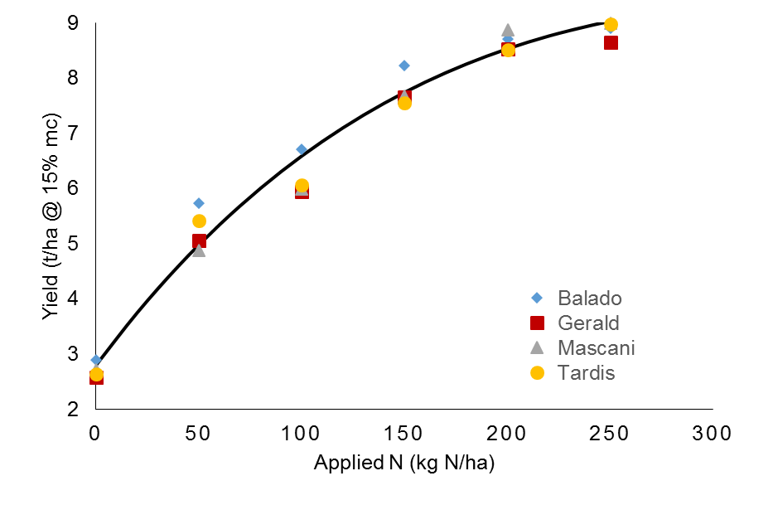
Figure 32. The yield (t/ha @ 15% mc) of the oat varieties Balado, Gerald, Mascani and Tardis at N rates of 0 to 250 kg N/ha. Line is N response curve fitted to all data (Variation Accounted For = 92.8%).

Oats in organic rotations

Weed competitive ability
Considering data from all years, early season weed cover had the greatest effect of grain yield (F_{7,44} = 122.81, P<0.001), when compared to total disease cover on the flag leaf (F_{1,44} = 18.84, P<0.001), and fertility level (F_{1,44} = 4.36, P=0.039). A significant variety by weed cover interaction (F_{7,44} = 4.34, P<0.001) indicated that this effect of weed competition on grain yield was dependant on the variety in that some varieties have a higher degree of weed tolerance than others.
The effect of LAI on weeds was found to be greatest when measured mid-season rather than early or late. Mid-season LAI was found to have a negative influence on percentage post-harvest weed cover (PHWC) in the husked oat trials (direct path -0.40, P<0.05) (Figure 33).

Figure 33. The relationship between mean values of mid-season Leaf Area Index (LAI) and percentage post-harvest weed cover for the five husked oat (×) and three naked oat varieties (○). n = 24 / variety.
Stem density (tillers per m²) had a negative influence on PHWC in both the husked and naked oat trials (direct path -0.44, P<0.001 and -0.38, P<0.001 respectively). The suppressive effect of stem density was greatest in 2010-11, the year with the greatest weed pressure (Figure 34). Although there was a strong effect of year on stem density (F_{3,30} = 111.89, P<0.001) the varietal effect (F_{7,30} = 10.24, P<0.001) was relatively consistent when considering the smaller variety by year interaction (F_{20,30} = 2.02, P=0.009).

Figure 34. Mean values of stem density and percentage post-harvest weed cover for all eight winter oat varieties in each of the four trial years. n = 6 / variety / year.

The effect of crop height on weeds was less consistent. Although height was not found to have a significant effect in path analysis across all years, height did correlate negatively with PHWC in the high weed pressure year; 2010-11 (r =0.82, P = 0.013) (Figure 35).

Figure 35. Mean values of crop height and percentage post-harvest weed cover in all eight varieties in each of the four trial years. n = 6 / variety / year.
There were significant varietal differences in the main weed suppressive traits measured (Table 23). Varietal differences in weed tolerance may be related to particular suppressive traits. For example crop height correlated positively with weed tolerance (r = 0.79, P=0.02) (Figure 36).

Table 23. Values of weed tolerance, mean values of weed suppressive traits for each variety. Values followed by the same letter do not significantly differ (P>0.05). n=24 for all varieties except Gerald where n=18. Values of weed tolerance represent a coefficient of yield loss with increased early weed cover.
Variety | Weed Tolerance | Mid-season LAI |  | Late-season LAI |  | Height (cm) |  | Stem density (stems m-²) |  | Establishment (plants m⁻²)
Balado | 0.00 | 4.78 | b | 5.19 | ab | 72.8 | e | 349.8 | c | 183.3 | bc
Mason | 0.64 | 4.57 | b | 5.36 | ab | 88.2 | d | 384.2 | bc | 169.3 | c
Bastion | 1.31 | 4.88 | ab | 5.58 | ab | 102.7 | b | 438.1 | ab | 191.4 | abc
Tardis | 1.39 | 4.81 | b | 5.01 | b | 97.0 | c | 409.8 | ab | 196.7 | abc
Mascani | 1.85 | 5.06 | ab | 5.49 | ab | 104.6 | b | 469.2 | a | 220.1 | a
Brochan | 1.87 | 5.59 | a | 5.77 | a | 95.1 | c | 416.9 | ab | 213.2 | ab
Racoon | 1.98 | 5.08 | ab | 5.31 | ab | 121.0 | a | 342.9 | c | 190.3 | abc
Gerald | 2.07 | 4.32 | b | 5.08 | b | 105.2 | b | 401.7 | bc | 202.3 | abc

Figure 36. The relationship between the mean crop height and the weed tolerance (the coefficient of yield loss due to increased weed competition) for each winter oat variety in a field trial at one site over four years.

Disease resistance
The trial season 2011-12 had the highest disease pressure and was the only year with significant levels of crown rust caused by Puccinia Coronata infection. Mildew, caused by Blumeria graminis, was not found at significant levels in any of the trial years. Significant differences in crown rust infection was found among varieties in 2011-12 (F_{7,8} = 3.99, P=0.002) (Figure 37). There was also 50.6% higher incidence of crown rust infection in plots with added fertility (F_{1,8} = 6.4, P=0.014).

Figure 37. Mean values of crown rust (Puccinia coronata) infection for eight winter oat varieties in 2011-12. n = 6. Varieties with the same letter do not significantly differ (P>0.05).

Leaf spot, caused by Pyrenophora avenae, was recorded in 2009-12 and 2010-11. Mascani was the only variety found to have significantly greater susceptibility to leaf spot (F_{7,10} = 7.29, P<0.001). The added fertility treatment was found to significantly reduce leaf spot infection by an average of 26.8% in 2010-11 (F_{1,10} = 6.50, P = 0.015).

Response to fertility and lodging
Although additional fertility had a significant effect on grain yield (F_{1,42} = 7.47, P=0.007), yields only increased by an average of 0.21t/ha over all trial years. The dwarf variety Mason had the greatest yield response to fertility whilst Mascani had a lower average yield with additional fertility (Figure 38).

Figure 38. Mean grain yields of eight winter oat varieties under two fertility levels in all four trial years.
Adding fertility increased straw height by an average of 3.2cm for all varieties (F_{7,42} = 35.75, P<0.001). There was no significant variety by fertility interaction suggesting that the effect of fertility on height was consistent for all varieties tested. Straw yield differed among varieties (F_{7,31} = 4.17, P<0.001) (Figure 39).and the effect of fertility neared significance (F_{1,31} = 3.08, P=0.08) with higher fertility plots averaging 0.39 t/ha more straw.

Figure 39. Mean straw yields of eight winter oat varieties in four trial years. Varieties with the same letter do not significantly differ (P>0.05). n = 24 / variety.
There were significant differences among varieties in lodging angle (F_{7,42} = 7.40, P<0.001) which was also 49.7% greater with additional fertility for all varieties (F_{7,142} = 15.53, P<0.001) No significant variety by fertility interaction suggests that all varieties increased lodging risk at higher fertility levels to a similar degree. Susceptibility to lodging increased dramatically in varieties with straw heights over one meter (Figure 40). Racoon had relatively low lodging risk when considering its tall height. This may be due to Racoon’s high mean straw density (22.07 mg/cm) which was significantly greater than all five other conventional height varieties (F_{7,24} = 40.55, P<0.001).

Figure 40. Mean straw height and mean lodging angle for eight winter oat varieties in all four trial years. n = 24.

Oat performance compared to wheat and barley.
Joint regression analysis highlights the value of oats as a more resilient crop in organic systems. Average husked oat yields were higher than wheat and barley varieties grown at the same site for the four trial years. Husked oat and wheat yields were comparable in the two high yielding years; however the yield advantage of husked oats was greater in the lower yielding years (Figure 41).

Figure 41. Joint regression analysis of mean yields of husked oats (5 varieties), naked oats (3 varieties), winter wheat (2 varieties) and winter barley (2 varieties) grown at the same site over four trial years.

Oat grain quality
There were significant differences in specific weight among varieties. (F_{7,61} = 370.80, P<0.001) (Figure 42). A near significant variety by fertility by year interaction (F_{20,61} = 1.65, P=0.052) suggests that additional fertility had an effect only on some varieties in some years. The specific weight of Balado was significantly reduced by an average of 1.71 kg/hl at the higher fertility level across all four trial years (F_{1,15} = 5.83, P=0.042). Gerald had 6.06 kg/hl lower specific weight at higher fertility in 2012-13 (F₁ = 80.99, P<0.001), Brochan had 1.95 kg/hl lower specific weight at higher fertility in 2011-12 (F_{1,2} = 5.70, P=0.033) and Mascani had 1.75kg/hl lower specific weight at higher fertility in 2010-11(F₁ = 4.59, P=0.012).

Figure 42. Mean values of specific weight for five husked and three naked winter oat varieties from four trial years. Varieties with the same letter do not significantly differ (P>0.05). n = 24 / variety.

Modelling the lodging process of oats
A specific objective of the QUOATS project was to develop an oat lodging model. To address the differences between oat and wheat crops a more complex generalised model of the lodging process has been developed and a paper describing this model is currently in press (Baker et al., 2014). This model builds on earlier lodging work on wheat but is different in a number ways. The major developments that have been made are as follows;
• The model now considers the dynamics of both isolated plants and a plant canopy and thus allows for the variation of plant and canopy morphology during the growing season to be taken into account, through a simple consideration of the effective intercrop stiffness (shoot natural frequency) and damping coefficient. Essentially this methodology assumes that for the non-interlocking canopy the wind loads plants individually, through penetration of gusts into the upper part of the canopy which load the upper area of each plant. For an interlocking canopy, the wind loads the canopy as a whole through the application of a shear stress on the top of the canopy.
• The model allows the bending moment along the height of the stem to be calculated and thus enables the possibility of stem lodging at any point up the stem to be investigated.
• The new model allows for a more complex wind field above the crop rather than the simple step wind input of the current model, specifically modelling the fluctuating flow that results in the flow / canopy structure interactions known as honami, and allows for wind fluctuation / crop interactions in a simple way.
• The new model is based upon a mechanical model of the wind / plant /soil interactions that captures most of the important physical processes. It can be applied to clarify the nature of the lodging process and calculate lodging risk through a simple graphical formulation. In particular simple formulae are defined for lodging risk that are a function of a small number of dimensionless variables with identified physical meanings (Figure 43). This shows the regions of lodging in the hourly mean wind speed and daily rainfall plane, and also the assumed probability distribution of these parameters. The overall risk can be determined by integrating the probability distribution over the regions of the wind speed / rainfall plane where lodging occurs. The provisional nature of these results must be borne in mind, but they do illustrate the potential of the model, which can be used to investigate how lodging occurs for a variety of plant types and soil and weather conditions.
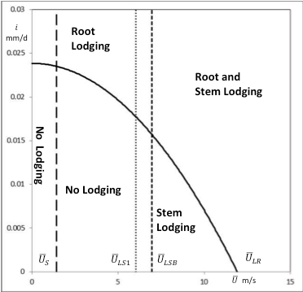
Figure 43. Lodging regions in wind speed / rainfall plane. Need to define symbols in legend.

Sensitivity analysis
A sensitivity analysis for the lodging associated plant characteristics has been performed. The variety ranges for each plant characteristic were taken from measurements taken on a field experiment carried out in 2010-11 in Herefordshire. The results show that the plant characteristics with the greatest effect on the wind speed required to cause lodging and on overall lodging risk are the plant height, spread of the root plate, diameter of the stem, material strength of the stem wall and overall strength of the stem. Traditionally plant breeders have focussed on improving lodging risk by shortening the plant, but this analysis shows that improving the root plate spread and stem strength would be equally effective ways of increasing lodging resistance.
Investigations with the lodging model show that plant breeders have the potential to create very large changes in lodging risk by combining traits. For example, a crop with the minimum plant character values for lodging resistance is estimated to have a lodging probability of 0.103, which rises to 0.252 for a crop with the maximum plant character values. This range in lodging risk is similar to variation in lodging risk that might be expected from quite a large variation in rainfall and wind speed.
One of the potentially important model parameters is the area of plant which is impacted upon by the wind. This is known as the drag force or shear force area, and is the surface area of the plant multiplied by the drag coefficient. Progress was made with specifying this parameter using the wind tunnel tests, but it is not well understood for field grown plants in natural conditions. Doubling the shear force area from 10 cm² to 20 cm² has a large effect on the probability of lodging, so it is clear that further research must prioritise understanding this.

Discussion
Oats (Avena sativa L.) are regarded as a valuable break crop in cereal rotations and with a grain composition that makes the oat a healthy and nutritious cereal for human consumption but also as a high quality animal feed and with a range of unique characteristics that make it a source of high value industrial chemicals. Despite these positive attributes it was recognised that there is a need to improve some of the key traits that will increase the production and utilisation of oats whilst also mitigating climate and environmental change via reduced agricultural inputs. The QUOATS project aimed to address these specific issues by developing and applying state-of-the-art genomic and metabolomic tools for targeted genetic improvement of the key traits that impact on the sustainable production of oats and enhance the utilisation and exploitation of the grain. The project brought together a group of academic partners with expertise in oat genomics and plant breeding, metabolomics analysis, ruminant nutrition and plant pathology and agronomy complemented by industry partners from across the oat supply chain. The collaboration between academic and industry partners was integral to meeting the project objectives and validating the success of the IBERS oat breeding programmes in delivering oat varieties that meet end user requirements.

A central objective of the project was the development of the appropriate genomic tools and resources that would underpin the development of innovative oat varieties and ensure that oat breeding programme was in a position to benefit from developments in molecular approaches to genetic improvement of crops. Traditional plant breeding programs rely mainly on the phenotypes of advanced material being evaluated in several environments; selection and recombination are based solely on the resulting data plus pedigree information, when available. In this project we have developed molecular approaches combined with high throughput phenotyping to both enhance genetic gain and to understand the genetic basis of key traits in oats. Molecular diagnostic markers have been developed for traits controlled by major genes such as disease resistance, height, flowering time, grain lignin and β-glucan The IBERS oat breeding programmes is used to validate the selection of specific traits. In the process we have developed new breeding lines and genetic resources with enhanced expression of traits of interest. Marker Assisted Selection has been used in early generations of the breeding programme to ensure incorporation of specific desirable alleles from non-UK to UK adapted varieties. This approach has been very successful for the introgression of traits controlled by one or a few genes of large effect and the challenge for the future is to expand this into more complex traits governed by many genes, each with a small effect. This will be enabled by the development of genomic tools in this project. In addition, oat lines have been developed that differ for the presence/absence of chromosomal regions (QTL) for key traits associated with grain quality and yield i.e. height, flowering time, kernel content and grain size. Tests for the effect of these QTL are ideally conducted in near-isogenic lines (NILs) which are effectively the same cultivar but differ only in the presence or absence of the particular QTL being studied and such QTL-NILs have been developed in the QUOATS project. Future work will use this material to provide knowledge as to how these QTL work at a physiological level and provide valuable information that can be used by oat breeders for enhancing grain quality and yield in new varieties.

Milling quality
A key objective of the project was to improve our understanding of the factors that influence the milling quality of oats and exploit modern plant breeding approaches combined with high throughput phenotyping to develop improved oat varieties that better meet the needs of the milling industry. During the project considerable progress was made in the development of molecular markers for a range of agronomic and grain quality traits that are now integrated into the selection of material within the IBERS oat breeding programmes. This has been complemented by developments in the application of NIRS for several grain quality traits as well as the use of image analysis to quantify the relationship between grain shape and milling quality. This approach will continue to develop in future research.
The participation of the milling industry was an integral part of the project, providing feedback on the milling quality of different oat lines and varieties as well as validating the methodologies being applied and carrying out large scale pilot milling. This involved not only the development and application of molecular marker technology for key traits as well as the analysis of the factors impacting on quality, both genetic and environmental.
Central to this part of the project was a comprehensive set of field trials in which four widely used winter oat varieties were grown in over 30 field trials across the UK, in different management systems and environments. Grain from these field trials was used to analyse the G x E effects that underpin variation in grain quality and composition as well as mycotoxin.

Mycotoxin analysis
Analysis of genotypes from Workpackage X has allowed the range of resistance to HT2+T2 producing Fusarium species to be quantified and compared to control varieties. Analysis of the genotype x environment sensitivity of a sub-set of these samples has identified that this phenotype is stable within the genotypes screened and therefore the resistance demonstrated within field experiments will be representative of the resistance observed across various environments and over time. It should be noted that this analysis was completed on the log10 of the HT2+T2 concentration and therefore the range between susceptible and resistant varieties will increase as the mycotoxin concentration increases but the rankings will remain the same.
New winter varieties introduced during the QUOATS project are at the high end of the range of resistance currently available within UK varieties.
The nitrogen trials identified that the additional N applied within the organic system as 60 kg N of poultry manure pellets did not have a significant impact on HT2+T2 concentration whereas the higher N rate of application of RB209 (140 kg/ha) in the conventional system resulted in a significant reduction in HT2+T2. Reasons could be due to a thicker canopy resulting in a different micro-climate or a dilution effect of heavier grains. The significant differences observed between varieties in the nitrogen trials were consistent with those previously reported (Edwards 2012). Results from the organic system were consistently low which fits with previous results that organic systems have significantly lower HT2+T2 compared to conventional systems (Edwards 2009). This is likely to be a result of the long rotations with low cereal intensity used within organic systems.

Grain composition and its impact on shelf life
Analysis of grain composition was undertaken to obtain new knowledge on the impact of genotype and environment on the oat phytochemical composition and the consequences of the levels of key compounds on the shelf-life and organoleptic properties of oat-based food products. Determination of key compounds for a better shelf-life of oat-based food products is promising and further trials with several oat cultivars in oat-based products would help define and restrict the number of volatiles associated with the perception of rancidity. The genetic basis of these compounds was introduced through the QTL analysis performed on the selected mapping population; however, further work is necessary to consolidate the present findings. The effect of the environment on the levels of metabolites present in four oat cultivars was of great importance in this cereal. The health properties of certain compounds (including avenanthramides and β-glucan) make it necessary to understand the exact effect of growing parameters on their levels in oat. Further studies including several organic farms with detailed knowledge on the soil, climate, previous crops, etc. would allow for a better understanding of the impact of this type of farming on the levels of avenanthramides in oat. Moreover, the public concern about the presence of pesticides and related health issues in crops emphasize the need for more understanding over farming systems employed to grow oat.

Improved oats for livestock feed
Oats are recognised as a high quality cereal that is suitable for animal feed and previous work (HGCA OatLINK report) has focused on the breeding of oat varieties with improved feed value. This previous work focused on the selection for high oil composition (and high ME), primarily in naked oats for the poultry sector (Macleod et al., 2010). The Quoats project sought to build on that research and breed husked oat varieties with a high oil content and a low lignin husk enabling the oats to be directly fed to ruminants. Analysis of these low lignin husked lines showed that the lignin content was 1.5% in comparison with the 6% typically found in oat husks. Selection for low lignin husk was aided by the development of molecular markers (in WP1) for this trait that would ultimately be used to replace the phloroglucinol staining.
Consequently breeding husked oats for reduced lignin concentrations is a major objective of the IBERS oat breeding programme for the future. the programme will select for increased FA concentrations to produce more digestible oat with a high oil content offers potential as a ruminant dietary ingredient that could help mitigate methane emissions. Analysis of the oat grains showed that approximately 95% of the fatty acids in oat grains comprised palmitic acid, oleic acid and linoleic acid. The addition of supplementary fat to the diet of ruminants has been reported to effectively reduce methane production.
Breeding husked oats for reduced lignin concentrations and increased FA concentrations to produce more digestible oat with a high oil content offers potential as a ruminant dietary ingredient that could help mitigate methane emissions. Improved oat lines that combined high oil with a low lignin husk were developed within the project and the potential of these lines to reduce methane emissions by ruminants was demonstrated in vitro although not in vivo studies with sheep or dairy cows. A recent review has shown that supplementary fat, given to ruminants inhibits methane production, with medium-chain fatty acids (lauric, myristic acid) as well as poly-unsaturated fatty acids (linoleic and especially linolenic acid) having a significant effect (Rasmussen and Harrison, 2011) confirming the outcomes of the in vitro studies. In this project there were resources to complete a single study on sheep and dairy cows and neither of those studies showed a positive benefit of the high oil oats in reducing methane emissions. Conflicting findings between individual published trials have been attributed to differences in experimental design, the composition of the basic feeds, the fat sources used, and the number of animals involved (Rasmussen and Harrison, 2011). Future studies in which the experimental protocol is modified may give different results.
However the dairy feeding trials concluded that oats could be used to substitute wheat in the concentrate portion of dairy cow diets without loss in productivity which if developed further would provide a significant uplift in the use of oats in the ruminant sector. This is an important finding and information on the value of oats in ruminant diets urgently needs to be disseminated to the animal feed sector if the value of oats as a high quality ruminant feed is to be realised. An economic analysis as well as the LCA of these systems is currently being undertaken. An additional finding from the research was that the milk fat concentrations and yields were lower from animals offered diet C, which suggests an influence of the concentrate premix fed to these animals. Finally, the fatty acid profile of the milk produced by cows offered the two oat-based diets might be considered to be generally healthier than that produced by cows when offered the wheat-based diet. Further research in this area is necessary to build on these results and to consider how oats with different compositions will impact on milk quality.

Agronomy of oats in conventional and organic systems
Although oats are regarded as a low input cereal, as in other cereals nitrogen is a major input. A specific objective of the QUOATS project was to consider how plant breeding can be used to improve the sustainability of the oat crop through improved understanding of the nitrogen use efficiency of different oat lines and varieties, particularly in relation to the genes controlling the uptake (NiUpE) and utilisation (NiUtE). The response of oat varieties to N was studied in flowing solution culture, and in conventional as well as organic systems with the specific objective of identifying and quantifying variation in nitrogen use efficiency. Analysis of the N uptake efficiency and N utilisation efficiency during early growth (in flowing solution culture) and in the field were quantified. Of the varieties studied in conventional systems, Balado had the high potential yield due to high numbers of grains per panicle compared to the other varieties tested. Lower yields for Gerald and Mascani at high N rates and seed rates were associated with lodging due to their height. This also meant that more N was taken up in the straw reducing their NUE and sometimes NUpE. Differences in yield from seed rate treatments were due to differences in shoot numbers, although at high seed rates there were also fewer grains per panicle. Although the response of oats to N was only carried out in 2014, a very high yield potential season it showed that yields of all varieties continued to increase to the highest N rates applied, beyond the RB209 Recommended level. However, it was clear that the amount of N recommended in the fertiliser manual was significantly less than was optimal. Further N response experiments are required over a range of sites, seasons and varieties in order to understand the optimum N rates of oats.
One of the limiting factors in oat production is lodging which early in grain filling has been reported to reduce yields by 37%. Attempts to reduce lodging by introducing the dwarfing gene Dw-6 have made some progress through the breeding of shorter, stiffer strawed varieties however plant growth regulators are still routinely applied to oats. Further improved lodging resistance would reduce the need for application of PGR’s, increasing the sustainability of the oat crop. A comprehensive lodging model developed for wheat (Berry et al., 2004) was used as a basis for developing an oat lodging model, using a combination of filed measurements and wind tunnel studies to identify the key parameters involved in oat lodging. This confirmed the value of the oat lodging model as a valuable tool for plant breeders to define breeding targets for this important trait.
This study reinforced the suitability of oats for organic rotations. It was shown that competition from weeds is one of the biggest factors limiting yield in organic systems. Genotypic differences in weed tolerance were found among the varieties trialled and taller varieties tended to have a greater weed tolerance. Of the varieties studied in detail, Mascani had the highest average yield over the four trial years but had the smallest yield response to added fertility. This may highlight Mascani as a variety with low nitrogen requirements suitable for low input or organic systems. Oats are generally lower yielding than wheat in conventional systems. However, winter husked oat yields were found to be higher yielding and more stable than winter wheat or barley when grown under organic conditions in this study. The advantage of growing oats is often greater in lower yielding environments and demonstrates the greater reliability of oats in the more marginal and variable conditions typical of organic systems. This study confirms oats are a reliable and popular low input crop amongst organic farmers where they are generally grown as a second or third cereal in the rotation where there is typically lower N availability and greater weed pressure (Taylor and Cormack, 2002). Further research is needed to identify and develop the potential of the oat crop for enhanced weed competitive ability. This may include selection of breeding material with enhanced weed suppressive traits and weed tolerance and testing material under high weed pressure. A better understanding of the effects of genotype, environment and management under organic systems on oat grain milling qualities would facilitate a more stable oat market and further support the oat crop amongst growers in the organic sector.
Varietal differences in disease resistance were tested in 2011-12 as there was particularly high disease incidence in this season. Differences in crown rust (Pucinia coronata) resistance found in these trials are in line with current disease resistance values for varieties described on the HGCA recommended list (www.hgca.com/varieties). Additional fertility was found to significantly increase susceptibility to crown rust and is in line with results from studies of rust pathogens on wheat (Danial and Parlevliet, (1995). This may suggest that the negative effects of crown rust may be less severe in organic systems where available nitrogen is typically lower. Mascani was the only variety found to be more susceptible to leaf spot (Pyrenophora avenae) which was also lower with added fertility. However, leaf spot is not thought to be such a problematic disease as crown rust in terms of associated yield loss.

Conclusions
- This project has practically demonstrated the developments in genomics technologies over the last 5 years, how this can be applied to oats and utilised within oat breeding programmes. It has also developed the underpinning molecular marker technology which when allied with high throughput phenotyping can advance oat breeding and enable the effective and efficient selection of key agronomic traits as well as grain composition traits in parallel with other high throughput approaches such as NIRS and MARVIN.
- The project has shown the potential for improved milling quality and how new approached to analysis of grain size and shape (MARVIN) have value as means of quantifying the milling quality of varieties. This project has highlighted the rapid developments in genomics technologies over the last 5 years and how this knowledge can be applied to oats and utilised within oat breeding programmes.
- It has also developed the underpinning molecular marker technology which when allied with high throughput phenotyping can advance oat breeding and enable the effective and efficient selection of key agronomic traits as well as grain composition traits in parallel with other high throughput approaches such as NIRS and MARVIN.
- It has shown the potential for improved milling quality and value of new approaches to the analysis of grain size and shape as means of quantifying the milling quality of varieties. Development of high-throughput methods for grain quality will help better characterise new material coming through the breeding program and improve overall oat quality aided by ring testing with commercial partners and pilot milling of individual varieties.
- Breeding husked oats for reduced lignin concentrations offers potential as a ruminant dietary ingredient that could help mitigate methane emissions.
- Molecular markers for lignin content, developed within WP1 were used to develop improved oat lines that combined high oil with a low lignin husk.
- Dairy feeding trials concluded that oats could be used to substitute wheat in the concentrate portion of dairy cow diets without loss in productivity.
- The fatty acid profile of the milk produced by cows offered the two oat-based diets might be considered to be generally healthier than that produced by cows when offered the wheat-based diet.
- The response of oat varieties to N was studied in flowing solution culture, and in conventional as well as organic systems. Of the varieties studied in conventional systems, Balado had the high potential yield due to high numbers of grains per panicle compared to the other varieties tested. Lower yields for Gerald and Mascani at high N rates and seed rates were associated with lodging due to their height. This also meant that more N was taken up in the straw reducing their NUE and sometimes NUpE.
- Although the response of oats to N was only carried out in 2014, it suggested that the amount of N recommended in the fertiliser manual was significantly less than was optimal. Further N response experiments are required over a range of sites, seasons and varieties in order to understand the optimum N rates of oats.
- This study reinforced the suitability of oats for organic rotations.
- Competition from weeds is one of the biggest factors limiting yield in organic systems. Genotypic differences in weed tolerance were found among the varieties trialled and taller varieties tended to have a greater weed tolerance. Mascani had the highest average yield over the four trial years but had the smallest yield response to added fertility and could be regarded as a variety with low nitrogen requirements suitable for low input or organic systems.
- Winter husked oat yields were found to be higher and more stable than winter wheat or barley when grown under organic conditions. The advantage of growing oats is often greater in lower yielding environments and demonstrates the greater reliability of oats in the more marginal and variable conditions typical of organic systems.

Output and dissemination Record

Publications
Boyle, R., Corke, F and Howarth, C. (2014). Image based estimation of oat panicle development using local patterns. Functional plant biology (in press).
Cognat, C., Shepherd, T., Verrall, S.R., Stewart, D. (2012) Comparison of two headspace sampling techniques for the analysis of off-flavour volatiles from oat based products. Food Chemistry, 134, 1592-1600.
Cognat, C., Shepherd, T., Verrall, S.R., Stewart, D. (2014) Relationship between volatile profile and sensory development of an oat-based biscuit. Food Chemistry, 160, 72-81
Cowan, A.A., Marshall, A.H. and MacDuff, J.H (2010). Nitrogen use efficiency of selected winter oat lines in flowing solution culture. Association of Applied Biologists.xxxxxxx.
Decker EA, Rose DJ and Stewart D (2014). Processing of oats and the impact of processing operations on nutrition and health benefits. British Journal of Nutrition, 112, S58-S64.
Döring T and Pearce H (2012. Relationships between crop height, yield and lodging in organic oats. Proceedings of the 12th ESA Congress, Helsiinki, Finland, 528-529.
Döring T, Winkler L and Fradgley N (2012). Oat variety characteristics for suppressing weeds. Organic Research Centre Bulletin, Winter 2012 (111): 6-7
Gracia Montilla-Gracia Montilla-Bascón, Javier Sánchez-Martín, Nicolas Rispail, Diego Rubiales, Luis AJ Mur, Tim Langdon, Irene Griffiths, Catherine Howarth and Elena Prats. Genetic diversity and population structure among oat cultivars and landraces Plant Molecular Biology Reporter (accepted)
Marshall, A. H. , Edwards, S., Griffiths, I., Howarth, C. J., Langdon, T., White E. (2013). Crops that feed the world 9. Oats- a cereal crop for human and livestock feed with industrial application. Food Security, 5 (1), 13-33.
Moorby, J. M., Cowan, A. A., Leemans, D. K., Marshall, A. H. (2012). Methane production from novel oat varieties measured by gas production 2012 ADSA-AMPA-ASAS-CSAS-WSASAS Joint Annual Meeting, 15-19 July, Phoenix, Arizona.
Moorby J M, Cowan A A and Marshall A H (2012). Variation in chemical composition among breeding lines of novel oat varieties as ruminant feeds . ADSA-AMPA-ASAS-CSAS-WSASAS Joint Annual Meeting, 15-19 July, Phoenix, Arizona.
Oliver, R.E., Tinker, N.A., Chao, S., Lazo, G.R., Jellen, E.N., Carson, M.L., Rhines, H.W., Bonman, J.M., Lutz, J.D., Shackleford, I., Korol, A.B., Obert, D.E., Wight, C.P., Gardner, K., Hattori, J,, Beattie, A.D., Bjørnstad, A., Jannink, J.L., Brown-Guedira, G.L., Anderson, J., Mitchell Fetch, J., Harrison, S.A., Howarth, C.J., Ibrahim, A., Kaeppler, H., Kolb, F.L., McMullen, M.S., Murphy, J.P., Ohm, H.W., Pixley, K.V., Rossnagel, B.G., Yan, W., Miclaus, K.J., Hiller, J., Maughan, P.J., Redman, R., Islamovic, Jackson, E.W. (2013) SNP discovery and chromosome anchoring provide the first physically anchored hexaploid oat map and reveal synteny with model species. PLoS ONE 8(3): e58068.doi:10.1371/journal. phone.0058068
Pearce H and Döring T (2010). There is nothing like an oat The Organic Research Centre Bulletin 111.
Stewart D and McDougall G (2014). Oat agriculture, cultivation and breeding targets: implications for human nutrition and health. British Journal of Nutrition, 112, S50-S57.
Stewart D, Kennedy J and Pavel P (2014). Beyond nutrition and agriculture policy: collaborating for a food policy. British Journal of Nutrition, 112, S65-S74.
Valentine, J., Cowan, A. A., McDevitt, J. M., Marshall, A. H. (2010) Oat breeding. In Oats: Chemistry and Technology, Woods, P. J.Webster, F. H.
Wychowaniec J, Griffiths I, Mughal and Gay A (2013). Compaction of cereal grain. Philosophical magazine 93, 31-33, 4151-4158

Variety development
Table 1 Summary of IBERS bred winter and spring oat lines currently in National and Recommended List trials
Stage | Name | Code | Type | Comments
RL 2013 | Rhapsody | 02-45Cn5 | winter | High yielding conventional height, good disease resistance
RL 2 | Elgar | 04-66ACn7 | winter | High yielding conventional height
RL 2 | Selwyn | 03-37Cn7 | winter | High yielding conventional height
RL 1 | Fergus | 05-82ACn19 | winter | High yielding short conventional height
RL 1 | Maestro | 04AW36Cn2 | winter | Very high yielding, semi dwarf height
NL 2 |  | 05-63Cn9 | winter | Very high yielding conventional height
NL 2 |  | 04-01ACn1 | winter | High yielding semi dwarf height
NL 1 |  | 05-86Cn26 | winter | High yielding conventional height
NL 1 |  | 06-01Cn138 | winter | High yielding conventional height
RL 2013 | Conway | 14340Cn | spring | High yielding conventional height, good disease resistance
RL 2 | Glamis | 14498Cn2 | spring | High yielding conventional height, good disease resistance
NL 2 |  | 14518Cn2/1 | spring | Conventional height, high beta glucan line
NL 1 |  | 14799Cn16/1 | spring | High yielding conventional height
NL 1 |  | 14789Cn2 | spring | High yielding conventional height

 | Table Progress of new winter oat varieties 2008- 2014
 |  |  | 2008 | 2009 | 2010 | 2011 | 2012 | 2013 | 2014
 | Added to NL |  | Balado | Bastion | Mason | Rhapsody | Elgar | Fergus
 |  |  |  |  |  | Beacon | Selwyn | Maestro
 |  |  |  |  |  | Conway | Glamis
 | Added to RL |  |  |  | Balado |  |  | Rhapsody
 |  |  |  |  | Fusion |  |  | Beacon
 |  |  |  |  |  |  |  | Conway
Code
 |  |  | 2008 | 2009 | 2010 | 2011 | 2012 | 2013 | 2014
81-26Cn | Gerald |  | RL | RL | RL | RL | RL | RL | RL
89-26ACn6/1 | Kingfisher |  | NL | NL | NL | NL | NL | NL
87-42CnI/2/2/1 | Millennium |  | NL | NL | NL | NL | NL | NL
89-226Cn1/2 | Grafton |  | RL | RL | RL | RL | RL | RL | RL
93 – 85ACn5/2/2 | Hendon | dwarf | RL | RL | RL | RL | RL | NL
93 – 122Cn5/1/2 | Expression |  | RL | RL | NL | NL | NL | NL
95 – 56ACn3 | Mascani |  | RL | RL | RL | RL | RL | RL | RL
240Cn3/1/1 | Racoon |  | NL | NL | NL | NL | NL | NL
96 – 21Cn7 | Brochan |  | RL | RL | RL | RL | RL | NL
96 – 41Cn3 | Tardis |  | RL | RL | RL | RL | RL | RL
98-28Cn | Balado | dwarf | RL1 | RL2 | RL | RL | RL | RL | RL
98-82Cn | Fusion | dwarf | RL1 | RL2 | RL | RL | RL | RL | RL
00 – 114Cn5 | Bastion |  | NL2 | RL1 | RL2 | NL | NL | NL
00-186ACn13 |  |  | NL1 | W
01-03ACn4 | Raglan |  | NL1 | NL2 | W
01 – 145Cn1/2 | Mason |  |  | NL1 | NL2 | RL1 | RL2 | NL
02 – 45Cn1 |  |  |  |  | NL1 | W
02 – 45Cn5 | Rhapsody |  |  |  | NL1 | NL2 | RL1 | RL2 | RL
03-90ACN4 | Beacon |  |  |  | NL1 | NL2 | RL1 | RL2 | RL
04-66ACn7 | Elgar |  |  |  |  | NL1 | NL2 | RL1 | RL2
03-37Cn7 | Selwyn |  |  |  |  | NL1 | NL2 | RL1 | RL2
00-61Cn3 | Solution |  |  |  |  | NL1 | NL2 | W
05-82ACn19 | Fergus |  |  |  |  |  | NL1 | NL2 | RL1
04AW36Cn2 | Maestro |  |  |  |  |  | NL1 | NL2 | RL1
03-36Cn6 |  |  |  |  |  |  | NL1 | W
04-01ACn1 |  |  |  |  |  |  |  | NL1 | NL2
05-63Cn9 |  |  |  |  |  |  |  | NL1 | NL2
04-204Cn7 |  |  |  |  |  |  |  | NL1 | NL2
05 – 86Cn26 |  |  |  |  |  |  |  |  | NL1
06 – 1Cn138 |  |  |  |  |  |  |  |  | NL1
06-22Cn121 |  |  |  |  |  |  |  |  | NL-1
06-28Cn12 |  |  |  |  |  |  |  |  | NL-1
06-6Cn130 |  |  |  |  |  |  |  |  | NL-1
07-156Cn1 |  |  |  |  |  |  |  |  | NL-1
07-3Cn1 |  |  |  |  |  |  |  |  | NL-1
08-82ACn4 |  |  |  |  |  |  |  |  | NL-1
08-21ACn1 |  |  |  |  |  |  |  |  | NL-1
08-40ACn9 |  |  |  |  |  |  |  |  | NL-1

Table Progress of new spring varieties 2008- 2014
 |  | 2008 | 2009 | 2010 | 2011 | 2012 | 2013 | 2014
Added to NL |  |  |  |  | Conway | Glamis
Added to RL |  |  |  |  |  |  | Conway
Spring oats
Bullion |  | NL | NL | NL | NL | NL | NL
Banquo |  | NL | NL | NL | NL | NL | NL
Zuton |  | NL | NL | NL | NL | NL | NL
Lennon |  | NL | NL | NL | NL | NL | NL
Conway |  |  |  | NL1 | NL2 | RL1 | RL2
Glamis |  |  |  |  | NL1 | NL2 | RL1
14675Cn |  |  |  |  |  | NL1 | W
14518Cn |  |  |  |  |  |  | NL1
key
NL | on national list
RL | on recommended list
RLT | in recommended list trial
NL2 | in national list trial year 2
NL1 | in national list trial year1
W | withdrawn from UK NL PBR
varieties in italics are naked

Technology Interaction
QUOATS Technology Interaction Activity Log (2009)
Event (and brief details): | Date: | Organiser (and participants):
Free range conference, Stoneleigh Park  (various discussions re naked oats) | 3 December | Poultry Xperience

QUOATS Technology Interaction Activity Log (2010)

Event (and brief details): | Date: | Organiser (and participants):
Annual Organic Conference, Harper Adams Univ. Col.  ( Circulated a flyer asking for interest in growing organic naked oats) | 7/8 January | Poultry Xperience
Approached 7 feed mills producing organic feed re the possibility of getting naked oats grown under contract | Various | Poultry Xperience
Visited GLW Feeds to outline potential of naked oats for poultry diets | 19 January | Poultry Xperience
‘Oat breeding’ presentation to Nuffield scholars (visit to IBERS) | March | IBERS
‘Progress in Oats’ presentation at the AHDB-HGCA monitoring meeting | March | IBERS, AHDB-HGCA
Papers presented at annual BBSRC Monogram Network Meeting; (1) Harnessing new technologies for sustainable oat production and utilisation, and (2) Nitrogen use efficiency in winter oats | March | IBERS
Press release issued and appeared in numerous publications, a sample of which is shown below:  - BBC Mid Wales News  - Welsh Icons  - The Scotsman  - FoodBev  - eGov monitor  - sopo  - Scottish Herald  - Press & Journal  - Courier & Advertiser  - Scottish Farmer | April | IBERS, all partners
‘Oat breeding at IBERS’ presentation to Canadian organic grain producers | April | IBERS
Meet N. Gossett, Norton Organics, to discuss the potential of naked oats in organic diets | 5 May | Poultry Xperience
Pig and Poultry Fair, Stoneleigh Park  ( discussed potential of naked oats with all the feed companies having stands at the event) | 11/12 May | Poultry Xperience
Visit to Masstock trial site (herbicide trial) | June | Du Pont
Cereals Event | June | Senova, all partners
Wakelyns Agroforestry Open Day (tour of plots and demonstration of varieties) | June | ORC, IBERS
Royal Welsh Show, Builth Wells | July | IBERS
QUOATS project featured in Senova booklet | July | Senova
QUOATS featured in Just Oats publication | July | Senova
‘Cereals in Practice’ Dundee | July | SCRI
Presented a paper to the management of GBSeeds and Masstock on the potential of naked oats in poultry diets | 11 August | Poultry Xperience
‘Oat Breeding’ presentation to Indian economics minister, Indian High Commission | September | IBERS
Papers presented at the European Oat Conference, Sweden:  (1) Progress in breeding oats as a high quality animal feed with environmental benefits,  (2) Harnessing new technologies for sustainable oat production and utilisation,  (3) Extinction or evolution,  (4) Fusarium mycotoxins in UK oat production | September | IBERS, Senova, Oat Services,  Harper Adams
Article in ORC Bulletin, Issue 102 | October | ORC
Pearce H., Döring T., 2010 There is nothing like an oat The Organic Research Centre Bulletin 111 | 2010 | ORC

QUOATS Technology Interaction Activity Log (2011)
Event (and brief details): | Date: | Organiser (and participants):
Paper entitled The trouble with oats…2 presented to Organic Producer Conference | January | Oat Services
Wynstay Farmers discussion on the potential of naked oats as an arable crop and in poultry diets | January | Poultry Xperience
Invited speaker at Scottish Agronomy Technical meeting, Perth | February | Harper Adams
Production of article on the use of naked oats in turkey diets in association with GLW Feeds | March | Poultry Xperience
OCW discussion group meeting – Pembrokeshire ( growing naked oats on farm) | May | IBERS (GDC)
OCW Discussion group meeting-Brecon (rotation planning – cereals in the rotation) | May | IBERS (GDC)
Project presented as part of ADAS Rosemaund Open Day | June | ADAS and IBERS
Featured at HCC/Farming Connect Development Farm event hosted by the Welsh Grassland Management competition winner Anglesey Irene Griffiths & Heather McCalman | June | IBERS (GDC)
Poster at Cereals 2011 | June | AHDB-HGCA
Platform speaker at the 33rd Mycotoxin Workshop, Germany | June | Harper Adams
Cereals Event | July | All
Cereals in Practice (James Hutton Institute) – Sandy Cowan presenting | July | JHI and IBERS
Presentation to EBLEX Progressive Farmers Group | July | IBERS
Presentation to Waitrose Primary Producers Group | July | IBERS
Royal Welsh Show | July | IBERS
Invited speaker at the 5th European Oat Conference, Ystad, Sweden (Simon Edwards) | September | Harper Adams
Invited speaker at the Nordic Oat Days 2011, Helsinki, Finland (Simon Edwards) | October | Harper Adams

QUOATS Technology Interaction Activity Log (2012)

Event (and brief details): | Date: | Organiser (and participants):
Invited speaker at European Fusarium Modelling Workshop, Piacenza, Italy | February | Harper Adams
Invited speaker at EC Agricultural Contaminants Working Group Fusarium Toxin Forum, Brussels | February | Harper Adams
Presentation to Monogram Workshop, Aberystwyth | March | IBERS
Invited speaker at the Romer Seminar "Mycotoxin risks in the supply chain", Runcorn | April | Harper Adams
Article for GLW Feeds Ltd Turkey Newsletter extolling the virtues of naked oats in turkey feed | May | Poultry Xperience
Invited speaker at the 31st Nordic Cereal Congress, Gothenborg, Sweden | May | Harper Adams
Article in Farmers Weekly – Growers urged to look at oats as a new crop | May | IBERS
Invited speaker at the FSA stakeholder meeting "Fusarium Toxins in Cereals", London | May | Harper Adams
Discussion with Mr Jim Paice, MP at Cereals Event | June | AHDB-HGCA
Promotion at Cereals Event | June | Senova, AHDB-HGCA and IBERS
Demonstrated QUOATS project for HGCA at CEREALS 2012, Lincolnshire | June | Harper Adams
Papers presented at the International Oat Conference, Beijing:  C. Howarth Genetic analysis of β-glucan content in diploid and hexaploid oat  A Cowan Variation in fatty acid composition within breeding lines of novel oat varieties as potential ruminant feeds  E. White Comparative physiology of oats, wheat and barley in the UK with particular emphasis on winter oat cultivars  Posters presented at the International Oat Conference, Beijing:  Alexander Cowan, Chris Green, Catherine Howarth, Athole Marshall, Brian Middleton, John Valentine, Ed Wadsworth - Development and Use of Naked Oats in the United Kingdom  Irene Griffiths, Alexander Cowan, Athole Marshall, Catherine Howarth - Comparison of Nitrogen Use Efficiency in Husked and Naked Oats  Karen Pearson, Irene Griffiths, Tim Langdon, Alexander Cowan, Catherine Howarth - QTL Associated with Powdery Mildew Resistance in Avena sativa  Irene Griffiths, Alexander Cowan, Alan Gay, Catherine Howarth - Why Size Matters: Grain Shape Analysis in Avena sativa L. | June | IBERS
Promotion of project at The Royal Welsh Show | July | IBERS
Posters at Joint Meeting of the ADSA / ASAS in Phoenix, Arizona | July | IBERS
Döring TF, Pearce H. 2012. Relationships between crop height, yield and lodging in organic oats. 12th Congress of the European Society for Agronomy Helsinki, Finland, 20-24 | August | ORC
Poster / abstract presented to the European Society of Agronomists 2012, Helsinki | August | ORC
Invited speaker at Nabim Technical Committee Meeting, London | September | Harper Adams
Invited speaker at Cereal Industry Mycotoxin Strategy meeting, Nabim, London | September | Harper Adams
Presentation to Swedish farmers; including discussion on oats and the QUOATS project | September | IBERS
Project featured at the Livestock Event, NEC Birmingham | September | IBERS
‘Grain shape analysis in Avena sativa L’ poster presented at Image Analysis Workshop, Nottingham | September | IBERS
‘Just keep tapping: an investigation into grain packing’ poster presented at International Workshop on Packing Problems, Dublin | September | IBERS
Invited speaker at BASF Technical Training Day, Cheadle Hulme | October | Harper Adams
Winter Fair, Builth Wells - BOBL Oats and QUOATS featured projects; Farmer factsheet on naked oats and poultry feeding produced | November | IBERS
Döring T, Winkler L, Fradgley N. 2012. Oat variety characteristics for suppressing weeds. The Organic Research Centre Bulletin 111 (in press) | November | ORC
Poster presentation (T. Stancic) at the World Mycotoxin Forum and IUPAC International Symposium on Mycotoxins and Phycotoxins, Rotterdam, The Netherlands | November | Harper Adams
Invited speaker (S Edwards) and Poster presentation (T Stancic) at the Nordic and Baltic Fusarium Symposium, Uppsala, Sweden | November | Harper Adams
Bayer Technical Training Day, Peterborough | November | Harper Adams
Presentation (C. Cognat) at the ‘Young Researchers Food Sector Event’ – organised by KTN Biosciences, Edinburgh | November | JHI
ORC Bulletin, Winter 2012  Döring T, Winkler L and Fradgley N (2012). Oat variety characteristics for suppressing weeds. Organic Research Centre Bulletin, Winter 2012 (111): 6-7 | December | ORC
Paper presented at AAB Conference on Crop Genomics and Crop Improvement  C. Howarth Marker assisted selection for disease resistance and grain quality in oats | December | IBERS
QUOATS project reported to HGCA monitoring meeting | December | IBERS
Invited speaker at HGCA Agronomists Conference, Peterborough | December | Harper Adams

QUOATS Technology Interaction Activity Log (2013)

Event (and brief details): | Date: | Organiser (and participants):
Oats promoted on Mumsnet website, Facebook page, Twitter stream and e-newsletter | January – March | AHDB-HGCA
New oat recipe booklets produced – available in hardcopy and for electronic download from HGCA websites:  - http://wholegraingoodness.com  - http://allaboutoats.com  - http://rapeseedoilbenefits.com  and linked to from the QUOATS project websites | January | AHDB-HGCA
Poster presentation (C.Cognat) at the ‘Advanced Food Analysis Course’, Wageningen, The Netherlands | January | JHI
Invited speaker at the 2013 Association of Independent Crop Consultants Technical Annual Conference, Towcester | January | Harper Adams
Invited speaker at the Campden BRI Microbiology Technical Panel Meeting, Chipping Campden  (Series of events over several months) | February – August | Harper Adams
Paper presented to the ‘traditional farm fresh turkey’ farmers conference, Coventry | March | Poultry Xperience
Presentation to Collaborative Oat Research Meeting, Ottawa  C. Howarth and T. Langdon Oat population development and genomics at IBERS, Aberystwyth | March | IBERS
Papers presented at Monogram Meeting, Dundee  C. Howarth Development of markers associated with traits of agronomic importance in oats  T. Langdon Diversity in wild and domesticated Avena | April | IBERS
Local Organiser of European Fusarium Group meeting, Harper Adams | April | Harper Adams
Invited speaker at Food Standards Agency of Ireland Mycotoxin Meeting, Dublin | April | Harper Adams
Poster Presentation at the European Fusarium Seminar, Bordeaux | May | Harper Adams
Platform presentation at the Mycored International Conference "Global Mycotoxin Reduction Strategies", Apulia, Italy | May | Harper Adams
Demonstrator for HGCA-AHDB R&D at Cereals Event 2013 | June | Harper Adams
Presentation to MAGIC meeting, NIAB | June | IBERS
Presentation at the ADAS Rosemaund Open Day | June | ADAS
Cereals Events | June | IBERS, Senova
‘Oat varieties for organic systems’ poster displayed at Cereals 2013, and now on display in the Elm Farm conference hall | June | ORC
ORC Wakelyns Agroforestry Open Day | July | ORC
Soil Association farm walk at Wakelyns Agroforestry | July | ORC
Royal Welsh Show, Builth Wells | July | IBERS
Presentation to Welsh Government | July | IBERS
Oats presentation to Fulbright Scholars | July | IBERS
Presentation to Grosvenor Estate | July | IBERS
Key Challenge Event: bio-fortification and dietary choice | July | IBERS
Presentation and field tour at NIAB Innovation Farm Event | July | IBERS
Field demonstration at JHI Cereals in Practice Day | July | JHI and IBERS
Presentation to NFU delegates visit to IBERS  (Comment on event feedback form: “I never knew the oat crop could be so interesting.”) | July | IBERS
AHDB-HGCA visit | Summer | ORC
Platform and poster presentation at the 11th International Fusarium Workshop, Hangzhou, China | August | Harper Adams
Invited speaker and poster presentation at the International Congress for Plant Pathology, Beijing, China | August | Harper Adams
BBC Radio Wales Science Café interview (Catherine Howarth) – using Phenomics with oats | August | IBERS
Presentation to Nuffield Scholars | August | IBERS
Invited speaker at the European Commission Mycotoxin Forum, Brussels | September | Harper Adams
Invited speaker at National Cereal Mycotoxin Stakeholders meeting, Nabim, London | September | Harper Adams
Oat presentation to Ponterwyd Gardening Club | September | IBERS
The QUOATS project at Oats: Exploiting the benefits and overcoming the challenges | October | IBERS
Invited speaker at "Oats: Exploiting the benefits and overcoming the challenges" conference, BRI Campden, Chipping Campden | November | Harper Adams
Contribution at Reinvigorating local grain economies - A Workshop for growers, millers, bakers, maltsters and brewers | November | IBERS
Oat presentation to Australian Stapledon Fellows | November | IBERS
Presentation to Scottish Association of Young Farmers (The value of technology in agriculture) | November | IBERS
Consortium for Improving Plant Yield (CIPY) Workshop and Symposium on NGS data analysis and multi-omics integration, Wageningen | December | IBERS
Presentation at Functional Food workshop at University of Bangor | December | IBERS

QUOATS Technology Interaction Activity Log (2014)

Event (and brief details): | Date: | Organiser (and participants):
Oats workshop, Plant and Animal Genome XXI Conference, San Diego | January | IBERS
Presentation to Turkey Science and Production Conference, Chester | March | Poultry Xperience
Presentation to World Poultry Science Association (UK Branch) Spring Conference, Nottingham | April | Poultry Xperience
Project showcased at Pig and Poultry Fair, Stoneleigh | May | Poultry Xperience
Presentation to Eucarpia Conference | June | IBERS
Presentation to second Eucarpia Conference | June | IBERS

Acknowledgements
This research was carried out as part of the QUOATS LINK project LK09124 which was supported by the Sustainable Arable LINK programme by the Department for the Environment, Food and Rural Affairs (DEFRA), UK with support from the Biotechnology and Biological Research Council (BBSRC) and SEERAD.
The project would not have been feasible without the support of industry partners, Senova Ltd., British Oat and Barley Millers Association (BOBMA), Organic Research Centre Elm Farm, Phytatec, DairyCo, EBLEX, GBSeeds (Masstock UK), Mole Valley Feed Solutions, Bernard Matthews Foods Ltd., Poultry Xperience, nairns oatcakes, Halo Foods Ltd., Oat Services Ltd., Du Pont (UK), Felin Ganol Mill.

References
AFRC. 1992. Technical committee on responses to nutrients, report no. 9. Nutritive requirements of ruminant animals: protein. Nutr. Abstr. & Rev., Ser. B 62(12):787-835.
Anon, 2003
Agrama, H.A.S., A.G. Zakaria, F.B. Said, and M. Tuinstra, 1999: Identification of quantitative trait loci for nitrogen use efficiency in maize. Molecular Breeding 5, 187-195.
Ambler-Edwards, S, Bailey, K., Kiff, A, Lang, T, Lee, R, Marsden, T, Simons, D, Tibbs, H. (2009) Food Futures: Rethinking UK Strategy, Chatham House, Royal Institute of International Affairs
Armstead, I, Huang, L, King, J, et al. (2007). Rice pseudomolecule-anchored cross-species DNA sequence alignments indicate regional genomic variation in expressed sequence conservation. BMC Genomics 8: Article Number: 283
Baker 1995
Baker et al., 2014 in press
Berry, P. M., Sterling, M., Baker, C. J., Spink, J. H., and Sparkes, D. L. (2003). A calibrated model of wheat lodging compared with field measurements. Agricultural and Forestry Meteorology. 119, 167-180.
Berry, P.M., Sterling, M., Spink, J. H., Baker, C. J., Sylvester-Bradley, R., Mooney, S.J., Tams, A.R. and Ennos, A.R. (2004) Understanding and reducing lodging in cereals. Advances in Agronomy 84: 217-271
Berry, P.M., Sylvester-Bradley, R. and Berry, S. (2007). Ideotype design for lodging-proof wheat. Euphytica 154, 165-179.
Bertholdsson, N.-O., 2006: Important selection criteria for high N-use efficiency in wheat and barley. Unpublished.
Blumler, M.A. (1998) Evolution of caryopsis gigantism and agricultural origins, Research in Contemporary and Applied Geography: A Discussion Series, 22:1-46.
Brentrup, F., Kusters, J. et al. (2001). Application of the Life Cycle Assessment methodology to agricultural production: an example of sugar beet production with different forms of nitrogen fertilisers. European Journal of Agronomy 14: 221-233.
Brentrup, F., Kusters, J. et al. (2004). Environmental impact assessment of agricultural production systems using the life cycle assessment methodology: I. Theoretical concept of a LCA method tailored to crop production. European Journal of Agronomy 20: 247-264.
Brindzova et al 2008 Czech J. Food Sci. Vol. 26, No. 3: 163–173.
Cakmak I., Cakmak O., Eker S., Ozdemir A., Watanabe N. & Braun H.J. (1999) Expression of high zinc efficiency of Aegilops tauschii and Triticum monococcum in synthetic hexaploid wheats. Plant and Soil 215, 203–209.
Cameron, et al, 2008. Aging Cell 7, 69-77
Cavanagh, C., Morell, M., Mackay, I. et al. (2008). From mutations to MAGIC: resources for gene discovery, validation and delivery in crop plants. Current Opinion In Plant Biology 11: 215-221
Chardon F, Virlon B, Moreau L, Falque M, Joets J, Decousset L, Murigneux A, Charcosset A (2004) Genetic architecture of flowering time in maize as inferred from quantitative trait loci meta-analysis and synteny conservation with rice genome. Genetics 168:2169–2185
Cowan, A.A., Valentine, J. and Jones, D. (2003). New directions in the utilisation of oats in sustainable ruminant and poultry production. Aspects of Applied Biology, 70 17-24. Proceedings 'Crop Quality: Its role in sustainable livestock production', Association of Applied Biologists Conference, Manchester, 15-16 December 2003.
Cowan, A.A., Davies, D.R., Leemans, D.K. & Valentine, J. (2008) Can methane emissions of ruminant animals be reduced by altering composition of feed oats. Proceedings of International Conference ‘ Livestock and climate change’ Eds. P.Rowlinson, M. Steele and A. Nefzaoui, 17-20 May, 2008, Tunisia.
Cowell, S. J. and Clift, R. (1997). "Impact assessment for LCAs involving agricultural production." International Journal of Life Cycle Assessment 2: 9-103.
Cuddeford, D. (1995) Oats for animal feed. In: The Oat Crop. Production and Utilization. Ed. R. W. Welch. Chapman and Hall
Czerkawski, J. W. and G. Breckenridge. 1977. Design and development of a long-term rumen simulation technique (Rusitec). British Journal of Nutrition 38:271-384.
Danial, D. L., & Parlevliet, J. E. (1995). Effects of nitrogen fertilization on disease severity and infection type of yellow rust on wheat genotypes varying in quantitative resistance. Journal of phytopathology, 143(11-12), 679-681.
Davies, Z. S., D. Mason, A. E. Brooks, G. W. Griffith, R. J. Merry, and M. K. Theodorou. 2000. An automated system for measuring gas production from forages inoculated with rumen fluid and its use in determining the effect of enzymes on grass silage. Anim. Feed Sci. Technol. 83(3-4):205-221.
Deighton et al., J. Sci. Food Agric. 2000, 80, 1307-1313.
Dobson et al 2008 J. Agric. Food Chem., 56 (21), 10280–10291.
Donnison, IS, O'Sullivan, DM, Thomas, A, et al. (2005). Construction of a Festuca pratensis BAC library for map-based cloning in Festulolium substitution lines. Theoretical And Applied Genetics 110: 5 846-851.
EC 2013 Commission recommendation on the presence of T-2 and HT-2 toxin in cereals and cereal products. Official Journal of the European Union, L91:12-15.
Edwards SG (2007) Project Report No. 415 Investigation of Fusarium mycotoxins in UK barley and oat production, Stoneleigh: HGCA-AHDB.
Edwards SG 2009. Fusarium mycotoxin content of UK organic and conventional oats. Food Additives and Contaminants Part A-Chemistry Analysis Control Exposure & Risk Assessment, 26:1063-1069.
Edwards SG, Barrier-Guillot B, Clasen P-E, Hietaniemi V and Pettersson H (2009) Emerging issues of HT-2 and T-2 toxins in European cereal production. World Mycotoxin Journal 2: 173-179
Edwards SG, Imathiu SM, Ray RV, Back M and Hare MC (2012) Molecular studies to identify the Fusarium species responsible for HT-2 and T-2 mycotoxins in UK oats. International Journal of Food Microbiology 156: 168-175
Edwards SG (2012) HGCA Project Report 500 Improving risk assessment to minimise fusarium mycotoxins in harvested oats and malting barley. Stoneleigh: HGCA-AHDB,
Farrar, K, Asp, T, Lubberstedt, T, et al.(2007a). Construction of two Lolium perenne BAC libraries and identification of BACs containing candidate genes for disease resistance and forage quality. Molecular Breeding 19: 15-23
Farrar, K, Donnison, IS (2007b). Construction and screening of BAC libraries made from Brachypodium genomic DNA. Nature Protocols 7: 1661-1674 Field B and Osbourn AE (2008). Metabolic Diversification - Independent Assembly of Operon-Like Gene Clusters in Plants. Science 320, 543-547
Gallais, A., and B. Hirel, 2004: An approach to the genetics of nitrogen use efficiency in maize. Journal of Experimental Botany 55, 295-306.
Goffinet B, Gerber S (2000) Quantitative trait loci: a meta-analysis. Genetics 155:463–473
Guo, W et al. (2008). Avenanthramide, polyphenols from oats, inhibit 1L-1β-induced NF-kB activation in endothelial cells. Free Radical Biol Med 44, 415-419.
Goodlass, G., Wilshin, S. et al. (2003). The British survey of fertiliser practice. Fertiliser use on farm crops for the crop year 2002.
Gowda, M., Li, H. M., Alessi, J. et al. (2006) Robust analysis of 5 '-transcript ends (5 '-RATE): a novel technique for transcriptome analysis and genome annotation. Nucl. Acid Res. 34, e126.
Hanocq, E. Laperche, A, Jaminon, O, Lainé, A-L, Le Gouis, J (2006). Most significant genome regions involved in the control of earliness traits in bread wheat, as revealed by QTL meta-analysis. Theor. Appl. Genet. 110:106-115
Hasterok, R, Marasek, A, Donnison, IS, et al. (2006). Alignment of the genomes of Brachypodium distachyon and temperate cereals and grasses using bacterial artificial chromosome landing with fluorescence in situ hybridization. Genetics 173: 349-362 Hu, G, Burton, C (2008). Modification of Standard Enzymatic Protocol to a Cost-Efficient Format for Mixed-Linkage (1→3,1→4)-β-d-Glucan Measurement. Cereal Chem. 85: 648-653
Heinio et al., 2001 Cereal Chemistry 6, 707–714.
Imathiu, S.M., Ray R.V., Back M, Hare, M.C. and Edwards, S.G. (in press) Fusarium langsethiae pathogenicity and aggressiveness towards oats and wheat in wounded and unwounded in vitro detached leaf assays. European Journal of Plant Pathology
Isidore E, Scherrer B, Bellec A, Budin K, Faivre-Rampant P, Waugh R, Keller B, Caboche M, Feuillet C, and Chalhoub B (2005) Direct targeting and rapid isolation of BAC clones spanning a defined chromosome region. Functional and Integrative Genomics 5: 97-103
King, J, Armstead, IP, Donnison, SI, et al. (2007). Comparative analyses between Lolium/Festuca introgression lines and rice reveal the major fraction of functionally annotated gene models is located in recombination-poor/very recombination-poor regions of the genome. Genetics 177: 597-606
Knox A., Li C., Vágújfalvi A., Galiba G., Stockinger E. & Dubcovsky J. (2008) Identification of candidate CBF genes for the frost tolerance locus Fr-A m 2 in Triticum monococcum. Plant Molecular Biology 67, 257–270.
Le Gouis, J., D. Beghin, E. Heumez, and P. Pluchard, 2000: Genetic differences for nitrogen uptake and nitrogen utilisation efficiencies in winter wheat. European Journal of Agronomy 12, 163-173.
Le Gouis, J., O. Delebarre, D. Beghin, E. Heumez, and P. Pluchard, 1999: Nitrogen uptake and utilisation efficiency of two-row and six-row winter barley cultivars grown at two N levels. European Journal of Agronomy 10, 73-79.
Lee, C.J. et al., (1997). Comparisons of the β-glucan of barley and oat. Cereal chemistry 74, 571-575.
Lee, M. R. F., J. K. S. Tweed, A. P. Moloney, and N. D. Scollan. 2005. The effects of fish oil supplementation on rumen metabolism and the biohydrogenation of unsaturated fatty acids in beef steers given diets containing sunflower oil. Anim. Sci. 80:361-367
Liu et al., (2004. The antiatherogenic potential of oat phenolic compounds. Atherosclerosis 175, 39-49.
Luo, M-C., et al (2009). A high-throughput strategy for screening of bacterial artificial chromosome libraries and anchoring of clones on a genetic map constructed with single
nucleotide polymorphisms. BMC Genomics 10:28McDougall et al Journal of Chromatography B 871, 2008, 362-369.;
McCartney et al 2011
McLeod et al., 2010
Ma, C.Y. (1983) Can. Inst. Food Sci. Technol. J. 16, 201-205
Matilla et al., J. Agric. Food Chem., 2005, 53 (21), 8290-8295
Mensink, R. P., P. L. Zock, A. D. Kester, and M. B. Katan. 2003. Effects of dietary fatty acids and carbohydrates on the ratio of serum total to HDL cholesterol and on serum lipids and apolipoproteins: a meta-analysis of 60 controlled trials. The American Journal of Clinical Nutrition 77(5):1146-1155.
Merry, R.J., Davies, D.R., Lee, M.R.F., Dewhurst, R.J., Moorby, J.M., Leemans, D.K. et al. (2006). Effects of high-sugar ryegrass silage and mixtures with red clover silage on ruminant digestion. 1. In vitro and in vivo studies of nitrogen utilization. Journal of Animal Science 84 (11), 3049-3060.
Molteberg et al., 1996 J. Cereal Sci. 24, 273–282;
Moumen A., Yáñez Ruiz D.R., Carro M.D., Molina Alcaide E. Protozoa evolution in single-flow continuous culture and Rusitec fermenters fed high-forage diets. 2009. In : Papachristou T.G. (ed.), Parissi Z.M. (ed.), Ben Salem H. (ed.), Morand-Fehr P. (ed.). Nutritional and foraging ecology of sheep and goats. Zaragoza : CIHEAM / FAO / NAGREF, 2009. p. 303-308. (Options Méditerranéennes : Série A. Séminaires Méditerranéens; n. 85). 12. Seminar on: Nutritional and Foraging Ecology of Sheep and Goats, 2007/10/11-13, Thessaloniki (Greece).
Nemecek, T., A. Heil, et al. (2004). Life cycle inventories of agriculural production systems. Ecoinvent report no. 15. Dübendorf: Swiss Centre for Life Cycle Inventories (www.ecoinvent.ch).
Nielsen, K. L., Hogh, A. L., and Emmersen, J. (2006). DeepSAGE - digital transcriptomics with high sensitivity, simple experimental protocol and multiplexing of samples. Nucl. Acid Res. 34 e133.
Nix, J. ( 2005) Farm Management Handbook.
Nuopponen, M et al., (2006a). Estimation of wood density and chemical composition by means of diffuse reflectance mid-infrared Fourier transformation (DRIFT-MIR) spectroscopy. J. Agric Food Chem 54, 34-40.
Nuopponen et al., (2006b), J. Appl. Polym. Sci. 102, 810–819;
Nuopponen et al., (2006c) Cell Chem Technol 40, 735-738
Oliver et al., 2013
Pendleton, J. W. (1954). The effect of lodging on spring oat yields and test weights. Agronomy Journal 46, 265-267.
Qi X, Bakht S, Leggett M, Maxwell C, Melton R and Osbourn A. (2004) A gene cluster for secondary metabolism in oat – Implications for the evolution of metabolic diversity in plants. Proc. Natl. Acad. Sci., USA 101: 8233-8238
Rajendran, K., Tester, M & Roy, S.J. (2009) Quantifying the three main components of salinity tolerance in cereals Plant, Cell & Environment 32: 237-249
Rasmussen, J. and Harrison, A. (2011). The benefits of supplementary fat in feed rations for ruminants with particular focus on reducing levels of methane production. ISRN Veterinary Science
Rhoné B, Remoue C, Galic N, Goldringer I, Bonnin I (2008) Insight into the genetic bases of climatic adaptation in experimentally evolving wheat populations. Molecular Ecology, 10.1111/j.1365-294X.2007.03619.x
Rines, HW, Porter HL Porter, H.L., Carson, M.L., Ochocki, G.E. (2007) Introgression of crown rust resistance from diploid oat Avena strigosa into hexaploid cultivated oat A. sativa by two methods: direct crosses and through an initial 2x+4x synthetic hexaploid Euphytica. 158:67-79.
Rivals, E., Boureux, A., Lejeune, M, et al. (2007). Transcriptome annotation using tandem SAGE tags. Nucl. Acid Res. 35 e108.
Rogers W.J., Miller T.E., Payne P.I., Seekings J.A., Sayers E.J., Holt L.M. & Law C.N. (1997) Introduction to bread wheat (Triticum aestivum L.) and assessment for bread-making quality of alleles from T. boeoticum Boiss. ssp. thaoudar at Glu-A1 encoding two high-molecular-weight subunits of glutenin. Euphytica 93, 19–29
Ross et al 2007 Phytochemistry 68, 218-228.
Ruan et al (2007). Fusion transcripts and transcribed retrotransposon loci discovered through comprehensive transcriptome analysis using Paired-End diTags. Genome Research 17 828-838.
Shepher et al, 2007 Metabolomics 3(4), 475-48;
Shewrey et al, J. Agric. Food Chem. 2008, 56, 9777–9784.
Snape JW, Sarma R, Quarrie SA, Fish L, Galiba G, Sutka J (2001) Mapping genes for flowering time and frost tolerance in cereals using precise genetic stocks. Euphytica 120:309–315
Simons, KJ, Fellers JP, Trick HN, Zhang Z, Tai Y, Gill BS, Faris JD (2006) Molecular characterization of the major wheat domestication gene Q, Genetics 172, 547-555.
Sodkiewicz W. (2002) Diploid wheat –Triticum monococcum as a source of resistance genes to preharvest sprouting of triticale. Cereal Research Communications 30, 323–328.
Sodkiewicz W., Strzembicka A. & Apolinarska B. (2008) Chromosomal location in triticale of leaf rust resistance genes introduced from Triticum monococcum. Plant Breeding 127, 364–367.
Spink et al., 2004
Stewart, et al 2007. Molecular Nutrition and Food Research 51, 645-651.
Stopes, C., Lord, E.I., Philipps, L. & Woodward, L. (2002). Nitrate leaching from organic farms and conventional farms following best practice. Soil Use and Management 18, 256-264.
Sukhija, P. S. and D. L. Palmquist. 1988. Rapid method for the determination of total fatty acid content and composition of feedingstuffs and feaces. J. Agric. Food Chem. 36:1202-1206.
Sure et al., Arch Dermatol Res (2008) 300:569–574.
Sylvester Bradley, R. (1993). Opportunities for lower nitrogen inputs without loss of yield or quality: an agronomic and economic appraisal. Proceedings of the cereals R & D conference . Home Grown crereals Authority. Robinson College, Cambridge, 5-6 january, pp198-217.
Taylor, B. R., & Cormack, W. F. (2002). Choice of cereal and pulse species and varities. In Organic cereals and pulses. Papers presented at conferences held at the Heriot-Watt University, Edinburgh, and at Cranfield University Silsoe Campus, Bedfordshire, 6 and 9 November 2001 (pp. 9-28). Chalcombe Publications.

Theodorou, M. K., B. A. Williams, M. S. Dhanoa, A. B. McAllan, and J. France. 1994. A simple gas production method using a pressure transducer to determine the fermentation kinetics of ruminant feedstuffs. Anim. Feed Sci. Technol. 48:185-197.
Thompson,R.K., Mustafa, A.F., McKinnon, J.J., Moenz,.D and Rossnagel, B. (2000). Genotypic differences in chemical composition and rumen degradability in oat hulls. Canadian Journal of Animal Science 80, 377-399.
Tinker N.A., Kilian, A., Wight, C.P., Heller-Uszynska, K., Wenzl, P., Rines, H.W., Bjornstad, A., Howarth, C.J., Jannink, J-L., Anderson, J.M., Rossnagel, B.G., Stuthman, D.D., Sorrells, M.E., Jackson, E.W., Tuvesson, S., Kolb, F.L., Olsson, O., Federizzi, L.C., Carson, M.L., Ohm, H.H., Molnar, S.J. Scoles, G.J., Eckstein, P.E., Bonman, J.M., Ceplitis, A., Langdon, T. (2009). New DArT markers for oat provide enhanced map coverage and global germplasm characterization BMC Genomics 10: 39
Valentine, J., Jones, D. M., Jones, J. E., Griffiths, T. E. R., and Middleton, B. (1997). “Genetic improvement in oats with specific reference to winter-hardiness and lodging resistance of winter oats and improvement of naked oats.” HGCA Research Project No 145. Home-Grown Cereals Authority, London.
Verardo, V., Serea, C., Segal, R. and Caboni, M.F. 2011. Free and bound minor polar compounds in oats: different extraction methods and analytical determinations Journal of cereal Science 54, 211-217
Ward et al., J. Agric. Food Chem., 2008, 56 (21), 9699-9709.
Weightman, R, Laverick, R. and Maunsell, C. (2002) The Oatec project. Final report, 10pp.
Werpy et al., (2004). Top value added chemicals from biomass.1. Results of screening for potential candidates from sugars and synthetic gas. PNNL-14808.
Wood, P.J. (2007). Cereal [beta]-glucans in diet and health. Journal of Cereal Science 46, 230-238.
Yan L., Loukoianov A., Tranquilli G., Helguera M., Fahima T., Dubcovsky J. (2003). Positional cloning of the wheat vernalisation gene VRN1. Proc Natl Acad Sci USA 100:6263-6268.

Appendices

Appendix 1

Summary of oat crossing procedures

From parent selection to sowing
In January lines are selected which are going to be used in the crossing program. These decisions are based on various factors such as beta glucan, disease resistance, lignin content and most importantly yield. Parents are chosen based on these characters. Once the parents have been selected they are sown in the glasshouse. They are sown in two sowings, sown about a week apart. The first sowing is aimed to be sown in the glasshouse in 6 inch pots in the first week of February. This is for all parents except F1s, because of hybrid vigour these are sown one week later. i.e. the first sowing of F1s coincides with second sowing of the non-F1 parents. These plants will be ready for crossing about the first couple of weeks in May. From April onwards check on the plants regularly to look for mildew and other disease.

Crossing
When a panicle is between half-way and completely emerged from the flag leaf sheath it can be used as a pollen donor. Panicles can be emasculated once between five and ten spikelets are showing above the flag leaf ligule.
To emasculate an oat panicle first open the flag leaf sheath to expose the whole panicle. Remove any thin, young looking spikelets. Cut the leaf sheath just below the remaining spikelets and wrap around the stem to protect the panicle. To emasculate the spikelet hold the spikelet in one have with the short glume upwards cut the spikelet at an angle. Using fine pointed tweeters remove what remains of the secondary spikelet. From the primary spikelet remove the three yellow anthers. Repeat this process for all the spikelets on the panicle. Once emasculated, push a 6ft cane into the pot. Just below the emasculated panicle using two green twist-its attached a glass test tube to the cane. Then using a further green twist-its attached the emasculated panicle to the cane. Cut the panicle from the pollen donor plant and place in the test tube so that is it above the emasculated panicle. Over both panicles place a crossing bag (a hole will need to be cut for the cane). Secure at the base with a green twist-it. Secure the bag to the cane using electrical tape.

Harvesting crosses
Crosses can be harvested roughly 28 days after the last cross has been completed. Place the harvested emasculated head in a packet with the label. Leave the packets in a warm place for three days. The seed can then be removed from the spikelets and the number of seed set counted. Place the seed in the cold store over the weekend. It is then ready to be sown in the glasshouse.

Appendix 2

Appendix 3

Appendix 4

ORC Trials
Table 1. Sowing dates, soil fertility levels, fertility application and harvest dates for each trial year.
 | 2009-10 | 2010-11 | 2011-12 | 2012-13
Sowing date | 14th October | 19th October | 12th October | 16th October
Pre-fertility available nitrogen (kg/ha) | 16.1 | 56.7 | 28.7 | 18.3
Fertility application date | 14th April | 17th March | 16th March | 19th February
Harvest date | 19th August | 10th August | 22nd August | 23rd August

EXPERIMENTAL DESIGN
Five husked oat varieties (Balado, Brochan, Gerald, Mascani and Tardis) and three naked oat varieties (Bastion, Mason and Racoon) were trialled at two fertility levels (untreated and 1.76 kg/ha of organic chicken manure pellets delivering 60 kg/ha of available nitrogen) in a randomised complete block design including three replicates per variety/fertility treatment. Gerald was not included in the first trial year. Husked and naked oat trials were positioned in separate but adjacent areas in the same field each year. Plots measuring 1.2 x 10.2 m were drilled at 20cm row spacing at a seed rate aiming to establish plant populations commonly used in organic systems of 425 plants m⁻². Sowing rate was calculated by taking into account mean seed weight and seed germination success of each variety:

ASSESSMENTS
Table 2. Field assessments carried out throughout each trial season.
Assessment | Timing | Description | N. samples per plot
Germination | GS 10-12 | Number of crop plant in 0.25m⁻² | 2
Establishmet | GS 25 | Number of crop plant in 0.25m⁻² | 2
Ground cover | GS 31, Post-harvest | % ground cover of crop and weeds in 0.25m⁻² | 2
Leaf Area Index (LAI) | GS 31, 41 and 65 | Measured using a Sun Scan Canopy Analysis System type SS1, (Delta-T Devices, Cambridge, UK) | 5
Straw height | GS 60 | Straw length (cm) from ground to base of panicle | 10
Stem density | GS 69 | Number of tillers in 1m row length | 2
foliar diseases | When significant disease levels were reached | % cover infection on the flag leaf of foliar diseases, including; Crown Rust (Puccinia coronata), Powdery Mildew (Blumeria graminis f.sp. avenae) and Leaf Spot (Pyrenophora avenae) | 10
Crop samples | GS 90 | Destructive samples prior to harvest of all crop plants to ground level over a 1m row length were taken twice per plot and used to determine grain numbers, weight per stem and straw biomass. | 2
Lodging | GS 90 | Mean angle from upright | 1
Yield | Post-harvest | Grain yield (t/ha) standardised at 15% moisture content | 1
Specific weight | Post-harvest | Hectolitre weight (kg/hal) standardised at 15% moisture content | 1
Thousand grain weight | Post-harvest | Weight of 1000 grains (g) | 1

STATISTICAL ANALYSIS
Differences in crop traits among varieties, fertility levels and years was analysed using ANOVA including block as a factor. Analysis of covariance (ANCOVA) was used to determine the most influential factors affecting grain yield and to quantify weed tolerance for each variety Stepwise model reduction was carried aout based on Akaike Information Criterion (AIC) and normality of residuals was checked using the Shapiro test. Pearson’s correlation test was used to determine the relationship between suppressive traits and weed tolerance.
The relative influence of competitive traits was analysed using path analysis to evaluate the cause and effects of confounding dependant and independent variables within a hypothesised theoretical model to generate standardised path coefficients were generated from partial multiple regressions and correlation coefficients. The husked and naked oat trials were analysed separately due to the inherent yield differences and because they were trialled separately in some years.

